**CS 136 Section Notes**

**Section 2**

A brief history of C

* Developed to make the Unix OS more portable
* Specifically designed to give programmers ‘low-level’ access to memory and be easily translatable into machine code
* Portions of all the popular OS are written in C

Comments

* 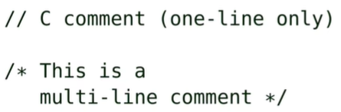
* 

Expressions

* Infix notation
* Normal arithmetic rules apply
* 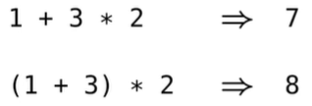
* 4 * 5 / 2 is equivalent to (4 * 5) / 2
* When working with integer values in C, do not add a leading (preceding) zero (0) to the value. For example, do not write 017 if you want to represent the number 17. In C, integer values that start with a zero are evaluated in octal (base 8), so 010 is equivalent to 8. Integer values that start with 0x are evaluated in hexadecimal, so 0x10 is equivalent to 16.

Operators

* Ex: +, -, *
* C does not have an exponentiation operator x^n. It does have a (^) operator that is the bitwise exclusive operator.

The / Operator

* When working with integers, the C operator rounds towards zero
* 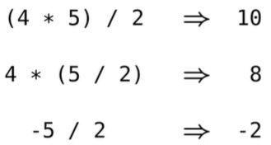

The % Operator

* The modulo (%) operator produces the remainder after integer division
* 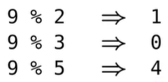
* The value of (a % b) is: a - (a / b) * b
* (i % j) has the same sign as i

C identifiers

* Functions, variables, and structures require an identifier (or name)
* C identifiers must start with a letter, and can only contain letters, underscores and numbers
* Use underscore_style for identifiers with compound words. Ex: hst_rate

Anatomy of a function definition

int my_add(int a, int b) {

return a + b;

}

* braces ({}) indicate the beginning/end of a function block
* return keyword, followed by an expression, followed by a semicolon (;)
* parameters (a, b) are separated by a comma
* the function and parameter types are specified (i.e., int). The int in front of a and b indicate the a is an int and b is an int. The int in front of the function name indicates the function’s return type is an int.
* Note the placement of the braces ({}) and the use of whitespace and indentation (more on this later).

Static Type System

* C uses a static type system which means all types must be known before the program is run and the type of an identifier cannot change
* For instance in the function above, the parameters a and b are both ints and the return type of my_add is an int
* Since C uses static typing, there are no functions equivalent to integer? and string?
* In C, it is impossible to raise a ‘type’ runtime error since you cannot violate the contract type. Runtime errors cannot occur since C won’t even let the function run in the first place, an error will occur before that

Function Terminology

* We call a function by passing it arguments.
* A function returns a value.
* my_add(1, 2) ⇒ 3
* We call my_add and pass it the arguments 1 and 2.
* my_add(1, 2) returns 3.

Void Keyword

* Use the void keyword to indicate a function has no parameters.

int my_num(void) {

return my_add(40, 2);

}

* To call a parameterless function, put nothing between the parentheses (do not pass void).
* my_num() ⇒ 42

No Nested functions

* Functions cannot be defined (nested) inside of another function
* 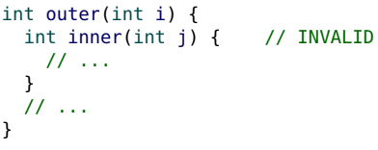

Function Documentation

* Provide a purpose for every function that shows an example of it being called, followed by a brief description of what the function does (not how it does it).
* No contract types are necessary (they are part of the definition).
* Add a requires comment if appropriate. The syntax for requires is not precise, using plain english is good enough.
* 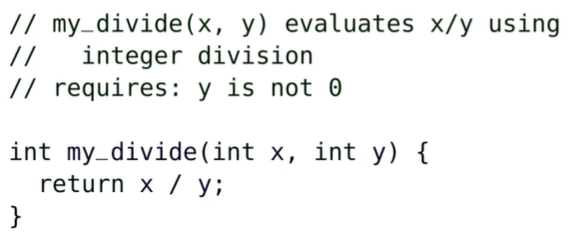
* Note the indent in the second line of the purpose statement

Whitespace

* C ignores most whitespace
* 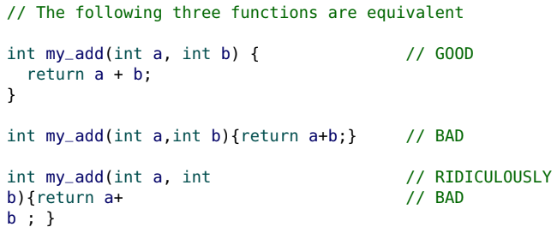

CS 136 style

int my_add(int a, int b) {

return a + b;

}

* a block start (open brace {) appears at the end of a line
* a block end (close brace }) is aligned with the line that started it, and appears on a line by itself
* indent a block 2 (recommended), 3 or 4 spaces: be consistent
* add a space after commas and around arithmetic operators
* Typing Ctrl-I in Seashell will auto-indent your code for you.
* When there are a large number of parameters, a large expression or a long purpose, continue (indented) on the following line.
* 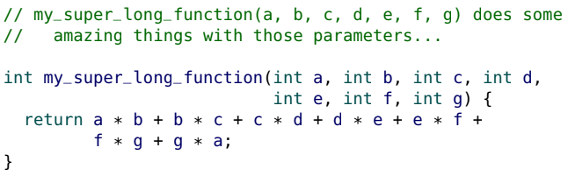

Entry Point

* Typically, a program is “run” (or “launched”) by an Operating System (OS) through a shell or another program such as DrRacket.
* The OS needs to know where to start running the program. This is known as the entry point.
* In C, the entry point is a special function named main. Every C program must have one (and only one) main function.
* In many interpreted languages (including Racket), the entry point is simply the top of the file being “run”.

main

* main has no parameters and an int return type. Actually main has optional parameters but will be discussed later on.
* 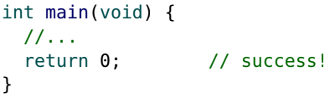
* The main function’s integer return value communicates to the OS the “error code”. The error code of 0 means success.
* main is a special function and does not require an explicit return value. The default value is success (zero) and zero is returned automatically if it is not present.
* There is a constant EXIT_SUCCESS (defined as zero) which is also popular in practice.
* 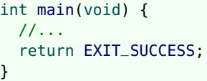

Top-level expressions

* In C, top-level expressions (code outside of a function) are not allowed. This is generally true for most programming languages with an entry point.
* Code only executes inside of a function.
* 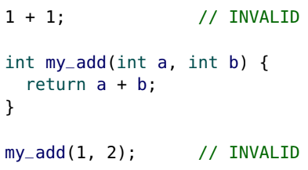

Tracing Expressions

* We have provided tracing tools to help you “see” what your code is doing.
* Here, we use trace_int inside of main to trace several expressions and display them to the screen (console):
* 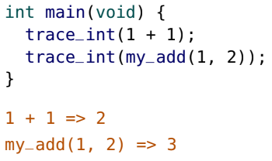
* Leave your tracing in your code. It is ignored in our tests and does not affect your results (no need to comment it out). In fact, adding them is good evidence you are trying to debug code.

Running First Program

* 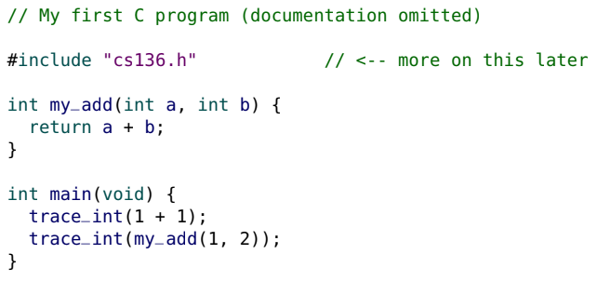
* Note the necessary #include line at the top of the program.
* For now, always add this line (it is explained in Section 06).

Function ordering

* Always place function definitions above any other functions that reference them (so main is at the bottom).
* Consider the ordering of these two function (with bad order)
* 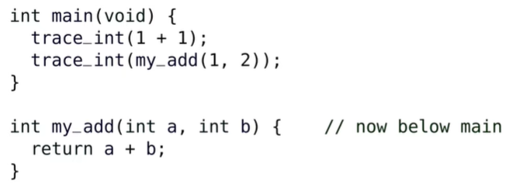
* If main appears above my_add, it causes an error such as
* 
* When C runs your program, it scans from top to bottom and while it's scanning, it makes sure all the types match. Thus, when it reaches my_add in the main function, C doesn't know anything about my_add is since it hasn't reached the my_add function yet.

Programming Documentation

* Document a program (state its purpose) at the top of the file (not necessarily where main is defined).
* 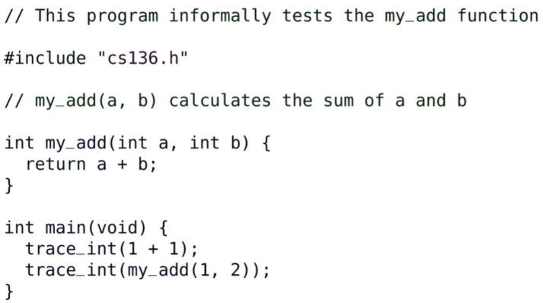
* Note that the main function has no purpose statement. Instead, we describe what our program does at the top of the program.

Testing

* Our tracing tools are an excellent way for you to interact with your code and help you “see” what is happening. They are helpful to informally test your code. They are not a viable strategy to thoroughly test.
* However, to facilitate more thorough testing, we will need Boolean expressions

Boolean Expressions

* In C, Boolean expressions do not produce “true” or “false”.
* They produce either:

• zero (0) for “false”, or

• one (1) for “true”.

* In our environment, the constants true and false have been defined to be 1 and 0 (for convenience).

Comparison operators

* The equality operator in C is == (note the double equals)
* 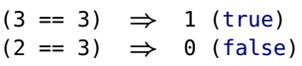
* The not equal operator is !=
* 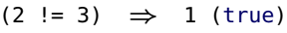
* The operators <, <=, > and >= behave exactly as expected
* 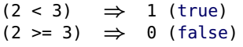

Logical Operators

* The Logical operators are: ! (not), && (and), || (or):
* 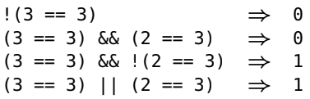
* Similar to Racket, C short-circuits and stops evaluating an expression when the value is known.
* (a != 0) && (b / a == 2) does not generate an error if a is 0.
* Operators (or functions) that expect a Boolean value (e.g., &&) will consider any non-zero value to be “true”.
* Only zero (0) and the value NULL are considered to be false
* 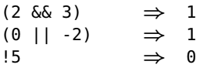
* Below is a table that goes from highest priority to lowest priority in terms of the order of operations.
* 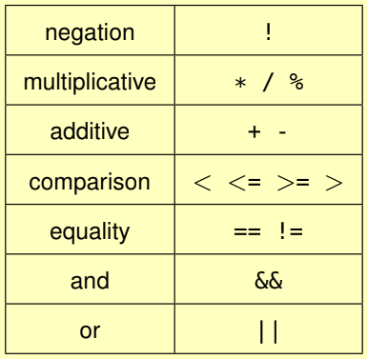

bool type

* The bool type is an integer that can only have a value of 0 or 1.
* 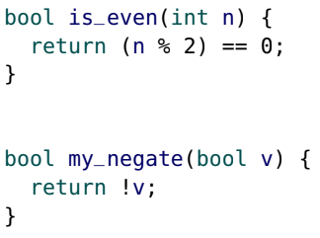

Assertions

* Use the assert function to test functions
* assert(my_add(1, 2) == 3);
* assert(exp) stops the program and displays a message if the expression exp is false (zero).
* If exp is true (non-zero), it does “nothing” and continues to the next line of code.
* Often better to use assert than trace_int for testing. But when we debug, use trace_int
* 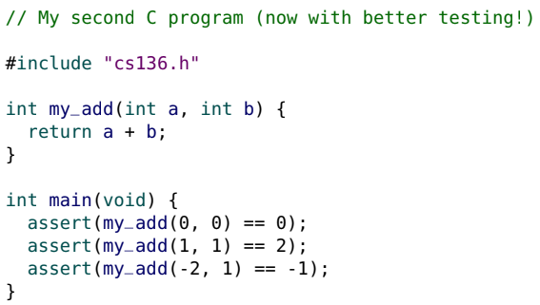

Function Requirements

* The assert function is also very useful for verifying function requirements.
* assert any feasible function requirements
* 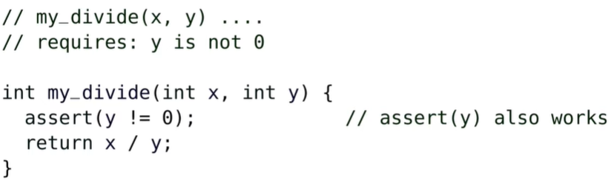
* For this specific example, we could actually just say assert(y). Since we are checking to make sure y!=0, we are checking if y is any non-zero number. Any non-zero number is true in C. So y=0 is the same as saying y is false. So if we assert(y), we are doing assert(0) which returns false and stops the program. If y is not 0, then assert(y) will be true.
* Some requirements are infeasible to assert, or (as we will discuss in Section 08) they would be inefficient to assert.
* It is good style to communicate (i.e., document) that a requirement is not asserted:
* 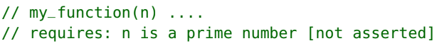

Multiple Requirements

* With multiple requirements, it is better to have several small asserts.
* It makes it easier to determine which assertion failed (which requirement was not met).
* 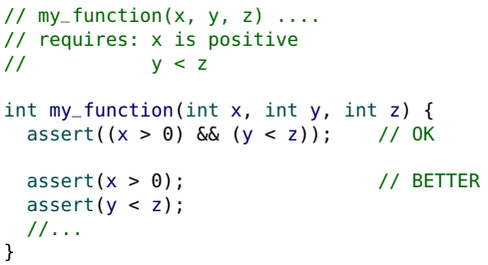

Statements

* Blocks ({}) can contain multiple statements:
* 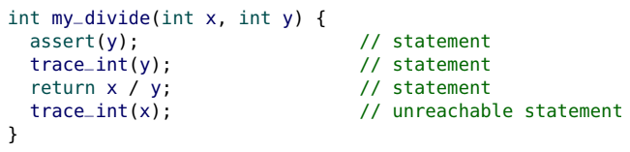
* Statements are executed in sequence (one after the other).
* The return statement ends the function.
* In the above code, trace_int(x); will never execute.
* We can use blocks not just for functions, if statements, loops, we can actually add them anywhere.
* 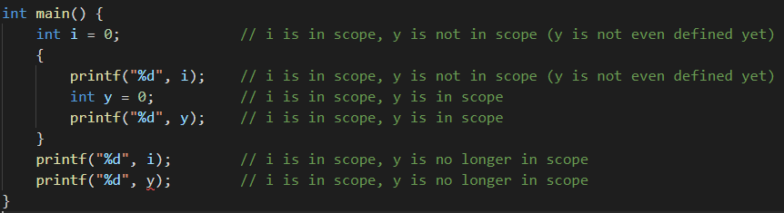

Brief introduction to control flow

* The return statement is a special kind of statement known as a control flow statement.
* return “controls the flow” of the program by ending the function and returning to the caller.
* The control flow determines which code is executed

Conditionals (If Statements)

* The if control flow statement allows us to have functions with conditional behavior.
* 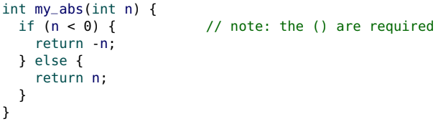
* There can be more than one return in a function, but only one value is ever returned.
* The function stops when the first return is executed.
* If there are more than two possible results, use else if.
* 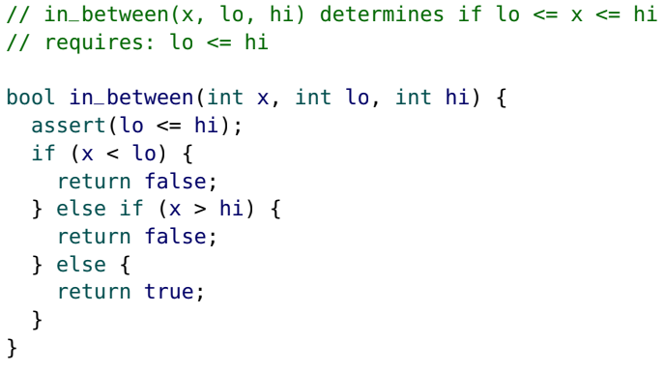

Ternary Operator

* C’s if statement does not produce a value: it only controls the “flow of execution” and cannot be used inside of an expression. Racket can use cond in expressions as shown below, but C cannot do that.
* 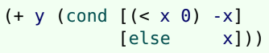
* Instead of if statements, the C ternary conditional operator (?:) does produce a value.
* The value of the expression:
  + q ? a : b
  + is a if q is true (non-zero), and b otherwise.
* 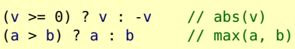

Recursion

* 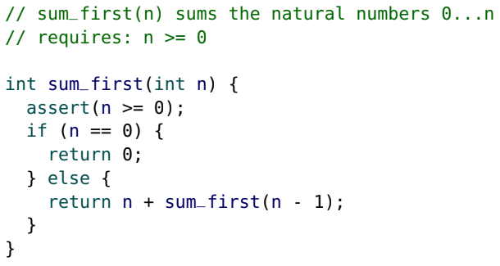

**Section 3**

Functional and Imperative programming

* In CS 135 we used the functional programming paradigm:
  + functions are “pure” (a.k.a. “mathematical”):
    - functions only return values
    - return values only depend on argument values
  + only constants are used
* In the imperative programming paradigm functions may be “impure” and we will use variables.
* A programming paradigm can also be thought of as a programming “approach”, “philosophy” or “style”.

Compound statement

* In English, an imperative is an instruction: “Give me your money!”
* In imperative programming, a sequence of statements are executed. We have already seen this:
* 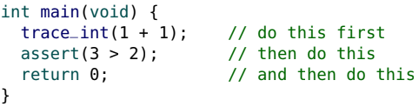
* A block {} is formally known as a compound statement, which is simply a sequence of statements (to be executed in order). Blocks can also contain local variable definitions.

Imperative programming

* A program is mostly a sequence of statements to be executed.
* Control flow is used to change the order of statements (Section 04).
* The most significant difference between the functional and imperative paradigms is: Imperative programming uses side effects (functional programming does not).
* In this section we explore side effects, beginning with output.

I/O

* I/O (Input/Output) is the term used to describe how programs interact with the “real world”.
* A program (“app”) on your phone may interact with you in many different ways:
* Input: touch screen (onscreen keyboard), voice, camera
* Output: screen (display), sounds, vibrations
* It may also interact with non-human entities: files, printers, GPS, other computers on the internet

Text I/O

* To display text output in C, we use the printf function.
* 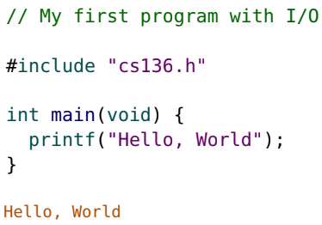
* 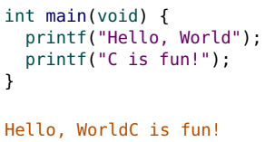
* The newline character (\n) is necessary to properly format output to appear on multiple lines.
* 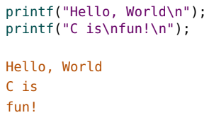
* The first parameter of printf is a "string".
* To output values, use a format specifier (the f in printf) within the string and provide an additional argument.
* For an integer in “decimal format” the format specifier is "%d".
* 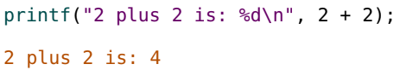
* There can be multiple format specifiers, each requiring an additional argument.
* 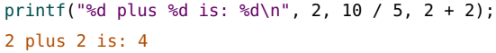
* To output a percent sign (%), use two (%%).
* 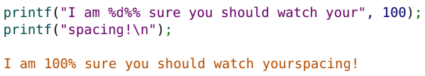
* Similarly, to print a backslash (\), use two (\\). to print a quote ("), add an extra backslash (\")
* The full C printf format specifier syntax controls the format and alignment of output.
* 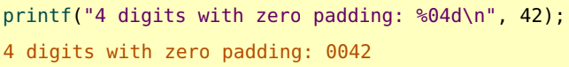

Functions with side effects

* Consider the two functions below:
* 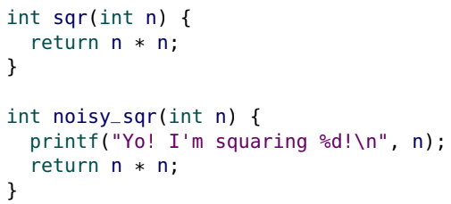
* Both functions return the same value.
* However, noisy_sqr does more than return a value.
* In addition to returning a value, it also produces output.
* noisy_sqr has a side effect.

Side effects and state

* In general, a programming side effect is when the state of something “changes”.
* State refers to the value of some data (or “information”) at a moment in time.
* Consider the following “real world” example: You have a blank piece of paper, and then you write your name on that paper. You have changed the state of that paper: at one moment it was blank, and in the next it was “autographed”. In other words, the side effect of writing your name was that you changed the state of the paper.

Documenting side effects

* The printf function has a side effect: it changes the output (or “display”).
* By calling printf, the function noisy_sqr also has a side effect.
* Clearly communicate if a function has a side effect. In this course, there is no need to provide any detail in the “effects:” section ( // effects: produces output is sufficient). Occasionally, you may want to describe the output in the purpose.
* 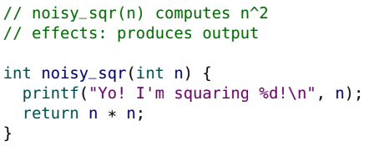
* If a side effect occurs conditionally, add the word “may”:
* 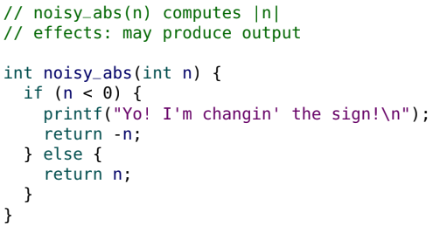

Debugging tools

* Statements used for debugging and informal testing (e.g., assert, trace_int) are not considered side effects.
* Do not document asserts or tracing in the “effects:” section.
* Feel free to leave your tracing code in your assignments: they will not affect your test results.

I/O Terminology

* In the context of I/O, be careful with terminology.

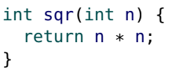

* Informally, someone might say: “if you input 7 into sqr, it outputs 49”.
* This is poor terminology: Instead, say: “if 7 is passed to sqr, it returns 49”.
* Ex:
  + 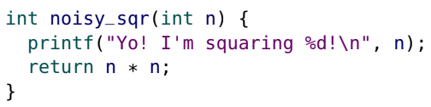
  + For noisy_sqr, say: “if 7 is passed to noisy_sqr, it outputs a message and returns 49”.

Testing I/O

* asserts can test that sqr and noisy_sqr return the correct values:
* 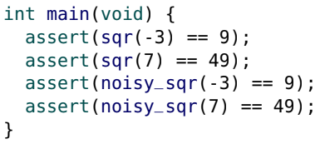
* But assert cannot be used to test that noisy_sqr produces the correct output.

Seashell: [RUN] vs. [I/O TEST]

* In Seashell there are two ways of “running” a program.
* The only difference is the I/O behaviour:
* With the [RUN] button, input is read from the keyboard.
  + Any output is displayed in the console (“screen”).
* With the [I/O TEST] button, input is read from input file(s)
  + (e.g., testfile.in) instead of the keyboard.
  + If a corresponding output test file exists (e.g., testfile.expect), Seashell checks the output against the expected output test file to see if they match.
  + I/O tests always require an .in file even if it’s empty
  + 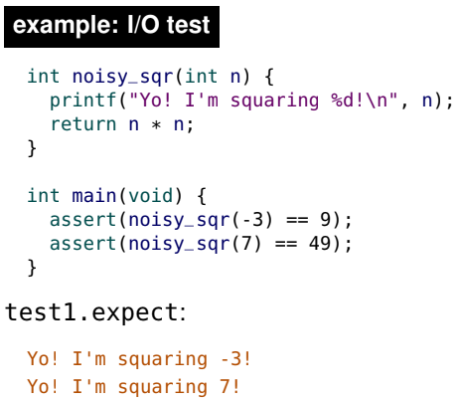

void functions

* noisy_sqr has a side effect and returns a value.
* It is possible for a function to only have a side effect, and no return value.
* The void keyword is used to indicate a function that returns “nothing”.
* 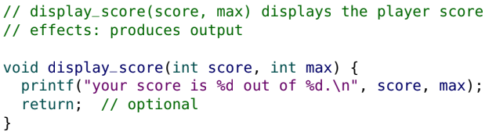
* In a void function, the return is optional and has no expression (when the end of a void function is reached, it returns automatically).

printf return value

* Surprisingly, printf is not a void function (it returns an int), it’s just discarded.
* printf returns the number of characters printed.
* printf("hello!\n") returns 7 (\n is a single character).

Expression Statements

* The following expressions all have a value of 11:
  + 11
  + 10 + 1
  + sqr(6) - sqr(5)
  + printf("expression\n")
  + printf("five\n") + 6
* An expression statement is an expression with a semicolon (;).
* 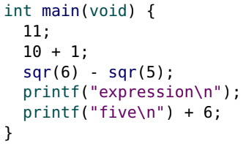
* However, these 11’s are never printed so what happens to all of those elevens? The value of an expression statement is discarded after it is executed.
* The purpose of an expression statement is to generate side effects.
* Seashell will give a warning if an expression statement obviously has no side effect such as: 8 + 1;.
* If an expression contains a function call there is no warning because side effects are “assumed” (even if there are none).

Statements

* There are only three types of C statements:
* 1. compound statements (blocks) {}
  + a sequence of statements (to be executed in order)
* 2. expression statements
  + for generating side effects (values are discarded)
* 3. control flow statements
  + control the order in which other statements are executed (e.g., return, if and else)

More side effects

* In addition to: Output (e.g., printf), we will encounter two more types of side effects (in this section): Input and Mutation (modifying variables)
* All side effects involve changing state.

Variables

* Variables store values.
* To define a variable in C, we need (in order):
  + the type (e.g., int)
  + the identifier (“name”)
  + the initial value
  + 
* The equal sign (=) and semicolon (;) complete the syntax.
* Definitions are not statements. They are different “things” (syntactic units).

Mutation

* When the value of a variable is changed, it is known as mutation.
* 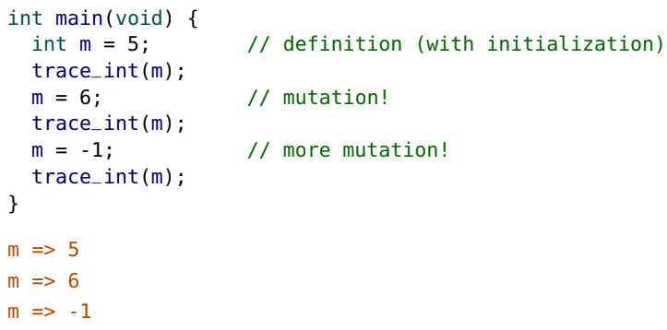
* At every moment in time, a variable must have a value.
* When mutation occurs, the “state” (value) of the variable changes.
* Mutation is a side effect.

Assignment Operator

* In C, mutation is achieved with the assignment operator (=).
* m = m + 1;
* The right hand side is evaluated first.
* The “right hand side” (RHS) must be an expression that produces a value with the same type as the LHS.
* The LHS must be the name of a variable (for now).
* The LHS variable is changed (mutated) to store the value of the RHS expression. In other words, the RHS value is assigned to the variable.
* This is a side effect: the state of the variable has changed.
* The assignment operator is not symmetric. So x = y; is not the same as y = x;
* In addition to the mutation side effect, the assignment operator (=) also produces the right hand side value.
* The following is occasionally used to perform multiple assignments.
* 
* The way (x = (y = (z = 0))) is the value of 0 is stored into z and (z = 0) collapses and produces the value of whatever is on the right hand side. So the expression becomes (x = (y = 0)). This process is repeated until all of x,y,z are 0.
* Consider the following code:
  + 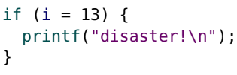
  + (i = 13) assigns 13 to i and collapses to produce the value 13. But 13 is equivalent to true. So the if expression is always true, and it always prints disaster! If this was intended, you still shouldn’t do this as it’s bad style.
  + Pro Tip: some defensive programmers get in the habit of writing (13 == i) instead of (i == 13). This causes an error if they accidentally use a single =
* Avoid having more than one side effect per expression statement as it’s confusing and abd style
* 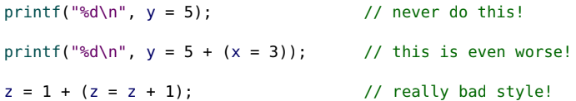

Initialization

* C allows a variable definition without initialization, but it is bad style.
* 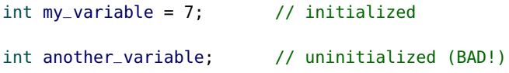
* The = used in initialization is not the assignment operator.
* Both initialization and assignment use the equal sign (=), but they have different semantics.
* 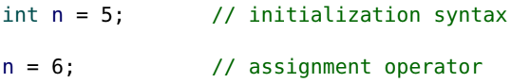
* The distinction is not too important now, but the subtle difference becomes important later.
* 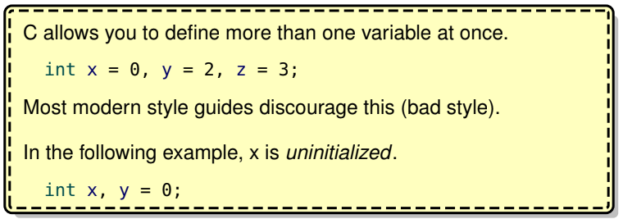

More assignment operators

* The compound addition assignment operator (+=) combines the addition and assignment operator (for convenience).
* 
* Additional compound operators include: -=, *=, /=, %=.
* There are also increment and decrement operators that increase or decrease a variable by one (either prefix or postfix).
* 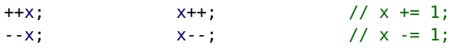
* If you follow the “one side effect per expression” rule it does not matter if you use prefix or postfix.
* If you don’t follow the rule, it does matter as shown below
* 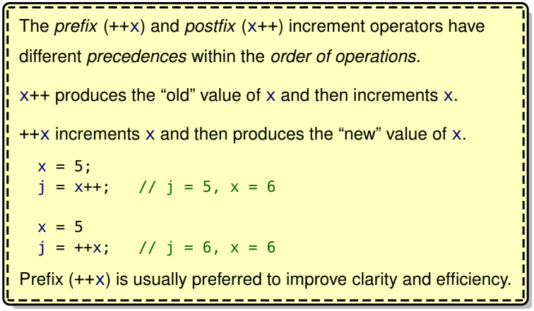

Constants

* A constant is a “variable” that is immutable (not mutable).
* In other words, the value of a constant cannot be changed.
* To define a C constant, we add the const keyword to the type.
* 
* In this course, the term “variable” is used for both variable and constant identifiers.
* In the few instances where the difference matters, we use the terms “mutable variables” and “constants”.
* It is good style to use const when appropriate, as it:
  + communicates the intended use of the variable
  + prevents ‘accidental’ or unintended mutation, and
  + may help to optimize (speed up) your code.

Global and local variables

* Variables are either global or local.
* Global variables are defined outside of functions (at the “top level”).
* Local variables are defined inside of functions.
* 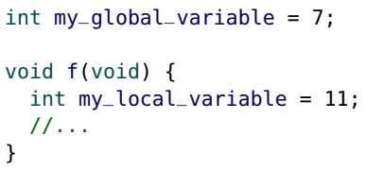

Variable Scope

* The scope of a variable is the region of code where it is “accessible” or “visible”.
* For global variables, the scope is anywhere below its definition.
* 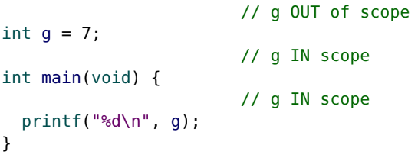

Block (local) scope

* Local variables have block scope.
* Their scope extends from their definition to the end of the block they are defined in.
* 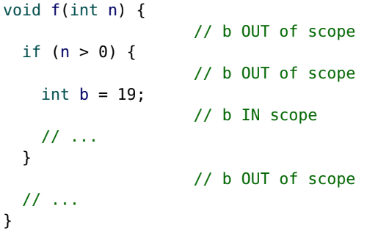
* 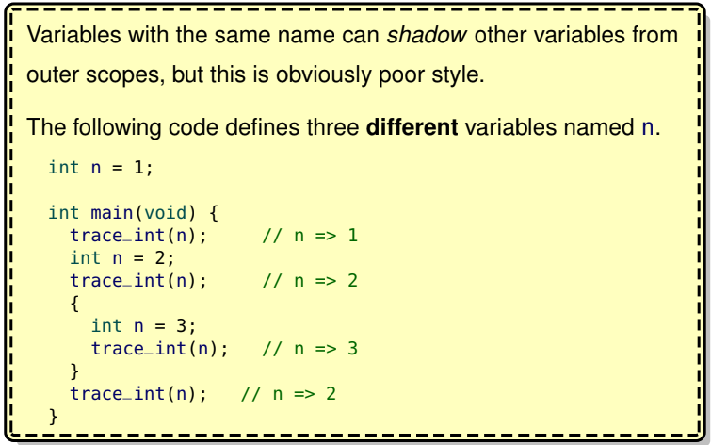

Impure functions

* Recall that the functional paradigm requires “pure” functions: functions only return values (no side effects) and the return values only depend on argument values.
* 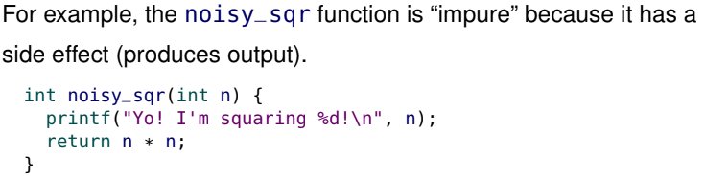
* “Impure” functions are sometimes called “procedures” or “routines” to distinguish their behavior from “pure” functions.

Mutating global variables

* A function that mutates a global variable has a mutation side effect (which makes it “impure”).
* Document any functions with mutation side effects.
* 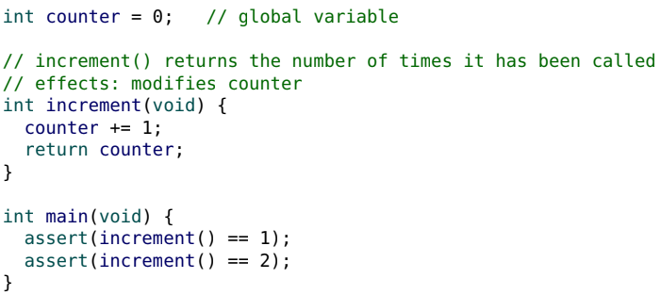
* In the example above, both assert statements pass. Notice these assert statements wouldn’t pass in functional programming. In functional programming, it is impossible for two functions to have different return values when the same arguments are passed to both.

Mutating local variables

* Mutating a local variable does not give a function a side effect.
* It does not affect the state outside of the function (global state).
* 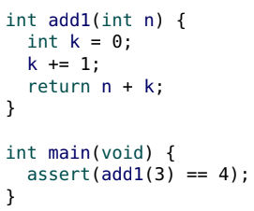
* The statement “k += 1;” has a side effect (mutation), but it only affects the state inside of the function (local state). add1 has no side effects and is still a “pure” function.

Mutating parameters

* Parameters are nearly indistinguishable from local variables, and can also be mutated.
* This version of add1 below is also a “pure” function (no side effects).
* 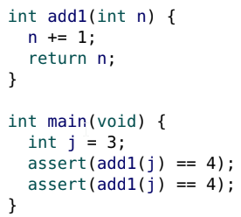
* Notice when we call the add1 function on j the first time, we don’t change the value of j (as shown in the second assert statement passing).

Global dependency

* A “pure” function only depends on its argument values.
* A function that depends on a global mutable variable is “impure” even if it has no side effects. Example of this is shown below.
* 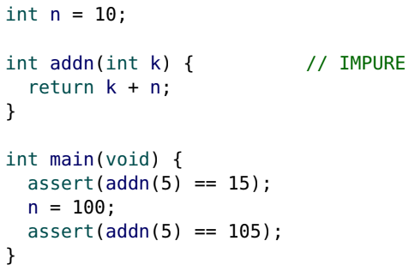

Avoiding global mutable variables

* Global mutable variables are almost always poor style and should be avoided.
* Unless otherwise specified, you are not allowed to use global mutable variables on your assignments.

Text Input

* Earlier, we learned how to output text with printf.
* We will now learn how to input text.
* The converse of printf is scanf, but we are not quite ready to use it (we introduce scanf in Section 05).
* For now, we will use an alternative method for reading input

read helper functions

* In this course we have provided some helper functions to make reading in input easier. For example:
* 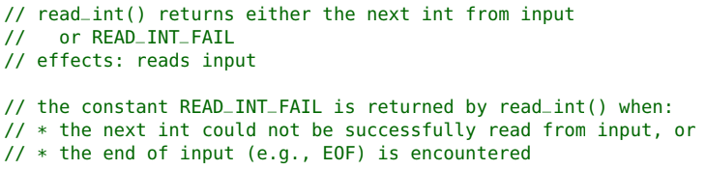
* Note how the side effect of reading input is documented:
* 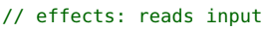
* Ex:
  + 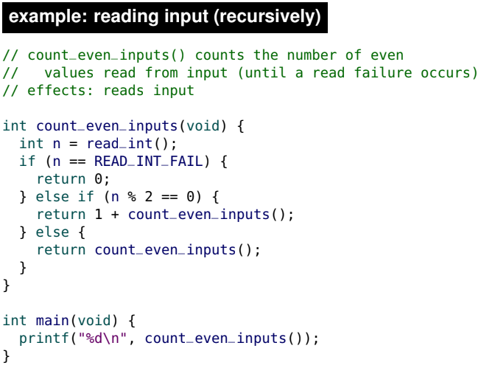
* If we [RUN] our program in Seashell, we can interactively enter int values via the keyboard.
* To indicate that there is no more input, press the [EOF] (End Of File) button, or type Ctrl-D.
* 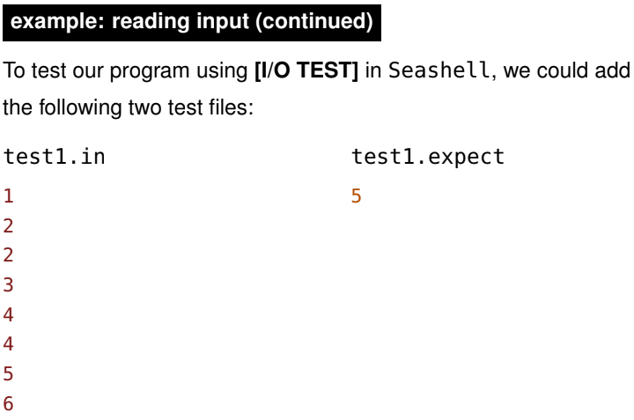
* One of the great features of the [I/O TEST] in Seashell is that you can add multiple test files.

Input formatting

* The read_int function ignores whitespace (newlines and spaces)
* The following two inputs are indistinguishable
* 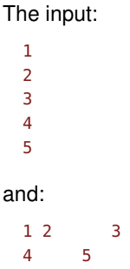

Reading input

* Be careful when reading input in our Seashell environment: once you read in a value, it can no longer be read again.
* Typically, it is best to store the read value (e.g., returned by read_int) in a variable so it can be referenced multiple times.
* 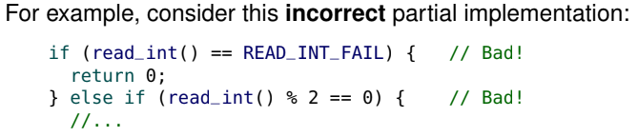
* The first read_int() reads in the first int, but then that value is now “lost”. The next read_int() reads in the second int, which is not likely the desired behaviour. For example if the first int was 5, C would read 5 and say it doesn’t pass the first condition and go to the second condition. Then it would read a new int and check if it’s even. But this is probably not what we want. We probably want to check if the input was an integer and even for the same input, not two different inputs.

Invalid input

* In this course, you do not have to worry about us testing your code with invalid input files.

Testing harness

* To summarize our function testing strategies:
  + return values: use assertions (e.g., in main)
  + input and output: [I/O TEST] (.in and .expect files)
* There is an alternate approach for testing return values.
* To test a function f we can write a dedicated test function that reads in argument values from input, passes those values to f, and then prints out the corresponding return values.
* This strategy is known as a testing harness.
* An example of this testing harness is shown below
* 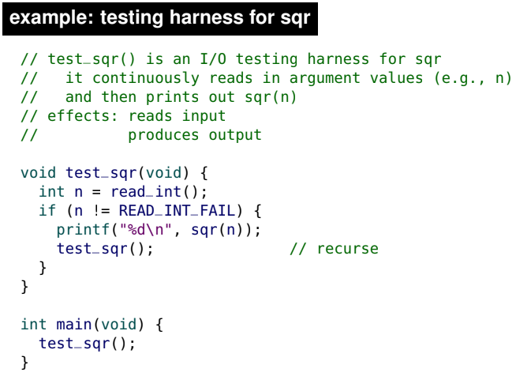
* 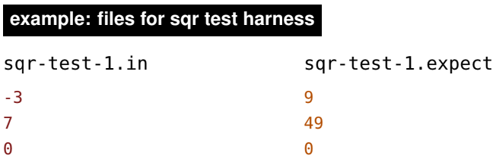

**Section 4**

Models of Computation

* In CS 135, we modelled the computational behaviour of Racket with substitutions (the “stepping rules”).
* all arguments are evaluated to values before a function can be called (“applied”)
* to call (“apply”) a function, we substitute the body of the function, replacing the parameters with the argument values.
* 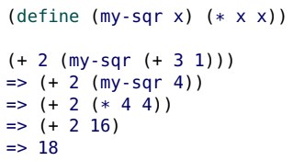
* Note the above is racket code. Similar to racket, in C, we cannot pass an expression as an argument for a function, we need to pass a simple value. However, the other substitution steps in Racket do not apply in C.
* In this course, we model the behaviour of C with two complimentary mechanisms:
  + control flow
  + Memory

Control flow

* We use control flow to model how programs are executed.
* During execution, we keep track of the program location, which is “where” in the code the execution is currently occurring.
* When a program is “run”, the program location starts at the beginning of the main function.
* For instance in the real world, we may use a finger to trace words as we read to keep track of where we are. The idea of where your finger is in the book is analogous to program location.

Types of Control Flow

* In this course, we explore four types of control flow:
* • compound statements (blocks)
* • function calls
* • conditionals (i.e., if statements)
* • iteration (i.e., loops)

Compound statements (blocks)

* We have already seen compound statements (blocks) where a sequence of statements (and definitions) are executed in order.
* 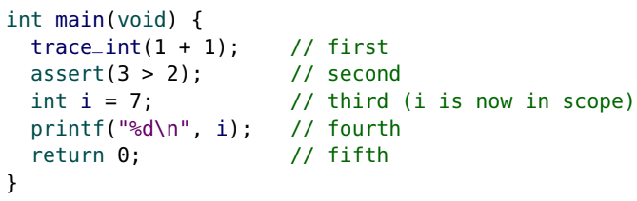

Function Calls

* When a function is called, the program location “jumps” from the current location to the start of the function.
* The return control flow statement changes the program location to go back to the most recent calling function (where it “jumped from”). The return keyword literally means return back to the programming location that we were at before we called this function.
* Obviously, C needs to “keep track” of where to go. We revisit this when we introduce memory later in this section.
* 

Conditionals (if)

* We introduced the if control flow statement in Section 02. We now discuss if in more detail.
* The syntax of if is
* 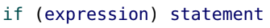
* where the statement is only executed if the expression is true (non-zero).
* 
* Remember: the if statement does not produce a value. It only controls the flow of execution.
* The if statement only affects whether the next statement is executed. To conditionally execute more than one statement, use a compound statement (block) by using the curly brackets.
* 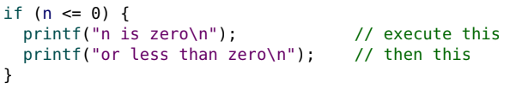
* Using a block with every if is strongly recommended even if there is only one statement. It is good style: it makes code easier to follow and less error prone. An example of this is shown below.
* 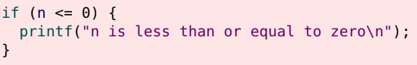
* Below is a flowchart that represents how the control flow of an if-statment works. Note below, statement A and Z get executed no matter what. The conditional part is whether or not the blue code block gets executed.
* 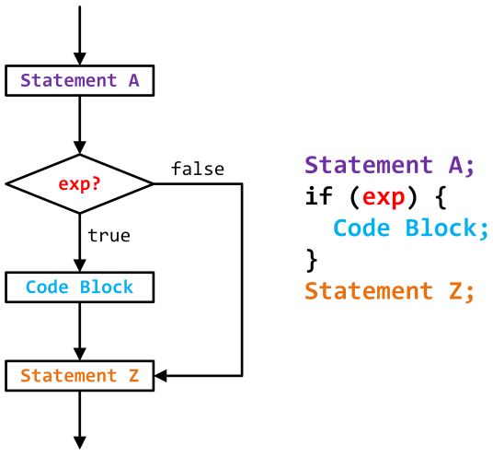
* As we have seen, the if statement can be combined with else statement(s) for multiple conditions.
* 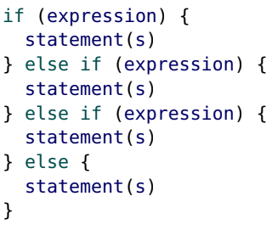
* Below is another flowchart diagram that represents how the if statement works when we also have an else if and else. Again, statements A and Z get executed no matter what.
* 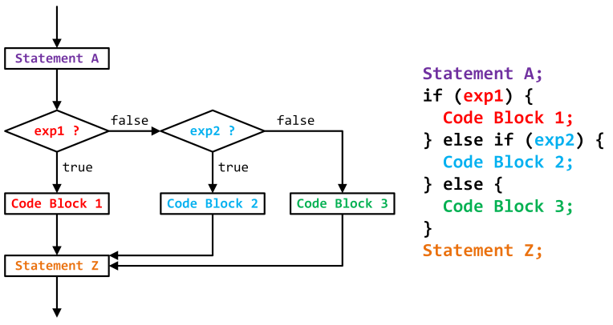
* If an if block contains a return statement, there may be no need for an else block.
* 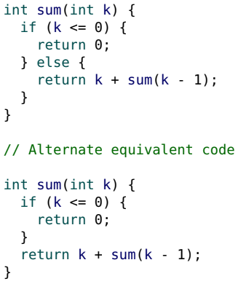

Looping

* With mutation, we can control flow with a method known as looping.
* 
* while is similar to if: the statement is only executed if the expression is true.
* The difference is, while repeatedly “loops back” and executes the statement until the expression is false.
* Like with if, always use a block ({}) for a compound statement, even if there is only a single statement.
* Below is another flowchart diagram that represents how the while statement works.
* 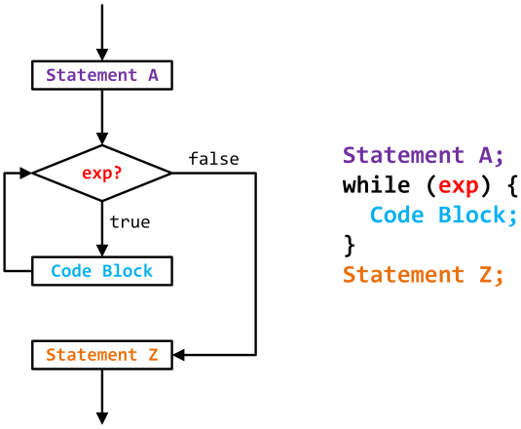
* Ex:
  + 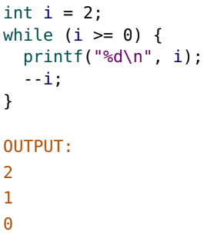
  + Note: the value of i after the while loop executes is -1 in this example. When i = 0, it satisfy the while condition and then is decremented by 1 so i = -1. However, i=-1 does not satisfy i >= 0 so it breaks the loop

Iteration vs. recursion

* Using a loop to solve a problem is called iteration.
* Iteration is an alternative to recursion and is much more common in imperative programming.
* 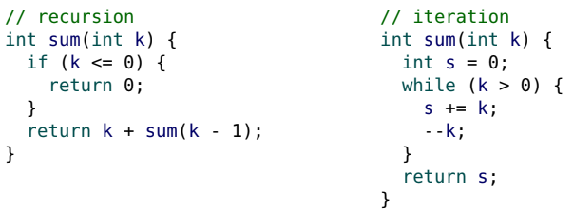
* When first learning to write loops, you may find that your code is very similar to using accumulative recursion.
* 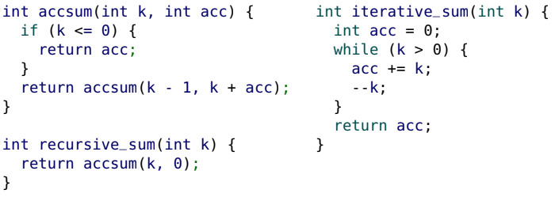
* For both accumulative recursion and iteration, we have an accumulator. In accumulative recursion we need an initial value for our accumulator which in this case is 0. Using loops, we also set an initial value for our accumulator variable which is also 0.
* For both accumulative recursion and iteration, we also have conditions that determine when to stop recursing/looping. In the accumulative recursion, the condition is if (k <= 0) and for the loop, the condition is while (k > 0). The statements but the ideas are the same.
* For both accumulative recursion and iteration, we also have statements telling the function what to do if we want to keep recursing/looping. In the accumulative recursion, we tell it to return accsum(k - 1, k + acc). In the loop, we tell it to do acc+=k; and --k;
* Looping is very “imperative”. Without mutation (side effects), the while loop condition would not change, causing an “endless loop”.
* Note: anything written with accumulative recursion can be written as a loop and vice versa
* Loops can be “nested” within each other.
* 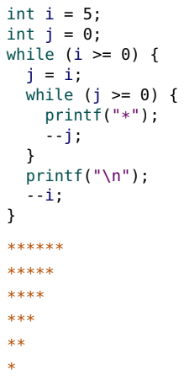 prints: 

Tracing tools

* The provided tracing tools can be used to help you understand your control flow and “see” what is happening in your program.
* This can help you debug your code.
* The tracing tools do not interfere with your I/O testing.
* On your assignments, never printf any unnecessary output as it may affect your correctness results. Rather, always use our tracing tools to help debug your code.
* 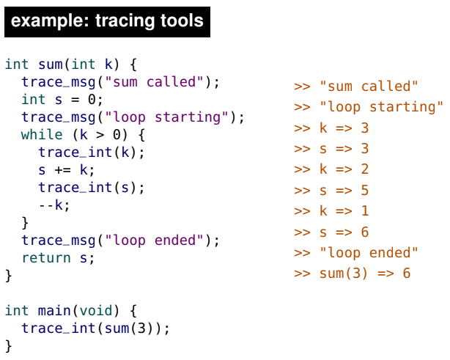

while errors

* A simple mistake with while can cause an “endless loop” or “infinite loop”. The following examples are endless loops (for i >= 0).
* Ex:
  + 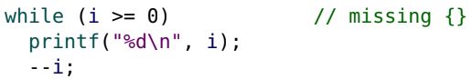
  + Without the parthentisis, the --i; is not actually in the while loop. So i never changes and we get an infinite loop
* Ex:
  + 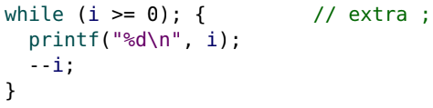
  + In this case, throwing a semicolon there executes a null statement. It’s not useful, but it just exists in C. The code block is not the statement that corresponds with the while. Rather, there is an empty null statement that would get repeatedly executed.
* Ex:
  + 
  + Use i == 100 and not i = 100. (i = 100) collapses to return a value of 100 which is true in C as it’s non-zero. Thus, it’s a while True loop which just keeps looping forever.
* Ex:
  + 
  + The above is a way of saying while True

do ... while

* The do control flow statement is very similar to while.
* 
* The difference between do while and while loops is that in do…while loops, the statement is always executed at least once, and the expression is checked at the end of the loop.
* 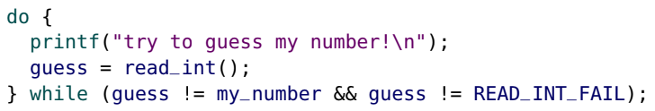
* 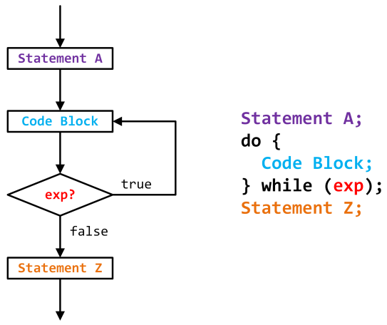

Break

* The break control flow statement is useful to exit from the middle of a loop. break immediately terminates the current (innermost) loop.
* break is often used with a (purposefully) infinite loop.
* 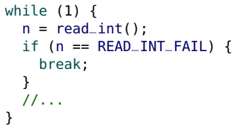
* break only terminates loops. You cannot break out of an if.

Continue

* The continue control flow statement skips over the rest of the statements in the current block ({}) and “continues” with the loop.
* 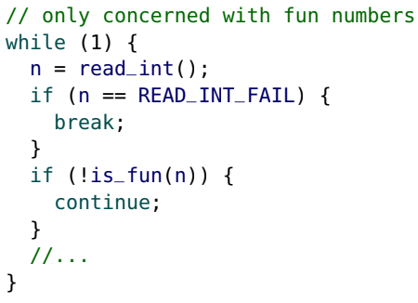
* Note in the above example, we check if the input is a number. If it’s not a number we break the loop. If it is, we check if it’s a fun number. If it isn’t, we go read the next number. If it is, we do something with the fun number.
* 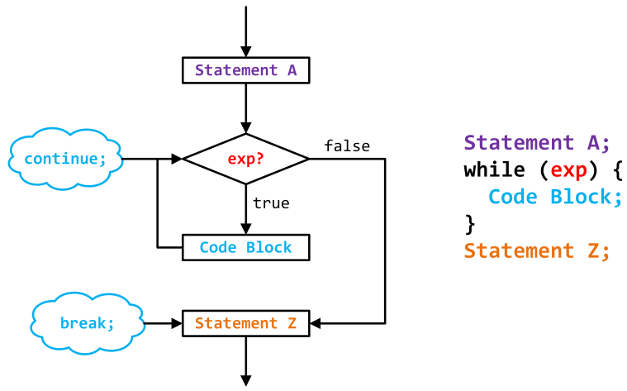

For loops

* The final control flow statement we introduce is for, which is often referred to as a “for loop”.
* for loops are a “condensed” version of a while loop.
* The format of a while loop is often of the form: 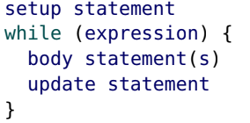which can be rewritten as a single for loop: 

For vs While

* 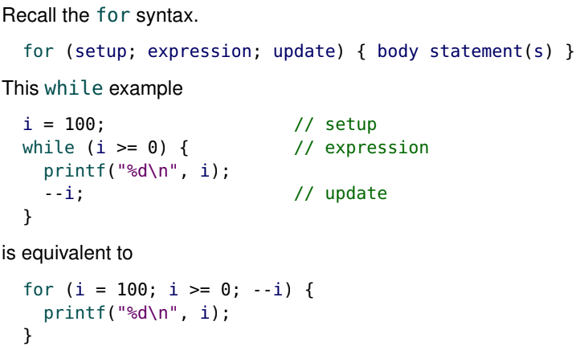
* Note in the examples above, we assume that is already defined. If it’s not, in the for loop we write int i = 100 instead of i = 100. If it is the case that i is already defined, note that if we were to print i right after the loop, the value of i would be -1 and not 0. Note if i was not previously defined and we instead write int i = 100 in the for loop, we cannot reference i outside the for loop as it’s no longer in scope.
* 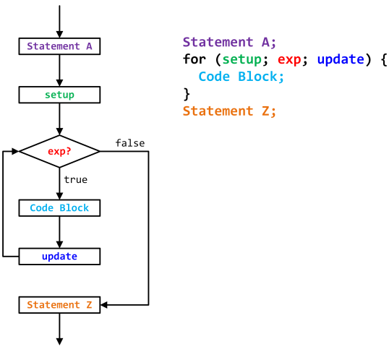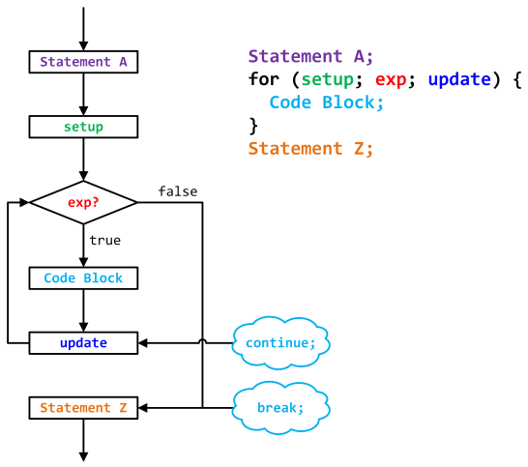
* A for loop is not always equivalent to a while loop. The only difference is when a continue statement is used. In a while loop, continue jumps back to the expression. In a for loop, the “update” statement is executed before jumping back to the expression.
* Most for loops follow one of these forms (or “idioms”).
* 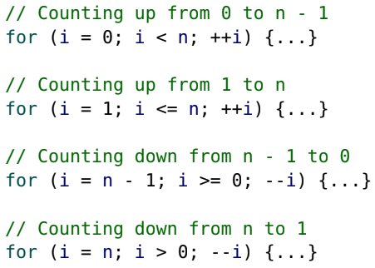
* It is a common mistake to be “off by one” (e.g., using < instead of <=). Sometimes re-writing as a while is helpful.
* In C99, the setup can be a definition. This is very convenient for defining a variable that only has local (block) scope within the for loop.
* 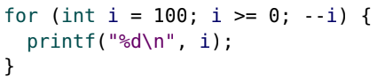
* 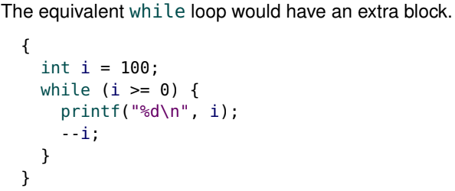
* Note the extra block in the while loop is used for scoping purposes of the variable i. i is not in scope outside the extra block
* Any of the three components of a for statement can be omitted.
* If the expression is omitted, it is always “true”.
* 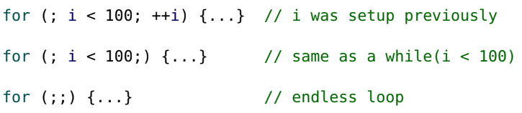
* 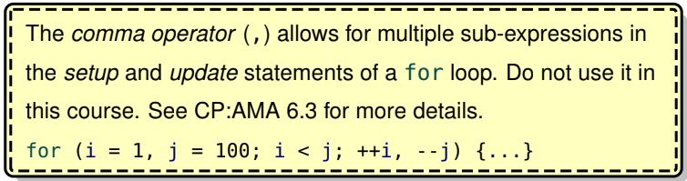
* Also do not use the comma operator as it can be very complicated to understand and is a very bad style.

Memory

* Often described in terms of bits
* One bit of storage (in memory) has two possible states: 0 (off) or 1 (on).
* A byte is 8 bits of storage. Each byte in memory is in one of 256 possible states.
* In this course, we will usually be dealing with bytes and not individual bits.

Accessing memory

* The smallest accessible unit of memory is a byte.
* Each byte of memory has an address.
* To access a byte of memory, its position in memory, which is known as the address of the byte, must be known.
* For example, imagine you have 1 MB of memory (RAM) which is 2^20 bytes of memory. The address of the first byte is 0, the address of the second byte is 1, … and the address of the last byte is 1048575 (or (2^20)− 1).
* Note: Memory addresses are usually represented in hex, so with 1 MB of memory, the address of the first byte is 0x0, and the address of the last byte is 0xFFFFF.
* You can visualize computer memory as a collection of “labeled mailboxes” where each mailbox stores a byte.
* 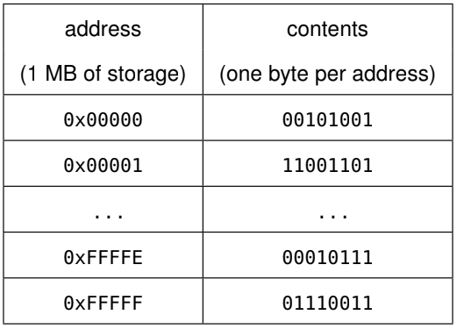
* The contents in the above table are arbitrary values.

Defining variables

* For a variable definition, C
* • reserves (or “finds”) space in memory to store the variable
* • “keeps track of” the address of that storage location
* • stores the initial value of the variable at that location (address).
* For example, with the definition: int n = 0; C reserves space (an address) to store n, “keeps track of” the address n, and stores the value 0 at that address.
* A new way of thinking of what a variable is is that a variable is a “name for a location” where a value is stored. So a variable is not a representation of a value, but rather the memory address where that value is to be stored.
* When a variable appears in an expression, C “fetches” the contents at its address to obtain the value stored there.

Sizeof

* When we define a variable, C reserves space in memory to store its value – but how much space is required?
* It depends on the type of the variable.
* The size operator (sizeof) produces the number of bytes required to store a type (it can also be used on identifiers). sizeof looks like a function and behaves like a function, but it is technically an operator.
* 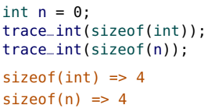
* In this course, the size of an integer is 4 bytes (32 bits).
* Ex:
  + 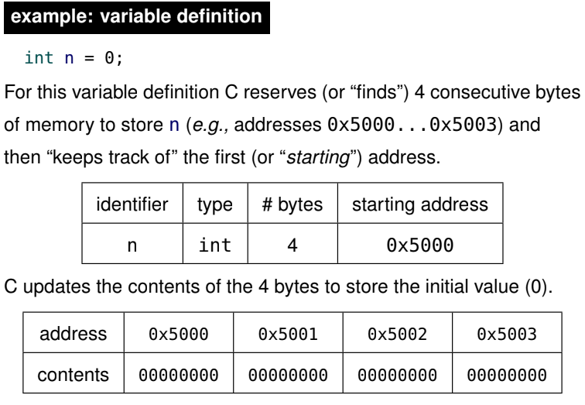
  + The reason we allocate 4 bytes for this variable is because its type is int and the sizeof(int) is 4.
  + Note: the starting address of a variable is the address of its first byte in memory.

Integer Limits

* Because C uses 4 bytes (32 bits) to store an int, there are only 2^32 (4,294,967,296) possible values that can be represented. The two in 2^32 is because a bit can contain two possible values, so 32 bits can contain 2^32 possible values.
* The range of C int values is −2^31 to (2^31)-1 inclusive or −2,147,483,648 to 2,147,483,647 inclusive.
* In our CS 136 environment, the constants INT_MIN and INT_MAX are defined with those limit values.
* There are more negative numbers than positive numbers. Since we have to account for zero, the number of positive and negative numbers cannot be the same.

Overflow

* If we try to represent values outside of the int limits, overflow occurs.
* Never assume what the value of an int will be after an overflow occurs. The value of an integer that has overflowed is undefined.
* By carefully specifying the order of operations, sometimes overflow can be avoided.
* Ex:
  + 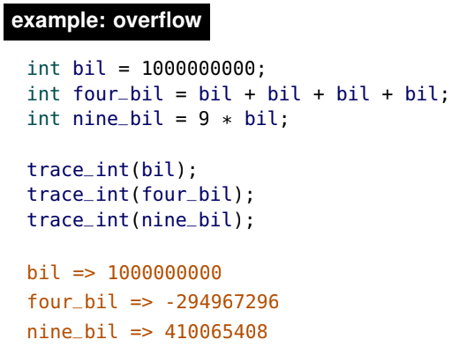
  + Both the variables four_bil and nine_bil contain numbers that have overflowed.
  + Remember, do not try to “deduce” what the value of an int will be after overflow – its behaviour is undefined.

Char

* The char type is also used to store integers, but C only allocates one byte of storage for a char (an int uses 4 bytes).
* There are only 2^8 (256) possible values for a char and the range of values is (−128 . . .127) in our Seashell environment.
* Because of this limited range, chars are rarely used for calculations.
* As the name implies, they are often used to store characters.

ASCII

* Early in computing, there was a need to represent text (characters) in memory.
* The American Standard Code for Information Interchange (ASCII) was developed to assign a numeric code to each character.
* Ex: Upper case A is 65, while lower case a is 97. A space is 32.
* ASCII was developed when teletype machines were popular, so the characters 0 . . . 31 are teletype “control characters” (e.g., 7 is a “bell” noise).
* The only control character we use in this course is the line feed (10), which is the newline \n character. Note that when we write \n inside a string or as a character, it’s being stored as the value 10.
* 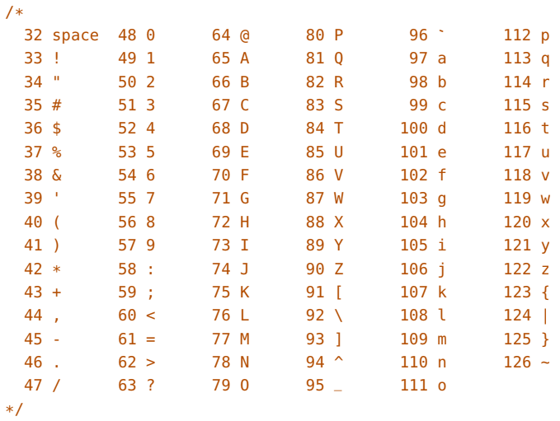

C characters

* In C, single quotes (') are used to indicate an ASCII character.
* For example, 'a' is equivalent to 97 and 'z' is 122.
* C “translates” 'a' into 97.
* In C, there is no difference between the following two variables:
* 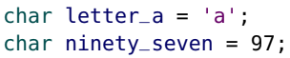
* Always use single quotes with characters: "a" is not the same as 'a'.
* The printf format specifier to display a character is "%c".
* Ex:
  + 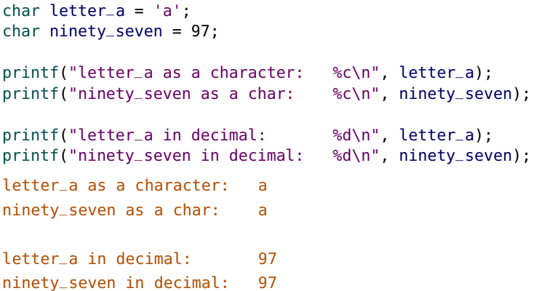
  + This example illustrates there is literally no difference in terms of the value between letter_a and ninety_seven. In memory, they have the same value. Each char is just 1 byte of information, it is just a question of whether we want to interpret that byte as a number or a char.

Character arithmetic

* Because C interprets characters as integers, characters can be used in expressions to avoid having “magic numbers” in your code.
* 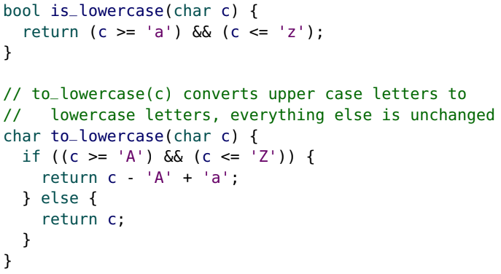
* We don’t want to use random numbers like 65 in our code. It’s much better to say ‘A’ instead of 65.

Reading characters from input

* We have also provided read_char for reading characters.
* When reading int values, we ignored whitespace in the input.
* When reading in characters, you may or may not want to ignore whitespace characters, depending on the application.
* read_char has a parameter for specifying if whitespace is ignored.

Symbol type

* There is no C equivalent of the Racket 'symbol type.
* C symbols are constants (often ints) with meaningful identifiers (“names”) but arbitrary (meaningless) values.
* Use ALL_CAPS for symbol names.
* Ex:
  + 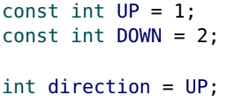
  + The values 1 and 2 are completely arbitrary.

Floating point types

* The C float (floating point) type can represent real (non-integer) values.
* 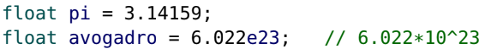
* Unfortunately, floats are susceptible to precision errors.
* Ex:
  + 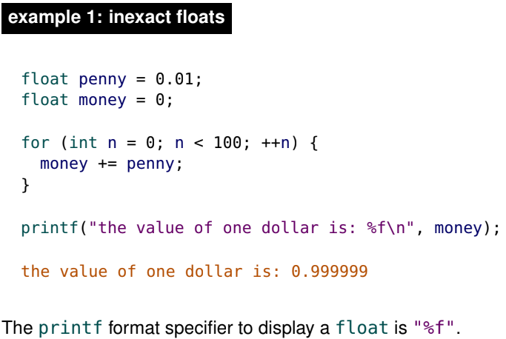
  + Notice this for loop demonstrates the imprecision within the float. The output should be 1 dollar, but instead, it outputs 0.999999
* Ex:
  + 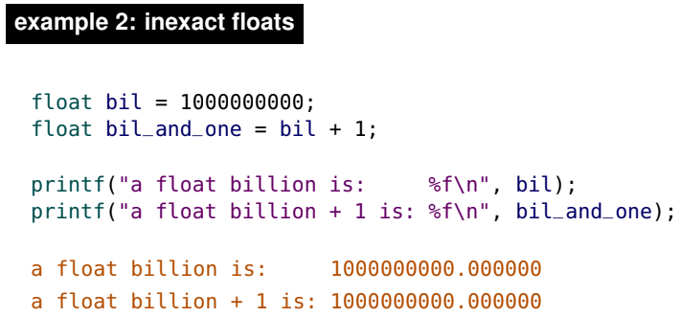
  + Notice this example is saying adding 1 to 1 billion is still 1 billion
* In the previous two examples, we highlighted the precision errors that can occur with the float type.
* C also has a double type that is still inexact but has significantly better precision. A double has more precision than a float because it uses more memory. A float uses 32 bits while a double uses 64 bits.
* Just as we use check-within with inexact numbers in Racket, we can use a similar technique for testing in floating point numbers C.
* Assuming that the precision of a double is perfect or “good enough” can be a serious mistake and introduce errors.
* Unless you are explicitly told to use a float or double, do not use them in this course.

Structures

* Structures (compound data) in C are similar to structures in Racket.
* 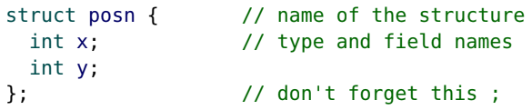
* Because C is statically typed, structure definitions require the type of each field.
* The structure type includes the keyword “struct”. For example, the type is “struct posn”, not just “posn”. This can be seen in the definition of p below.
* 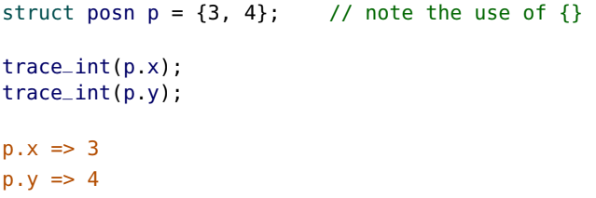
* Instead of selector functions, C has a structure operator (.) which“selects” the requested field.
* The syntax is variablename.fieldname
* 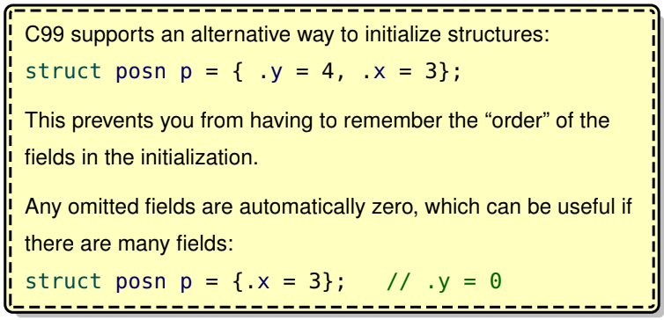

Mutation with structures

* The assignment operator can be used with structs to copy all of the fields from another struct. Individual fields can also be mutated.
* 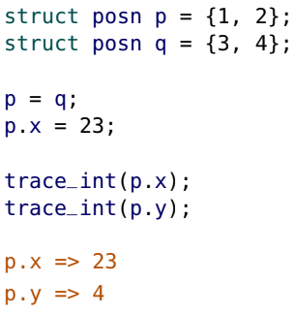
* Notice in the example above, p.x => 23 since we mutated the individual x field in the line p.x = 23;
* Notice in the example above, p.y => 4 since we copied all the fields (including the y field) from q in the line p = q;
* The braces ({}) are part of the initialization syntax and can not simply be used in assignment. Instead, just mutate each field. On rare occasions, you may want to define a new struct so you can mutate “all at once”.
* 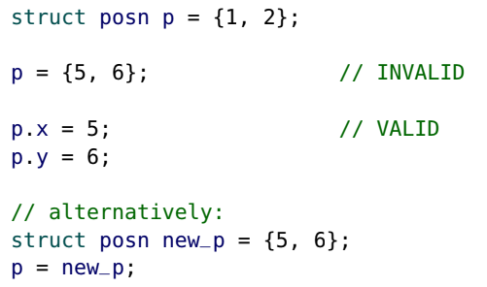
* The equality operator (==) does not work with structures. You have to define your own equality function.
* 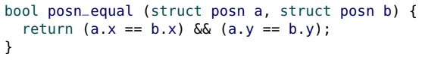
* Also, printf only works with elementary types. Print each field of a structure individually:
* 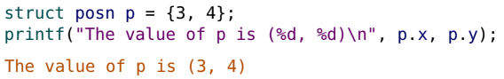

Structure in the memory model

* For a structure definition, no memory is reserved:
* 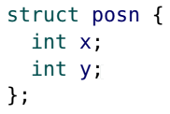
* Memory is only reserved when a struct variable is defined.
* 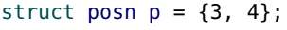

sizeof a struct

* 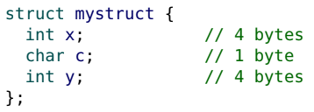
* 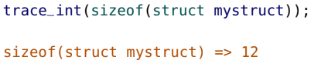
* The amount of space reserved for a struct is at least the sum of the sizeof each field, but it may be larger.
* In the example above, we might expect the size of mystruct to be 9 since we add 4+1+4 but that is not the case.
* You must use the sizeof operator to determine the size of a structure.
* <https://www.geeksforgeeks.org/is-sizeof-for-a-struct-equal-to-the-sum-of-sizeof-of-each-member/>
* If the fields of a struct are all the same type, then the size is exactly number_of_fields * sizeof(type_of_field)

Sections of memory

* In this course we model five sections (or “regions”) of memory:
* 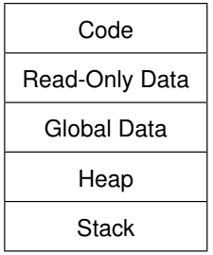
* We won’t deal with heap until we are in section 10

Temporary results

* When evaluating C expressions, the intermediate results must be temporarily stored.
* a = f(3) + g(4) - 5;
* In the above expression, C must temporarily store the value returned from f(3) “somewhere” before calling g.

The code section

* When you program, you write source code in a text editor using ASCII characters that are “human readable”.
* To “run” a C program, the source code must first be converted into machine code (more like a sequence of 1’s and 0’s) that is “machine readable”.
* This machine code is then placed into the code section of memory where it can be executed.
* Converting source code into machine code is known as compiling.

The read-only & global data sections

* Earlier we described how C “reserves space” in memory for a variable definition such as int n = 0;
* The location of memory depends on whether the variable is global or local.
* Global Variables
  + If the global variables are constants, they are placed in read-only data
  + If the global variables are mutable, they are placed in the global data section
  + Global variables are available throughout the entire execution of the program, and the space for the global variables is reserved before the program begins execution (before we run the main function). Since the main function may already use global variables, global variables must have space reserved for them before execution.
  + • First, the code from the entire program is scanned and all global variables are identified.
  + • Next, space for each global variable is reserved (either into read-only data section or global data section).
  + • Finally, the memory is properly initialized.
  + • Then, the main function is called.
  + 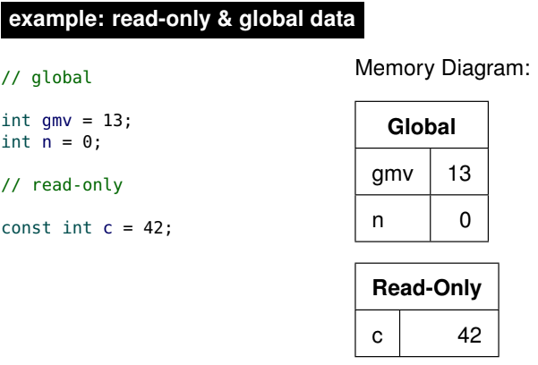
  + Notice the global mutable variables are stored in the global data section while the global constants are stored in the read-only data section. The read-only data section is called read-only since you can only read it, you cannot mutate it.

Function Calls

* Recall the control flow for function calls:
* • When a function is called, the program location “jumps” from the current location to the start of the function
* • return changes the program location to go back to the most recent calling function (where it “jumped from”)
* • C needs to track where it “jumped from” so it knows where to return to
* To keep track of where we ‘jumped from’, we have to store that information in memory.
* We model function calls with a stack, and store the information in the stack section of memory.

Stacks

* A stack in computer science is similar to a physical stack where items are “stacked” on top of each other.
* For example, a stack of papers or a stack of plates.
* Only the top item on a stack is “visible” or “accessible”.
* Items are pushed onto the top of the stack and popped off of the stack.

The call stack

* Whenever a function is called, we can imagine that it is pushed onto a stack, and it is now on the top of the stack.
* If another function is called, it is then pushed so it is now on top.
* The call stack illustrates the “history” or “sequence” of function calls that led us to the current function.
* When a function returns, it is popped off of the stack, and the control flow returns to the function now on top.
* 

The return address

* When C encounters a return, it needs to know: “where was the program location before this function was called?”
* In other words, it needs to “remember” the program location to “jump back to” when returning.
* This location is known as the return address.
* In this course, we use the name of the calling function and a line number (or an arrow) to represent the return address.
* The operating system calls the main function, so that is shown as "OS". So the return function for main is actually OS.
* Ex:
  + 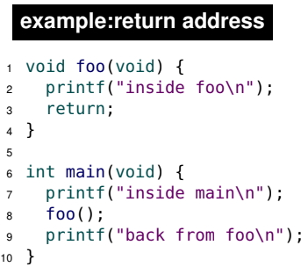
  + When foo is called, the program location is on line 8 of the function main so we would record the return address as: main: 8

Stack frames

* The “entries” pushed onto the call stack are known as stack frames.
* Each function call creates a stack frame (or a “frame of reference”).
* Each stack frame contains:
* • the argument values
* • all local variables (both mutable variables and constants) that appear within the function block (including any sub-blocks)
* • the return address (the program location within the calling function to return to)
* As with Racket, before a function can be called, all of the arguments must be values.
* C makes a copy of each argument value and places the copy in the stack frame. This is known as the “pass by value” convention.
* Ex:
  + 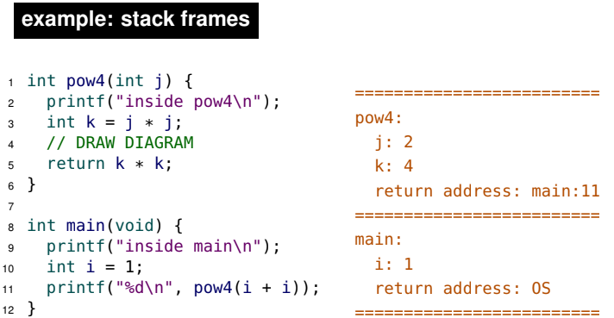
  + In the above example, we go to the main function at line 8. Thus, we add the main function stack frame onto the call stack. Recall the return address of the main function is OS so we include a return address of OS in the stack frame.
  + We print some text at line 9.
  + Then, we define a local variable named i with a value of 1. We add i and its value to the main function stack frame.
  + Then we go to line 11 and need to call in the pow4 function so we add the pow4 function stack frame onto the call stack. Since we were at line 11 of the main function when calling the pow4 function, a return address of main: 11 is included into the pow4 function stack frame. Note that the return address is different from the return value of a function.
  + When we called pow4 in the main function, we passed in a parameter of i + i. We cannot pass in expressions as arguments for a function. Instead we need to pass in values. Thus we evaluate i + i = 1 + 1 = 2. Thus, the parameter variable of j has a value of 2 and is added to the pow4 function stack frame.
  + Now we are at line 2 of pow4 and print some text
  + We go to line 3 of pow4 and define a local variable named k with a value of j * j = 2 * 2 = 4. We add j and its value to the pow4 function stack frame.
  + Now, we encounter the return statement in line 5. We check the return address of pow4 in memory and see that it’s line 11 of the main function so we go back to line 11 of the main function.
* Now we notice the fundamental difference between global and local variable.s
* Whereas space for a global variable is reserved before the program begins execution, space for a local variable is only reserved when the function is called.
* The space is reserved within the newly created stack frame.
* When the function returns, the variable (and the entire frame) is popped and effectively “disappears”.

Calling a function

* We can now model all of the control flow when a function is called:
* • a stack frame is created (“pushed” onto the call Stack)
* • the current program location is placed in the stack frame as the return address
* • a copy of each of the arguments is placed in the stack frame
* • the program location is changed to the start of the new function
* • the initial values of local variables are set when their definition is encountered

Return

* When a function returns:
* • the current program location is changed back to the return address (which is retrieved from the stack frame)
* • the stack frame is removed (“popped” from the Stack memory area)

Return vs. return address

* Beginners often confuse the return address and return statements.
* Remember, the return address is a location within the calling function.
* It has nothing to do with the location of any return statement(s) in the called function or if one does not exist (e.g., a void function).
* The only thing that relates the return address and return statements is when a return statement is encountered, then we look for the return address in memory.
* There is always one (and only one) return address in a stack frame. On the other hand, we can have a function with one or many return statements.

Recursion in C

* Now that we understand how stack frames are used, we can see how recursion works in C.
* In C, each recursive call is simply a new stack frame with a separate frame of reference.
* The only unusual aspect of recursion is that the return address is a location within the same function (since recursive functions call themselves).
* In this example, we also see control flow with the if statement.
  + 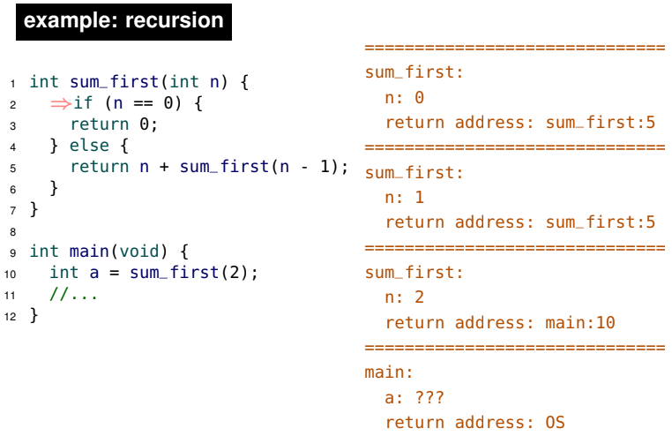
  + Notice the value of a in main is unknown (???) since we first have to evaluate sum_first(2)
  + So we call sum_first with a partner of 2. This is shown by adding the sum_first function stack frame into the call stack along with the parameter variable of n and its value of 2. We also add the return address which is main: 10 which is where we called the sum_first(2) function.
  + Then we see a recursive call, which adds more stack frames onto the call stack. Notice the name of the stack frames generated by the recursive calls are the same since recursive functions call themselves. In this example, the return addresses generated by all the recursive stack frames are the same (they could be different if there were different return addresses depending on if statements).
  + However, notice the local variables in each stack frame is different which allows us to keep track of the recursive calls and get closer to the base case and also keep track of the return statement value (temporary memory).
  + The only thing special about recursion is that sometimes the return address is related to a statement within the function.

Stack section

* The call stack is stored in the stack section, the fourth section of our memory model. We refer to this section as “the stack”.
* In practice, the “bottom” of the stack (i.e., where the main stack frame is placed) is placed at the highest available memory address. Each additional stack frame is then placed at increasingly lower addresses. The stack “grows” toward lower addresses. So it's like an upside down stack but for illustration purposes, we have a normal stack.
* If the stack grows too large, it can “collide” with other sections of memory. This is called “stack overflow” and can occur with very deep (or infinite) recursion.

Uninitialized memory

* In most situations, mutable variables should be initialized, but C allows variable definitions without any initialization such as: int i;
* Global Variables
  + For all global variables, C automatically initializes the variable to be zero.
  + Regardless, it is good style to explicitly initialize a global variable to be zero, even if it is automatically initialized such as: int g = 0;
* Local Variables
  + A local variable (on the stack) that is uninitialized has an arbitrary initial value.
  + 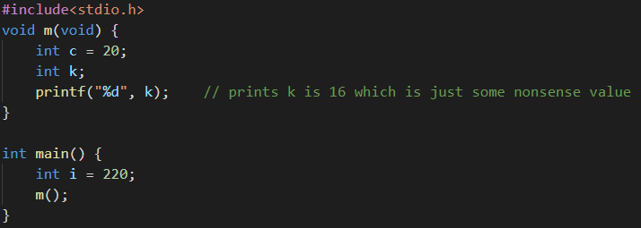
  + In the above example, k has a value of 16 but is some random garbage value.
  + Seashell gives you a warning if you obtain the value of an uninitialized variable.

Memory sections (so far)

* 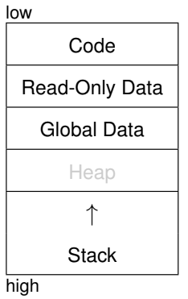
* The stack starts at a high memory address and grows towards lower memory addresses. If it grows too low, it collides with other sections of memory and stack overflow occurs. Recall this diagram upside down since a stack grows downwards and high is beneath low in this diagram (which is upside down.

Memory snapshot

* You may be asked to draw a memory diagram (including the call stack) at a particular moment in the code execution.
* For example, “draw the memory when line 19 is reached”.
* • make sure you show any variables in the global and read-only sections, separate from the stack
* • include all local variables in stack frames, including definitions that have not yet been reached (or are incomplete)
* • local variables not yet fully initialized have a value of ???
* • you do not have to show any temporary storage (e.g., intermediate results of an expression)
* When a variable is defined inside of a loop, only one occurrence of the variable is placed in the stack frame. The same variable is re-used for each iteration.
* Each time the definition is reached in the loop, the variable is re-initialized (it does not retain its value from the previous iteration).
* 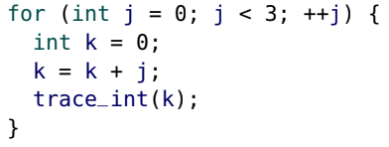 prints 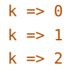

Scope vs Memory

* Just because a variable exists in memory, it does not mean that it is in scope.
* Scope is part of the C syntax and determines when a variable is “visible” or “accessible”.’Memory is part of our C model (which closely matches how it is implemented in practice).
* Ex:
  + 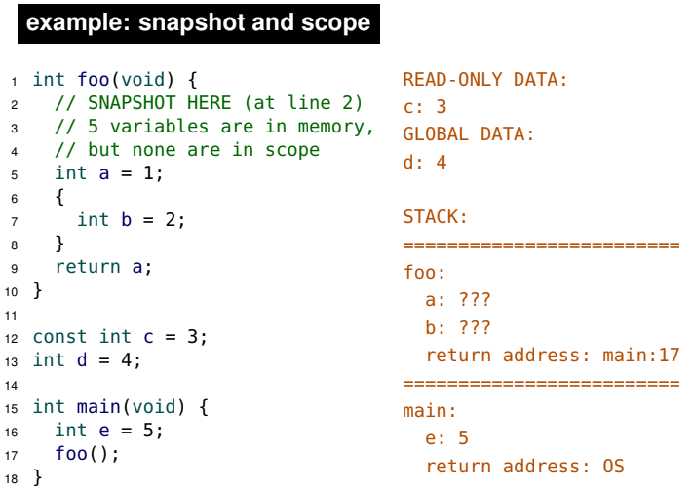
  + We have a global constant c = 3 which we put into read-only data
  + We have a global mutable d = 4 which we put into global data
  + We go to the main function
  + We call foo and add it to the call stack
  + We add any parameter values of foo into the call stack (there are none in this ex).
  + We add any local variables to foo which are the local variables a and b. Notice b and a have different scope, but that doesn’t matter. All local variables regardless of their blocks are placed into the stack frame and memory is allocated for them. We know the amount of memory we have to allocate because C is statically typed. However, we don’t know their values since they have not been initialized so we have ???.
  + Then we arrive at line 2 and look at the snapshot.
  + As of line 2, a and b are not in scope since they have not been reached yet. c and d are also out of scope since they were defined below the function. Also local variables from other functions such as e are also not in scope. Thus, even though there are 5 variables in memory, none of them are in scope.

Model

* We now have the tools to model the behaviour of a C program.
* At any moment of execution, a program is in a specific state, which is the combination of:
* • the current program location, and
* • the current contents of the memory.
* To properly interpret a program’s behaviour, we must keep track of the program location and all of the memory contents.

**Section 5**

Address operator

* C was designed to give programmers “low-level” access to memory and expose the underlying memory model.
* The address operator (&) produces the location of an identifier in memory (the starting address of where its value is stored)
* 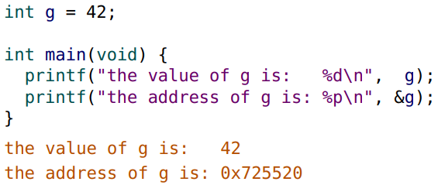
* The printf format specifier to display an address (in hex) is "%p".

Pointers

* If we can get the memory address of a variable, we might want to store it somewhere
* A pointer is a variable that stores a memory address
* To define a pointer, place a star (*) before the identifier (name).
* 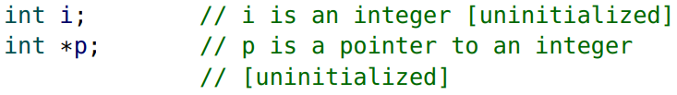
* p is the name of the pointer variable, not *p.
* Pointers can only point to certain types of values. It says p is a pointer to an integer. In other words, p can store memory addresses of integers. Recall memory addresses cannot change types since C is statically typed.
* int *p; says that we defined a variable p that is a pointer which points to a memory address that stores integers.
* 

Pointer types

* For each type there is a corresponding pointer type.
* 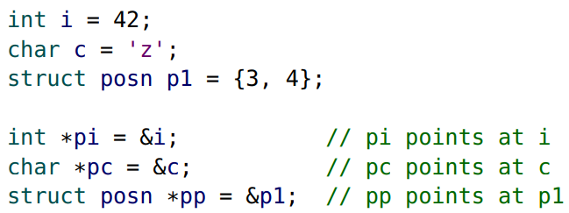
* The type of pi is an “int pointer” which is written as “int *”.
* The type of pc is a “char pointer” or “char *”.
* The type of pp is a “struct posn pointer” or “struct posn *”

Pointer initialization

* The pointer definition syntax can be a bit overwhelming at first, especially with initialization.
* Remember, that the following definition: 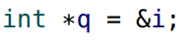Is comparable to the following:
* 
* The * is part of the definition and is not part of the variable name. The name of the above variable is simply q, not *q.
* Note: you are not allowed to write the following:
* 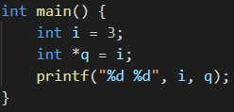
* The above image raises an error since q is an int pointer and thus, it must store the memory address of an integer. It cannot store the value of an integer.

Pointers to pointers

* Can a pointer point to itself?
* 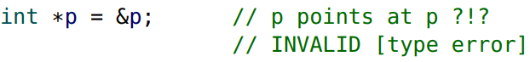
* No, it cannot as it raises a type error. Recall p is an integer pointer, not an integer. Since p is an integer pointer, p points at the memory address of an integer, not the memory address of an integer pointer (and &p is the memory address of an integer pointer, not a memory address of an integer).
* While a pointer cannot point at itself, we can define a pointer to a pointer.
* 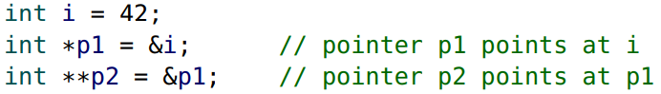
* The type of p2 is “int **” or a “pointer to a pointer to an int”. Thus, p2 stores the memory address of an integer pointer. Note that p2 does not store the memory address of an integer, but rather an integer pointer.
* C allows any number of pointers to pointers. More than two levels of “pointing” is uncommon.

Pointer Values

* Remember, pointers are variables, and variables store values.
* A pointer is only “special” because the value it stores is an address.
* 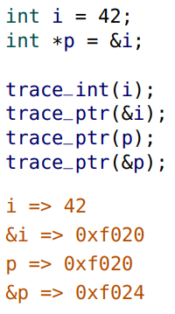
* Notice p stores the memory address of i which is why the same memory address is printed when we trace_ptr(&i) and trace_ptr(p).
* Notice since p is a pointer, it’s value is a memory address and thus, we have to use trace_ptr on it.
* Because a pointer is a variable, it also has an address itself which we can see through trace_ptr(&p)
* 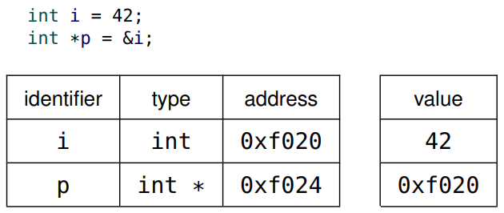
* When drawing a memory diagram, we rarely care about the value of the address, and visualize a pointer with an arrow (that “points”).
* 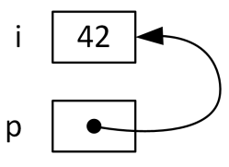

The NULL value

* NULL is a special value that can be assigned to a pointer to represent that the pointer points at “nothing”
* If the value of a pointer is unknown at the time of definition, or what the pointer points at becomes invalid, it’s good style to assign the value of NULL to the pointer. A pointer with a value of NULL is often called a “NULL pointer”.
* 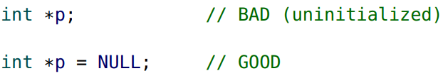

NULL is false

* NULL is considered “false” when used in a Boolean context.
* In C, false is defined to be zero or NULL.
* The following are equivalent and both are considered good style:
* 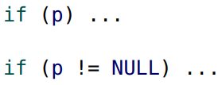

Pointer assignment

* As with any variable, the value of a pointer can be changed (mutated) with the assignment operator
* 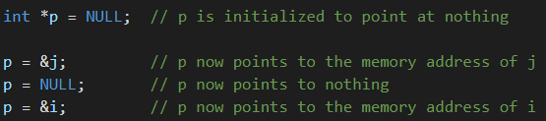

Sizeof a pointer

* In most k-bit systems, memory addresses are k bits long, so pointers require k bits to store an address.
* In our 64-bit Seashell environment, the sizeof a pointer is always 64 bits (8 bytes)
* The sizeof a pointer is always the same size, regardless of the type of data stored at that address.
* 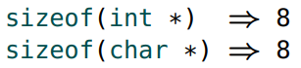

Indirection operator

* The indirection operator (*), also known as the dereference operator, is the inverse of the address operator (&).
* *p produces the value of what pointer p “points at”. When we saying *p = x_arbitrary, we are saying change the value of what p points at to take on the value of x_arbitrary.
* 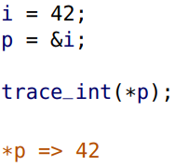
* *p is the value that p points at. p points to the memory address of i. The value at the memory address of i is 42 so *p2 is 42.
* Since * and & are inverses, The value of *&i or *&*&*&i is simply the value of i.
* Consider *&i. The value of *&i is the value at the memory address of i which is just the value i.
* The address operator (&) can be thought of as: “get the address of this box”.
* The indirection operator (*) can be thought of as: “follow the arrow to the next box and get its contents”.
* 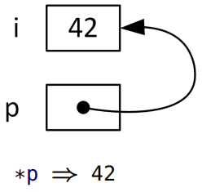
* If you try to dereference a NULL pointer, your program will crash. You cannot get the value in the memory address the pointer points at since the pointer doesn’t point at anything in the first place.
* 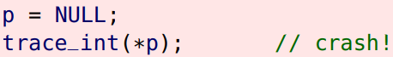

Multiple uses of *

* The * symbol is used in three different ways in C:
* • as the multiplication operator between expressions
  + 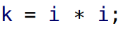
* • in pointer definitions and pointer types
  + 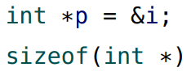
* • as the indirection operator for pointers
  + 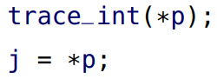

Dereferencing pointers to structures

* Unfortunately, the structure operator (.) has higher precedence than the indirection operator (*).
* Awkward parenthesis are required to access a field of a pointer to a structure: (*ptr).field. If we don't have these parenthesis, *ptr.field is equivalent to *(ptr.field) which is not what we want since ptr is not a structure so it as not .field field and thus will raise an error. On top of that, even if ptr.field didn’t somehow raise an error, you would then have to apply * onto it which is asking for what are the contents that ptr.field points at? But ptr.field doesn’t point at anything likely unless ptr.field is actually a pointer (highly unlikely)
* Fortunately, the indirection selection operator, also known as the “arrow” operator (->) combines the indirection and the selection operators.
* 
* 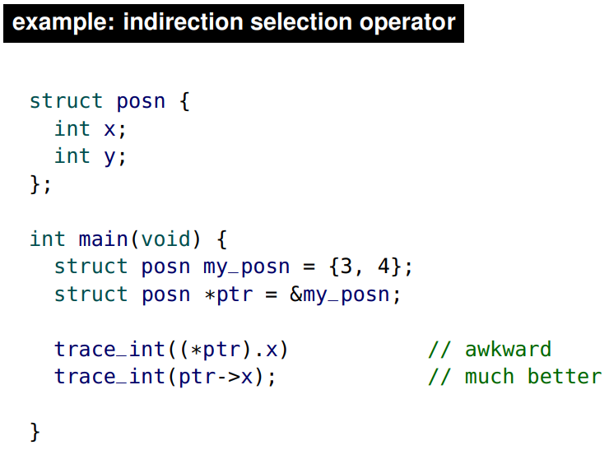

Pointer assignment

* Consider the following code
* 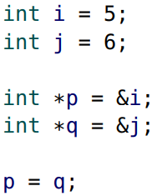
* The statement p = q; is a pointer assignment. It means “change p to point at what q points at”. It changes the value of p to be the value of q. In this example, it assigns the address of j to p.
* Recall when we have assignments, we evaluate the right hand side first. The right hand side is q which is the memory address of j. So now we say p takes on the value of q which means p takes on the memory address of j. So now, both p and q point at j and neither of them point at i.
* Note p = q; does not change the value of i nor j.
* 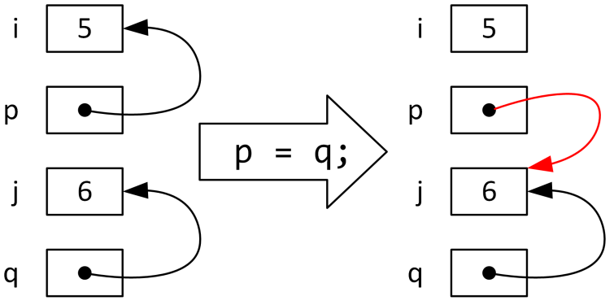
* Now consider another example:
  + 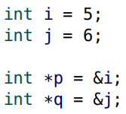
  + 
  + The statement *p = *q says change ‘the value of what p points at’ to take on ‘the value of what q points at’
  + To understand the statement *p = *q, we first evaluate the right hand side. *q is tells us to go to the memory address of whatever q points at, then go get its contents/value. q points at the memory address of j and j’s value is 6. Thus, *q is the value of j which is 6. Now, the left hand side takes on the value of the right hand side. The left hand side is the value in the memory address that p points at. P points at the memory address of i which has a value of 5. So *p is 5. Thus, *p = *q tells 5 to now be replaced by 6.
  + Notice that before we do *p = *q, while *p has a value of 5, we don’t care what it’s value is. Consider doing x = 4. Before saying x=4, x has some value but we don’t care, we change the value of x to 4.
  + In this example *p = *q is the same as saying i = j.
  + Note: p = *q wouldn’t make sense since p (an integer pointer) is taking on the value of 6 (an integer) and these data types don’t match. As well, *p = q wouldn’t make sense since *p (an integer) is taking on the value of q (an integer pointer) and these data types don’t match.
  + The above example does not change the value of p: it changes the value of what p points at. In this example, it changes the value of i to 6, even though i was not used in the statement.
  + This is an example of aliasing, which is when the same memory address can be accessed from more than one variable.
  + 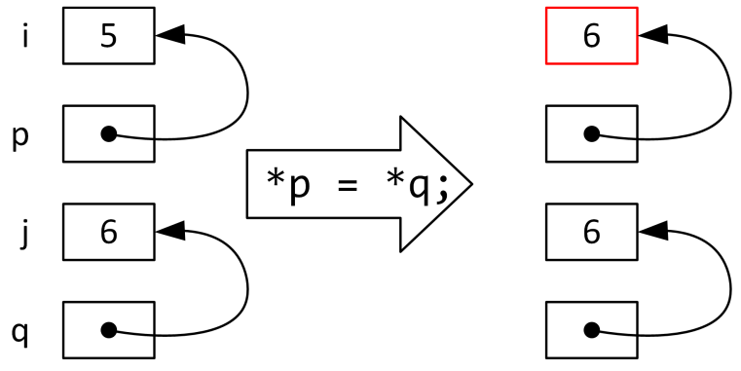
  + 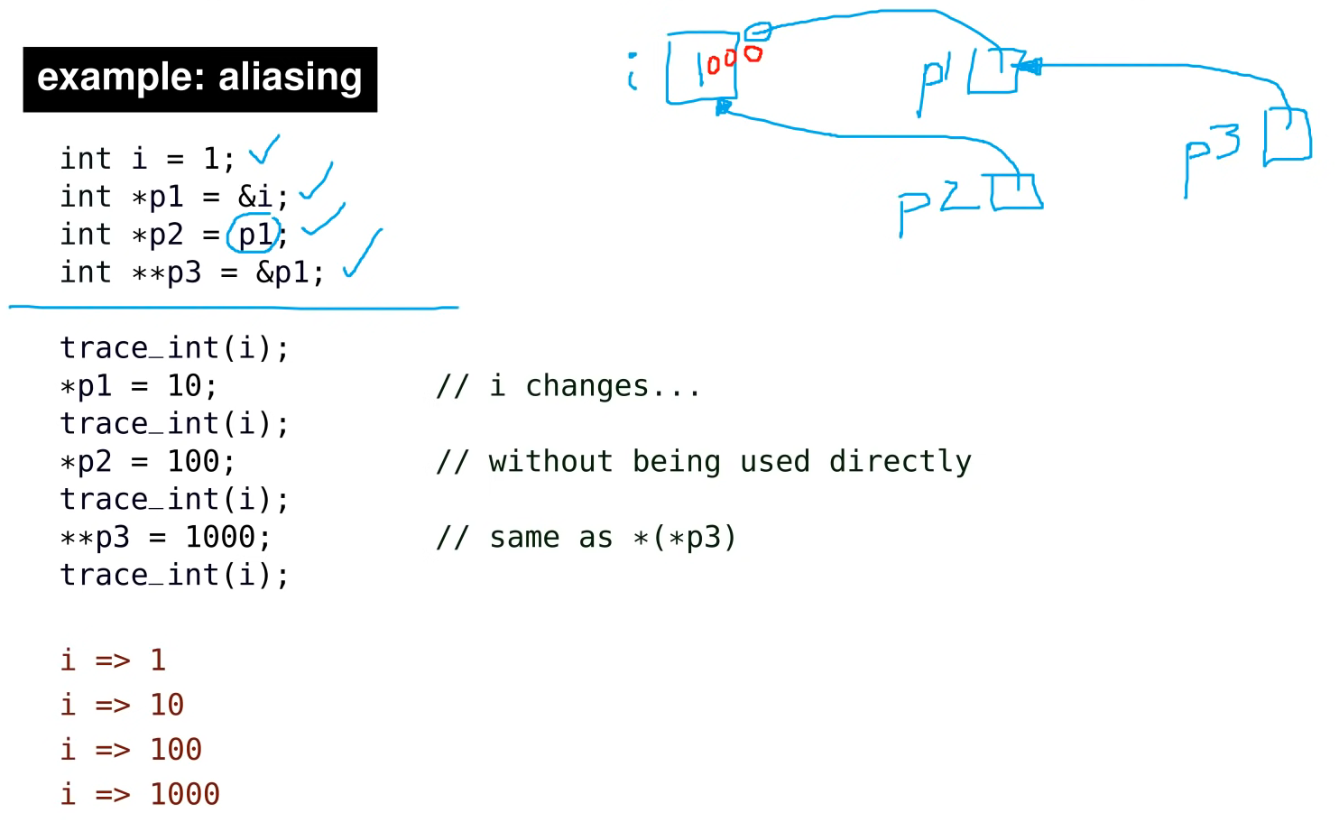
  + Notice when we say int *p2 = p1, p2 does not point at p1. Rather we evaluate the RHS and we get the value of p1 which is the memory address of i. Then we say the LHS which takes on the RHS. The LHS is a pointer p2 so we say p2 points at the memory address of i.

Mutation & parameters

* Consider the following C program:
* 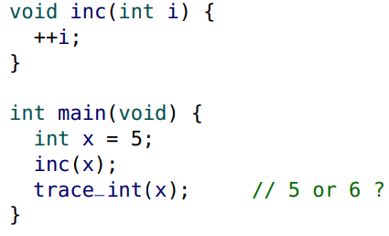
* It is important to remember that when inc(x) is called, a copy of x is placed in the stack frame, so inc cannot change x.
* The inc function is free to change its own copy of the argument (in the stack frame) without changing the original variable.
* 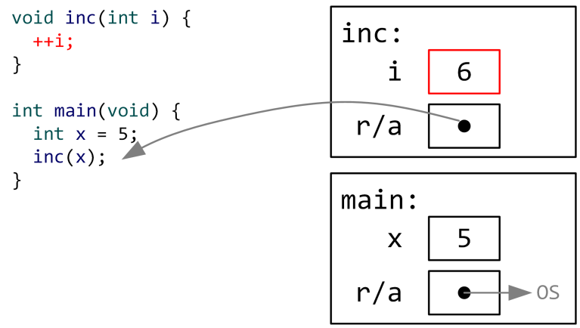
* Note that i is initially 5. Then we do ++i and then i becomes 6 as shown above. However, notice x is still 5 and remains untouched.
* In the “pass by value” convention of C, a copy of an argument is passed to a function.
* The alternative convention is “pass by reference”, where a variable passed to a function can be changed by the function. Some languages support both conventions.
* What if we want a C function to change a variable passed to it? (this would be a side effect)
* In C we can emulate “pass by reference” by passing the address of the variable we want the function to change.
* This is still actually “pass by value” because we pass the value of the address.
* By passing the address of x, we can change the value of x.
* It is also common to say “pass a pointer to x”.
* 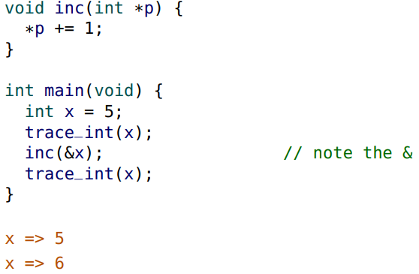
* Below is a snapshot when the line *p +=1; has been reached and executed.
* 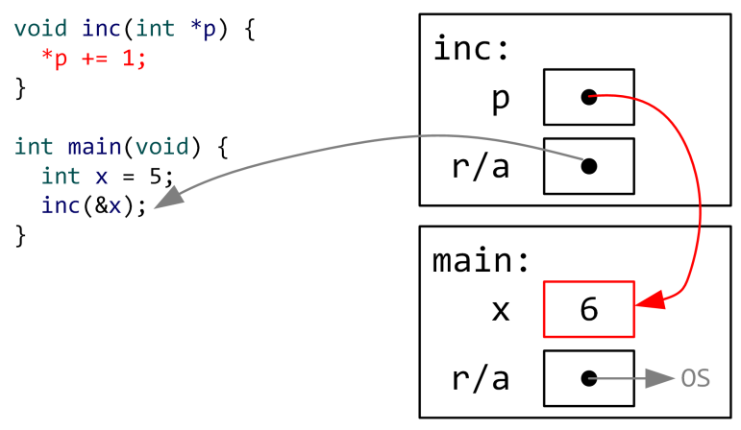
* Notice we are not violating the fact that we cannot look at stack frames below the top. We are currently in the inc stack frame and not looking at the main stack frame at all. Instead we are looking at the memory address of x.
* Most pointer parameters should be required to be valid (e.g., non-NULL). In the slides it is often omitted to save space.
* 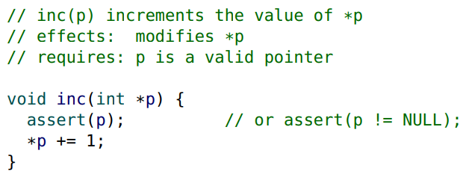
* 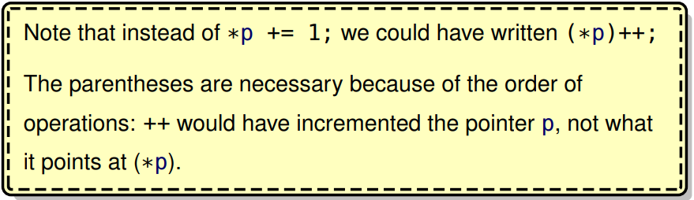
* 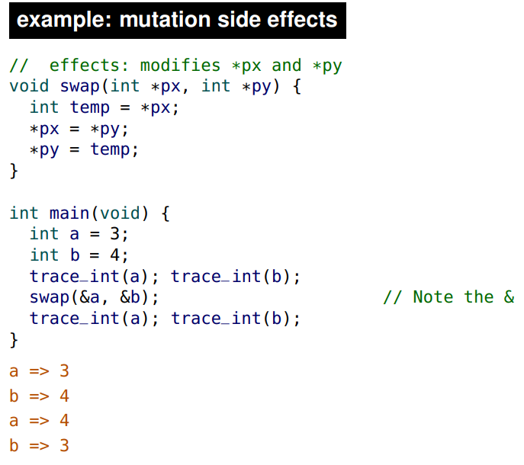
* Below is a diagram of the variables once the swap function has been called

| Variable Name | Variable Type | Memory Address (arbitrary values) | Value |
| --- | --- | --- | --- |
| a | int | 001 | 3 |
| b | int | 002 | 4 |
| px | int pointer | 003 | 001 |
| py | int pointer | 004 | 002 |

* Below is a diagram of the variables once the temp variable has been defined
* The line int temp = *px; tells us to get ‘the value associated with the memory address that px points to’ and make it ‘the value of temp’. px has a value of 001 so that is the memory address that px points to. The value associated with a memory address of 001 is 3. So temp takes on the value of 3.

| Variable Name | Variable Type | Memory Address (arbitrary values) | Value |
| --- | --- | --- | --- |
| a | int | 001 | 3 |
| b | int | 002 | 4 |
| px | int pointer | 003 | 001 |
| py | int pointer | 004 | 002 |
| temp | int | 005 | 3 |

* Below is a diagram of the variables once the line *px = *py; has been reached and executed.
* *py tells us to get the value associated with the memory address that py points at. py has a value of 002 so that is the memory address that py points to. The value associated with a memory address of 002 is 4.
* *px = *py now tells *px to take on a value of 4 so we go to the value associated with the memory address that px points to and change it to 4. The memory address that px points to is 001 and we go to the value associated with 001 which is 3. Note, we don’t care that the value is 3 since we are now saying 3 is being replaced by 4.

| Variable Name | Variable Type | Memory Address (arbitrary values) | Value |
| --- | --- | --- | --- |
| a | int | 001 | 4 |
| b | int | 002 | 4 |
| px | int pointer | 003 | 001 |
| py | int pointer | 004 | 002 |
| temp | int | 005 | 3 |

* Below is a diagram of the variables once the line *py = temp; has been reached and executed.
* *py tells us to go to the value associated with the memory address that py points at. py has a value of 002 so that is the memory address that py points to. The value associated with a memory address of 002 is 4. Note, we don’t care that the value is 4 since we are now saying 4 is replaced by the value of temp which is 3.

| Variable Name | Variable Type | Memory Address (arbitrary values) | Value |
| --- | --- | --- | --- |
| a | int | 001 | 4 |
| b | int | 002 | 3 |
| px | int pointer | 003 | 001 |
| py | int pointer | 004 | 002 |
| temp | int | 005 | 3 |

Documenting side effects

* We now have a fourth side effect that a function may have:
* • produce output
* • read input
* • mutate a global variable
* • mutate a variable through a pointer parameter

Returning an address

* A function may return a memory address.
* 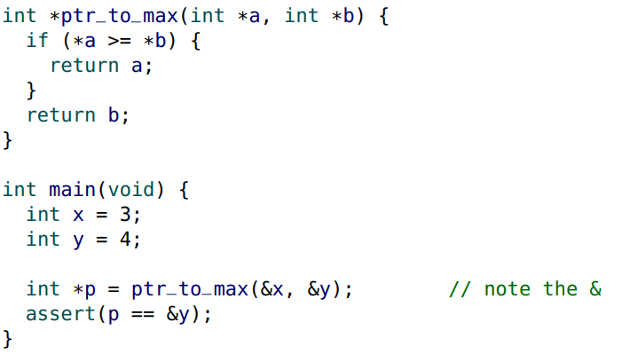
* A function must never return an address to a variable within its stack frame
* As soon as the function returns, the stack frame “disappears”, and all memory within the frame is considered invalid.
* 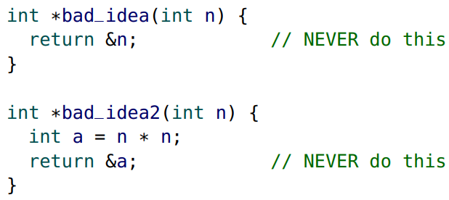
* In the first example, we shouldn’t return the address of n since once the stack frame is popped, the memory address it points at becomes invalid. A similar idea is applied for the second example.

C input: scanf

* So far we have been using our tools (e.g., read_int) to read input.
* We are now capable of using the built-in scanf function.
* scanf requires a pointer to a variable to store the value read in from input.
* 
* Just as with printf, multiple format specifiers can be used to read in more than one value. However only read in one value per scanf. This will help you debug your code and facilitate our testing.

scanf return value

* The return value of scanf is an int (has nothing to do with the integer that was read in)
* This return value is either:
  + • the quantity (count) of values successfully read, or
  + • the constant EOF: the End Of File (EOF) has been reached. EOF is defined as -1.
* If input is not formatted properly (e.g., the input is [hello] and we try to scanf an int with "%d"), then scan f returns 0 since it successfully read in 0 integers.
* In Seashell, a Ctrl-D (“Control D”) keyboard sequence (or the [EOF] button) sends an EOF.

Invalid input

* Always check the return value of scanf: one is “success”. (if you are following our advice to read one value per scanf).
* 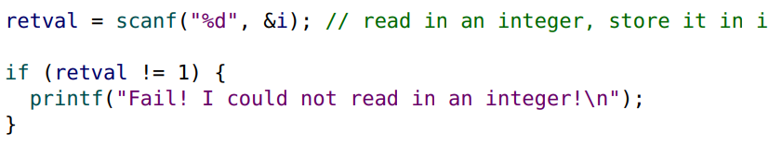

Multiple side effects

* Consider the following statement:
* 
* There are three separate side effects:
  + • a value is read from input
  + • i is mutated
  + • retval is mutated
* Earlier we encouraged you to only have one side effect per statement. Unfortunately, when using scanf it is impossible.
* 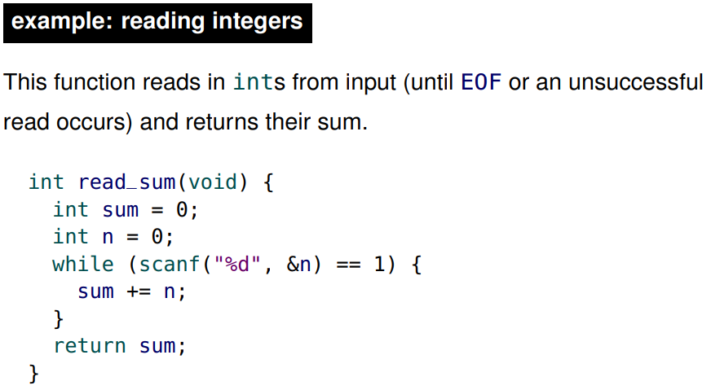
* In the above code, n is the variable used to store the result of scanf. Scanf reads in the input and returns 1 if the input was a valid integer. Otherwise, scanf returns a number not equal to 1 (indicating it did not read exactly 1 successful input). Scanf eventually fails either from invalid input or from reaching the end of the file.
* 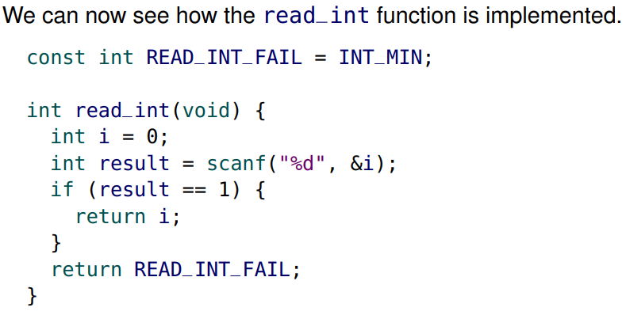
* On assignments and exams, you will now be using scanf instead of read_int.

Whitespace

* When reading an int with scanf ("%d") C ignores any whitespace (spaces and newlines) that appears before the next int.
* When reading in a char, you may or may not want to ignore whitespace: it depends on your application.
* 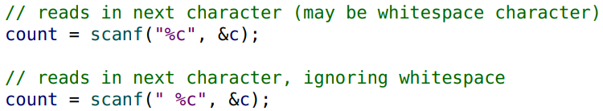
* The extra leading space in the second example indicates that leading whitespace is ignored

Using pointers to “return” multiple values

* C functions can only return a single value.
* However, recall how scanf is used: retval = scanf("%d", &i);
* We “receive” two values: the return value, and the value read in (stored in i).
* Pointer parameters can be used to emulate “returning” more than one value.
* The addresses of several variables can be passed to a function, and the function can change the value of those variables.
* Ex:
  + 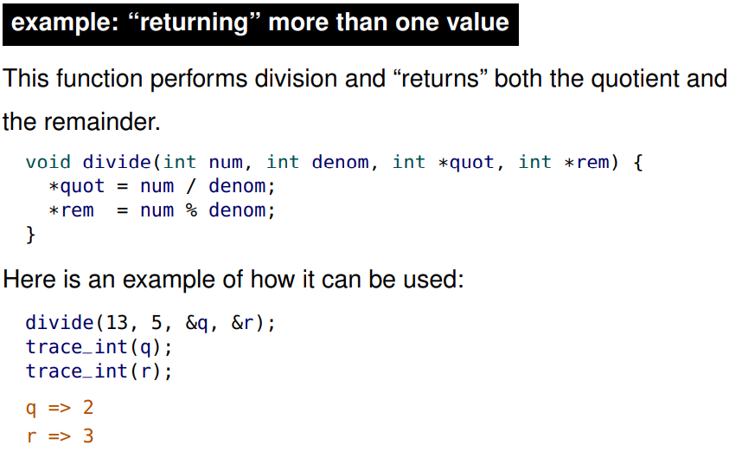
  + In the above example, assume that q and r are integers that are already defined.
  + We pass in the memory address of q and r into divide.
  + In the divide function, we set the value of the memory address that quot points at to be the quotient. Although the *quot parameter is a copy of the &q argument so they don’t have the same memory location, they have the same value. And their values are both memory locations (they have the same values since we copied the values) that both point to the memory address of q (since that was the argument). Now, we can reference to the value in the memory address of q using *quot and changing that value.
* This “multiple return” technique is also useful when it is possible that a function could encounter an error.
* For example, the previous divide example could return false if it is successful and true if there is an error (i.e., division by zero)
* 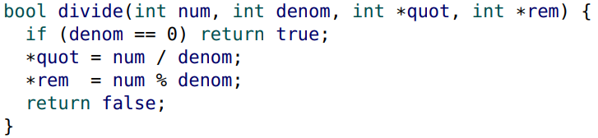

Passing structures

* Recall that when a function is called, a copy of each argument value is placed into the stack frame.
* For structures, the entire structure and its contents are copied into the frame. For large structures, this can be inefficient.
* 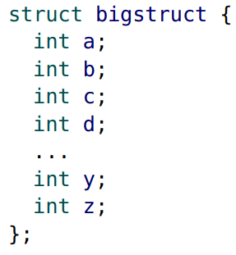
* To avoid structure copying, it is very common to pass the address of a structure to a function
* 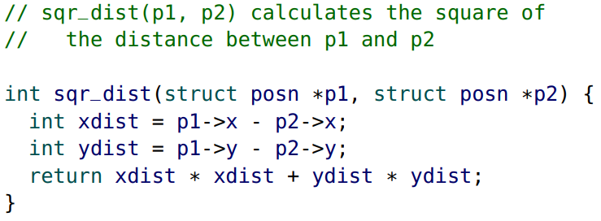
* Passing the address of a structure to a function (instead of a copy) also allows the function to mutate the fields of the structure.
* 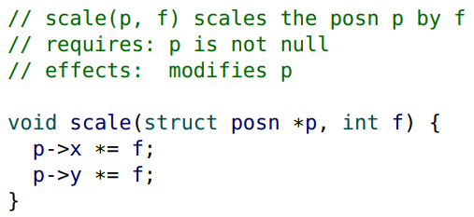
* In the above documentation, we used p, where *p would be more correct. It is easily understood that p represents the structure.
* 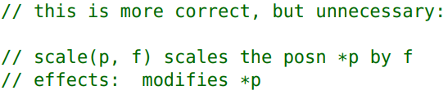
* We now have two different reasons for passing a structure pointer to a function:
  + • to avoid copying the structure
  + • to mutate the contents of the structure
* It would be good to communicate whether or not there is a side effect (mutation).
* However, documenting the absence of a side effect (“no side effect here”) is awkward. To resolve this awkwardness, we will introduce const pointers right below.

Const pointers

* Adding the const keyword to the start of a pointer definition prevents the pointer’s destination (the variable it points at) from being mutated through the pointer.
* 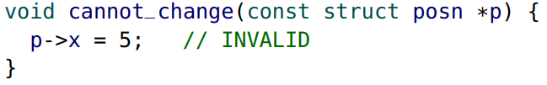
* It is good style to add const to a pointer parameter to communicate (and enforce) that the pointer’s destination does not change.
* Remember, a pointer definition that begins with const prevents the pointer’s destination from being mutated via the pointer.
* 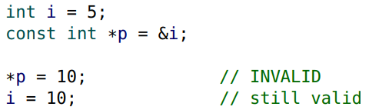
* However, the pointer variable itself is still mutable, and can point to another int
* 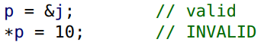
* Adding const to a pointer makes it so that you cannot change the values associated with the memory address that p points at. However, we can still change the memory addresses that p points at.
* A handy tip is to read the definition backwards: const int *p ⇒ “p is a pointer to an int that is constant”. (the integer is constant, not p)
* 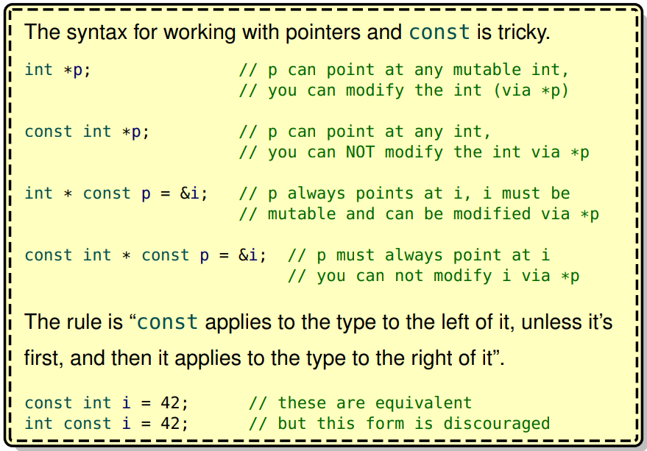

Const parameters

* As we just established, it is good style to use const with pointer parameters to communicate that the function does not (and cannot) mutate the contents of the pointer.
* 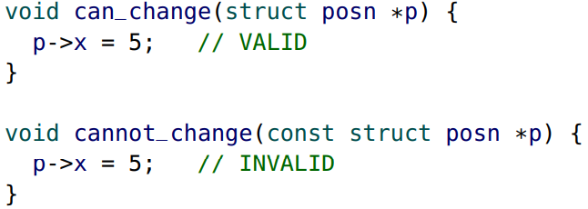
* What does it mean when const is used with simple (non-pointer) parameters?
* For a simple value (non-pointer value), the const keyword indicates that the parameter is immutable within the function.
* Remember that parameters behave the same as local variables and are stored in the stack frame.
* 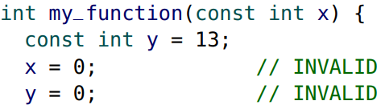
* It does not require that the argument passed to the function is a constant.
* Because a copy of the argument is made for the stack, it does not matter if the original argument value is constant or not.

Minimizing mutative side effects

* In Section 03 we used mutable global variables to demonstrate mutation and how functions can have mutative side effects.
* However, Global mutable variables are strongly discouraged and considered “poor style”. They make your code harder to understand, maintain and test.
* On the other hand, global constants are “good style” and encouraged.
* There are rare circumstances where global mutable variables are necessary.
* Your preference for function design should be:
  + 1. “Pure” function
    - No side effects or dependencies on global mutable variables.
  + 2. Only I/O side effects
    - If possible, avoid any mutative side effects.
  + 3. Mutate data through pointer parameters
    - If mutation is necessary, use a pointer parameter.
  + 4. Dependency on global mutable variables
    - Mutable global variables should be avoided.
  + 5. Mutate global data
    - Only when absolutely necessary (it rarely is).
* This preference is saying if we write a function, it’s best to make it a pure function. If that’s not possible, make it only have I/O side effects. If that’s not possible, so on and so on.

Function pointers

* In Racket, functions are first-class values.
* For example, Racket functions can be passed into other functions, functions can return functions, functions could be stored inside constants.
* In C, functions are not first-class values, but function pointers are.
* A significant difference is that new Racket functions can be created during program execution, while in C they cannot.
* In C, A function pointer can only point to a function that already exists.
* A function pointer stores the (starting) address of a function, which is an address in the code section of memory
* The type of a function pointer includes the return type and all of the parameter types, which makes the syntax a little messy.
* 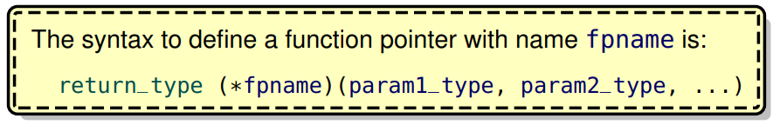
* 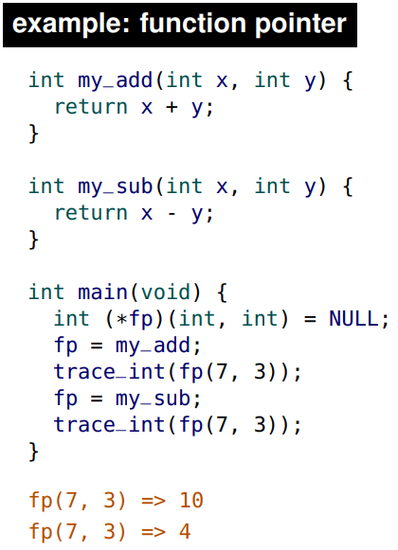
* In the function pointer definition, we initialize it to point at NULL (which is kinda useless considering the next line)
* Then, we initialize fp to point to the memory address of the my_add function.
* Notice when we trace it, we use fp(7, 3) as if fp was a function itself instead of doing *fp(7, 3).
* 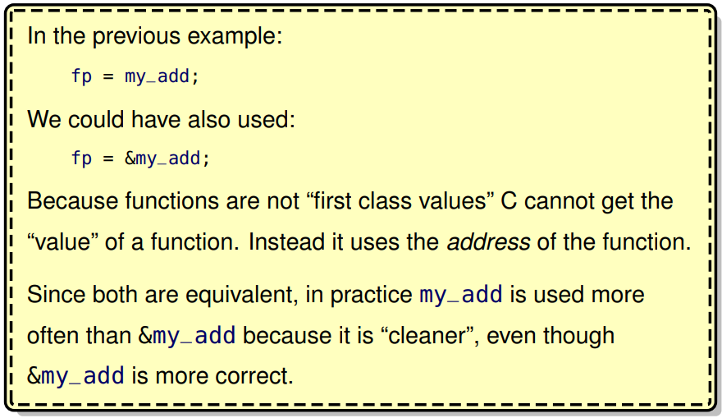
* 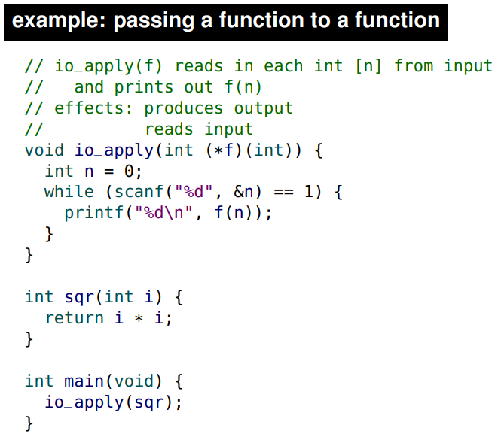
* The io_apply function takes in a function pointer, f. Then it reads in integers and stores the input in the integer n. If n is a valid integer, we then apply f on n using the syntax f(n). We passed in the sqr function as an argument into the io_apply function. In this example, f behaves very much like a normal function, but keep in mind it’s not a function, it’s a function pointer.

**Section 4**

Modularization

* So far we have been designing programs with all of our definitions in a single source (.c) file.
* For larger programs, keeping all of the code in one file is unwieldy.
* Teamwork on a single file is awkward, and it is difficult to share or re-use code between programs.
* A better strategy is to use modularization to divide programs into well defined modules.
* The concept of modularization extends far beyond computer science. There are examples of modularization in the human body (the different organs) that work together to make you. A practical example of a good modular design is an “AA battery”.
* We have already seen an elementary type of modularization in the form of helper functions that can “help” many other functions. We will extend and formalize this notion of modularization.
* When designing larger programs, we move from writing “helper functions” to writing “helper modules”
* A module provides a collection of functions/data structures/variables that share a common aspect or purpose.
* Modules have a primary purpose to provide functions. For convenience in these notes, we describe modules as providing only functions.
* The C language does not fully support modules as they are understood in modern programming.
* However, we can still achieve module-like behaviour and learn the core concepts of modularization.
* C “modules” are also commonly known as libraries.

Modules vs. files

* In this course, and in much of the “real world”, it is considered good style to store modules in separate files.
* While the terms file and module are often used interchangeably, a file is only a module if it provides functions for use outside of the file.
* There are circumstances where you have many modules in a single file, or a module across multiple files

Terminology

* It is helpful to think of a “client” that requires the functions that a module provides.
* 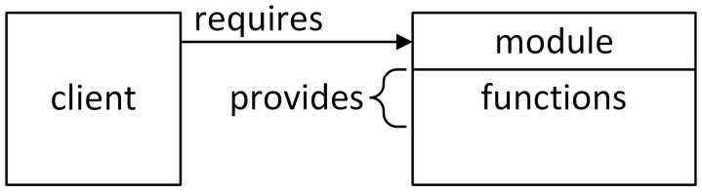
* In the above diagram, notice that the module provides functions. These functions are provided to a client. In practice, the client is a file that may be written by yourself, a co-worker or even a stranger. Conceptually, it is helpful to imagine the client as a stranger. We say that a client requires a module.
* Large programs can be built from many modules.
* A module can be a client itself and require functions from other modules.
* 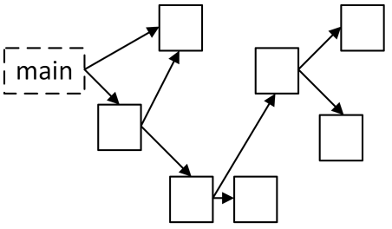
* The module dependency graph (shown above) cannot have any cycles.
* There must be a “root” (or main file) that acts only as a client. This is the program file that defines main and is “run”.
* Ex: 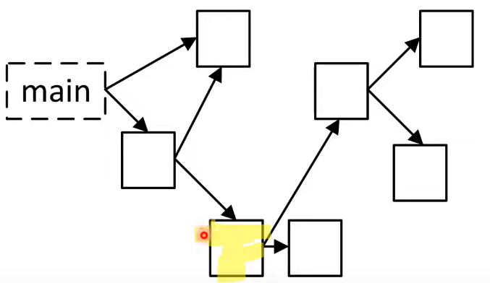
  + The highlighted module requires two other modules but also provides information to another module.

Building a program

* In Section 04 we briefly discussed how we convert (“compile”) a source file (.c) into machine code (.o or .ll) before it can be “run”.
* When building a program, we can combine (“link”) multiple machine code files together to form a single program.
* 
* Modules do not contain a main function. Only one and exactly one main function must be defined in a program. Also, the file that contains the main function does not have to be called main, but it can be.

Motivation

* There are three key advantages to modularization: re-usability, maintainability and abstraction.
  + Re-usability:
    - A good module can be re-used by many clients. Once we have a “repository” of re-usable modules, we can construct large programs more easily.
    - Ex: a AAA battery can be thought of as a module since there are many devices that use an AAA battery such as kids toys, remote controls, flashlights. Similarly to batteries, we want to write software that can be reused by many many applications.
  + Maintainability:
    - It is much easier to test and debug a single module instead of a large program. If a bug is found, only the module that contains the bug needs to be fixed. We can even replace an entire module with a more efficient or more robust implementation.
    - Ex: The batteries we used today are much better than the batteries of the past since they last longer, are more energy efficient, etc. Likewise, if we have a module used by many software projects, if we improve the module by making it faster, fixing bugs, then all the applications that use that module benefit.
  + Abstraction:
    - To use a module, the client needs to understand what functionality it provides, but it does not need to understand how it is implemented. In other words, the client only needs an “abstraction” of how it works. This allows us to write large programs without having to understand how every piece works.
    - Ex: most people don’t completely understand the chemistry and physics behind a battery. But we have an abstract concept that a battery provides electricity and that we can use it. Similarly, modules can provide functions to a client, but the client doesn’t need to completely understand how it works.
* Ex:
  + 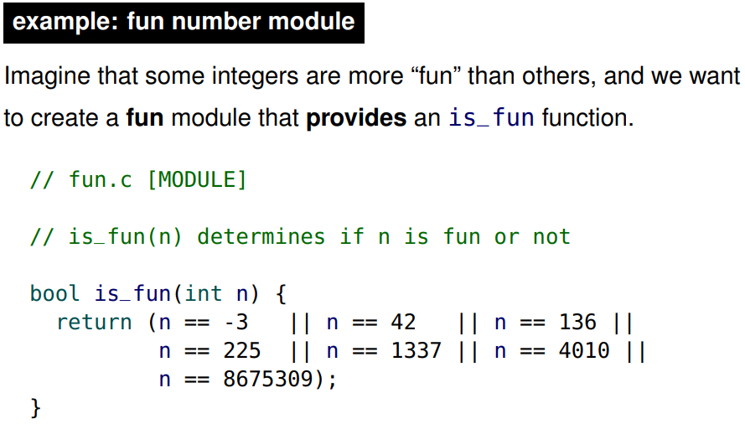
  + We have to learn a few more concepts before we can complete our module
  + Our (yet to be completed) fun module illustrates the three key advantages of modularization.
  + re-usability: multiple programs can use the fun module.
  + maintainability: When new integers become fun (or become less fun), only the fun module needs to be changed.
  + abstraction: The client does not need to understand what makes an integer fun.

Calling module functions

* is_fun is defined in the module (fun.c) file.
* How can we call is_fun from our client (e.g., main.c)?
* 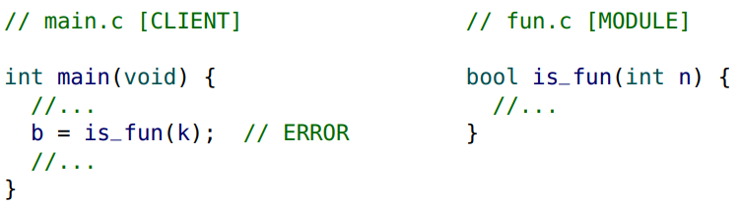
* Notice we try to call the is_fun function from another module but it doesn’t work.
* The is_fun function is not in scope.
* Also, because C is statically typed, it needs to know the return and parameter types of is_fun

Declarations

* In C, a function or variable must be declared before (“above”) it can be “accessed” (or referenced)
* A declaration introduces an identifier (“name”) into a program and specifies its type
* In C, there is a subtle difference between a definition and a declaration. (in many other places, they don’t bother to make the distinction)
* Here, when we use “identifiers” it does not include structures (structs) – they are declared differently (more on them later).

Declaration vs. definition

* • A declaration only specifies the type of an identifier.
* • A definition instructs C to “create” the identifier.
* However, a definition also specifies the type of the identifier, so a definition also includes a declaration. An identifier can be declared multiple times, but only defined once.
* A function declaration is simply the function header followed by a semicolon (;) instead of a code block. It specifies the function type (the return and parameter types).
* 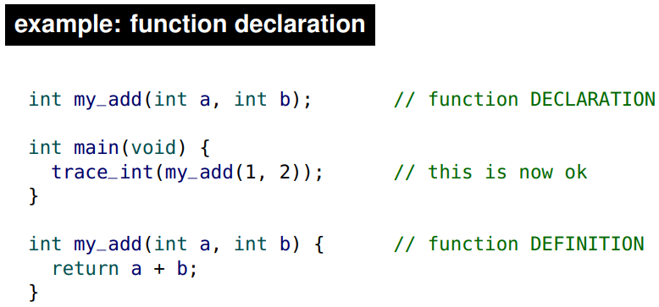
* Notice how the my_add function at the top doesn’t have a body.
* By declaring my_add above main, it is now available in main. Notice that my_add hasn’t been defined yet, but because we know my_add’s parameter and return types from the function declaration, C’s statically typed syntax is all good. Then at the bottom, we can provide a function definition for the function we declared. Obviously, the function names should match.
* 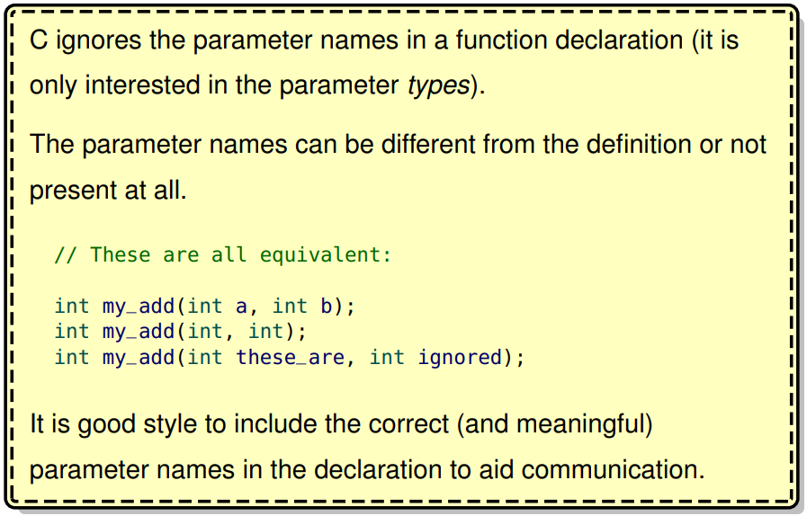
* All three lines of code (above) can be together and C wouldn’t mind.
* A variable declaration starts with the extern keyword, followed by the type and then the variable name. There is no initialization.

Variable Declarations

* 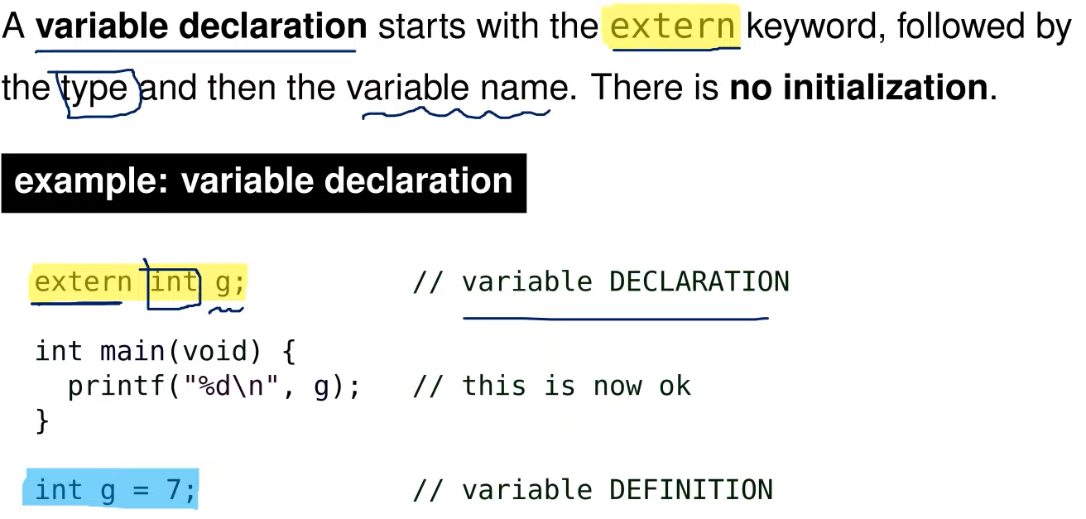
* Variable declarations are not nearly as common as function declarations

Revisiting Scope

* One way to think about declarations is that they extend the scope of an identifier
* 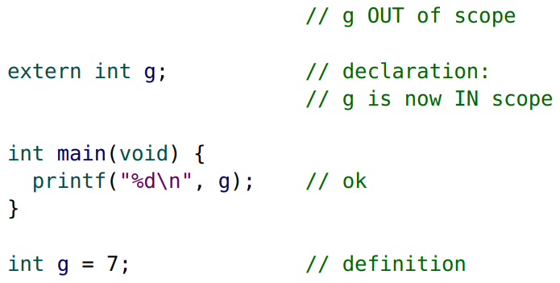
* Without the declaration, the scope of g would be after the definition. Thus without the declaration, g cannot be used in main.

Scope vs Memory

* Remember, don’t confuse the concepts of scope with memory (or storage).
* 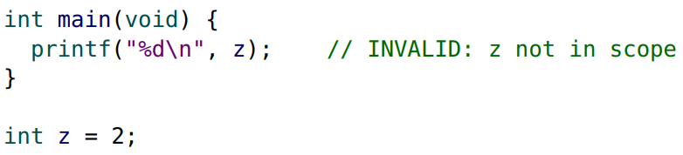
* Remember, all global variables (from all files) are in memory before the program is “run”.
* In the above example, z is in memory (and initialized) before main is called but z is not in scope within the main function because it has not yet been declared.

Program Scope

* A declaration can bring an identifier from another file into scope:
* 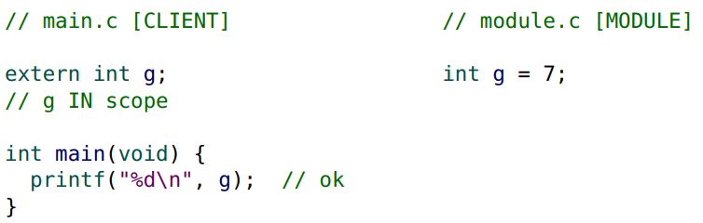
* By default, C global identifiers (global functions and global variables) are “accessible” to every file in the program if they are declared. We will refer to this as program scope.

Revisiting module functions

* We have solved our previous problem. We can now call our module function is_fun from our client (main.c) by declaring it:
* 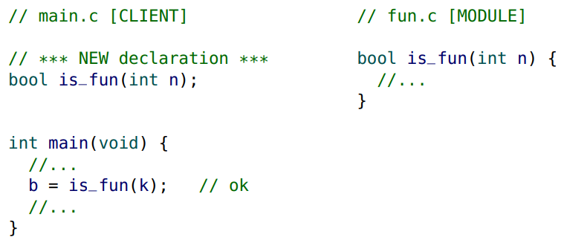

Module Scope

* To “hide” a global identifier from other files, prefix the definition with the static keyword.
* 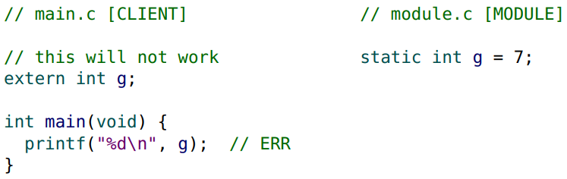
* In other words, the static keyword restricts the scope of a global identifier to the file (module) it is defined in
* We will refer to this as module scope
* In C, everything has program scope by default unless we go out of our way to give it static scope

Types of scope (revisited)

* • local (block) identifiers
  + only available inside of the function (or block)
* • global identifiers:
  + – program scope identifiers (default) available to any file in the program (if declared)
  + – module scope identifiers (defined as static) only available in the file they are defined in
* We continue to use global scope to refer to identifiers that have either program or module scope.
* Use static to give module functions and variables module scope if they are not meant to be provided.
* 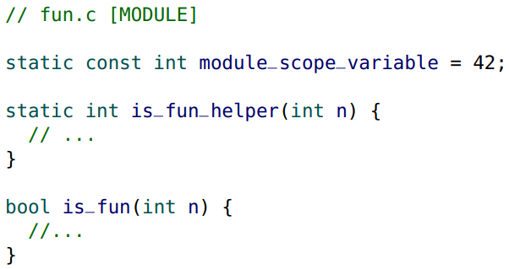
* The static keyword is not related to static typing. private would have been a better choice than static

Module interface

* The module interface is the list of the functions that the module provides (including the documentation).
* The interface is separate from the module implementation, which is the code of the module (i.e., function definitions)
* The interface is everything that a client would need to use the module. The client does not need to see the implementation.

Terminology (revisited)

* 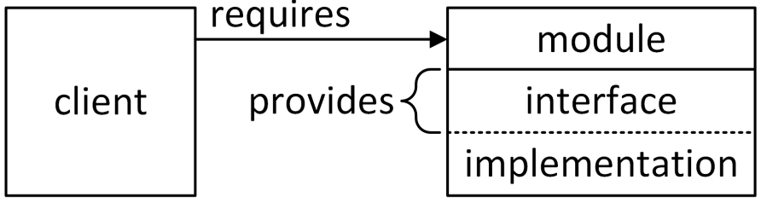
* The interface is what is provided to the client.
* The implementation is hidden from the client.

Interface contents

* The contents of the interface include:
* • an overall description of the module
* • a function declaration (not the function definition) for each provided function
* • documentation (e.g., a purpose) for each provided function
* Ideally, the interface would also provide examples to illustrate how the module is used and how the interface functions interact. Examples are not required in this course.

Interface (.h) files

* For C modules, the interface is placed in a separate file with a .h file extension.
* 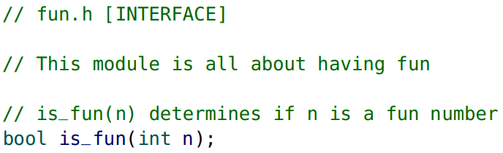
* This fun module would be a complete interface
* The interface (.h) file has everything the client needs.
* Interface files are also known as header files.
* Clients can read the documentation in the interface (.h) file to understand how to use the provided functions.
* The client can also “copy & paste” the function declarations from the interface file to make the module functions available
* 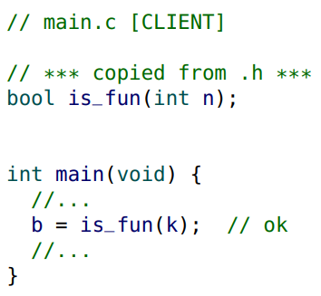
* But there is a much more elegant solution.

#include

* A preprocessor directive temporarily “modifies” a source file just before it is run (but it does not save the modifications).
* The directive #include “cut & pastes” or “inserts” the contents of another file directly into the current file.
* 
* For clients, this is perfect: it inserts the interface of the module containing all of the function declarations, making all of the provided functions available to the client.
* Always put any #include directives at the top of the file.
* 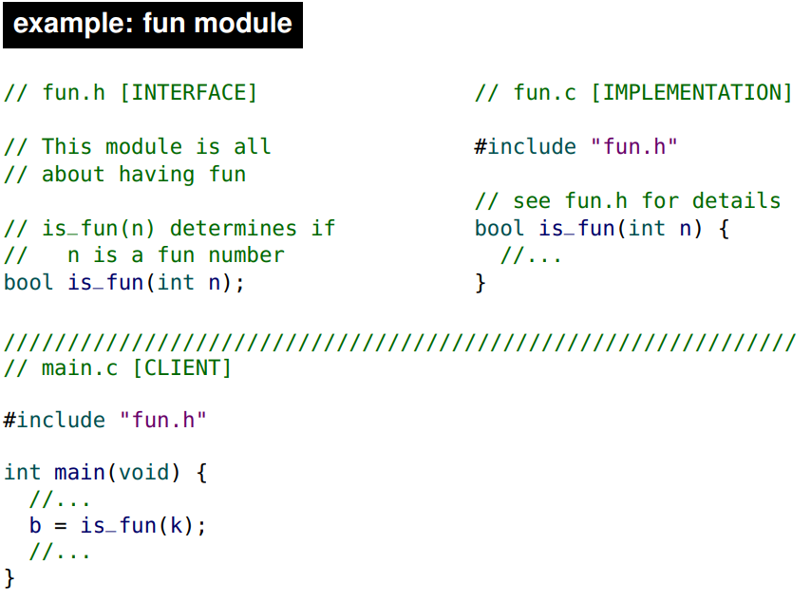
* The above example shows the entire fun module being used
* The fun.h module is split into two different pieces. The fun.h interface and fun.c implementation. Notice that the implementation also includes through the line #include “fun.h”. Also in the implementation, notice we don’t need to document any functions that already appear in the interface. It’s actually a bad idea to provide documentation for both since it would require us to change the documentation in two places if we ever do change it. However, sometimes we might want to have some hidden documentation that the user doesn’t need to see so it is fine to put it in the implementation.
* The client down below has the line #include “fun.h” which takes the contents of fun.h and copy pastes it into the client program. A lot of what is being copy pasted is commented so that doesn’t change much. But the function declaration is also being copy pasted. Thus, the is_fun function has scope from the include line and down in main.c. Thus, we are able to call the is_fun function in the main function.

Implementation notes

* In the previous example, the fun implementation file (fun.c) included its own interface (fun.h).
* This is good style as it ensures there are no discrepancies between the interface (declarations) and the implementation (definitions).
* The function is_fun is fully documented in the interface file for the client, so in the implementation a simple comment referring the reader to the interface file is sufficient.
* 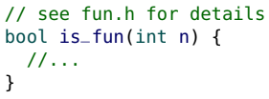
* 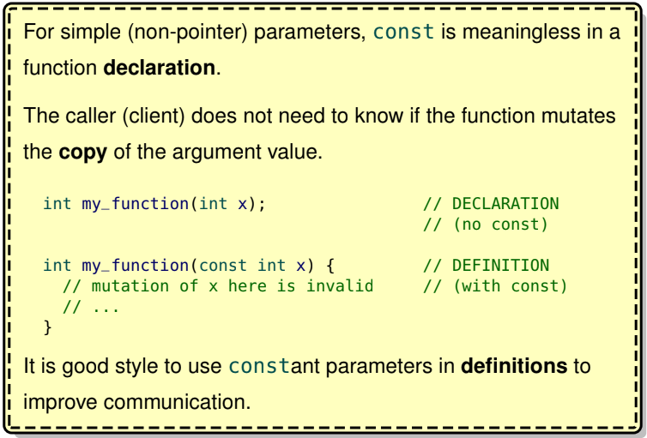
* Since simple parameters are copied, changing the copied parameter value cannot change the original argument value. Thus, adding const is meaningless since it’s implied the original argument value cannot change
* 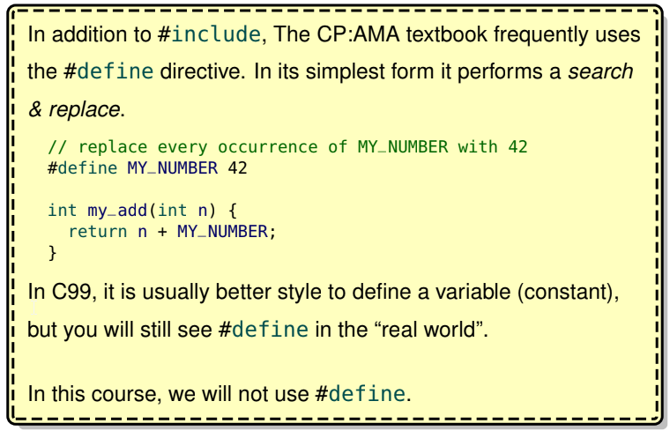

cs136.h

* Since the beginning of this course, we have seen #include "cs136.h" in our programs. We now understand that we have been using support tools and functions (e.g., trace_int and read_int) provided by a cs136 module.
* 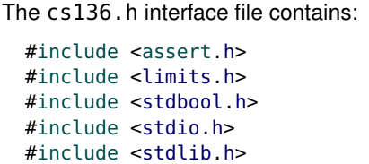
* So our cs136 module was requiring additional modules.

C standard modules

* Unlike Racket, there are no “built-in” functions in C.
* Fortunately, C provides several standard modules (also known as libraries) with many useful functions.
* For example, the stdio module (standard i/o module) provides printf and scanf. Technically, printf and scanf are not part of the C language and these functions are only available if you include the module.
* When using #include, we use angle brackets (<>) to specify that the module is one of the standard modules and quotes ("") for “regular” modules (i.e., ones we have written). These brackets/quotes tell C where to find the module.
* 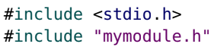
* Here are some of the other modules that we have been using:
  + • <assert.h> provides the function assert
  + • <limits.h> provides the constants INT_MAX and INT_MIN
  + • <stdbool.h> provides the bool data type and the constants true and false
  + • <stdlib.h> provides the constant NULL
* 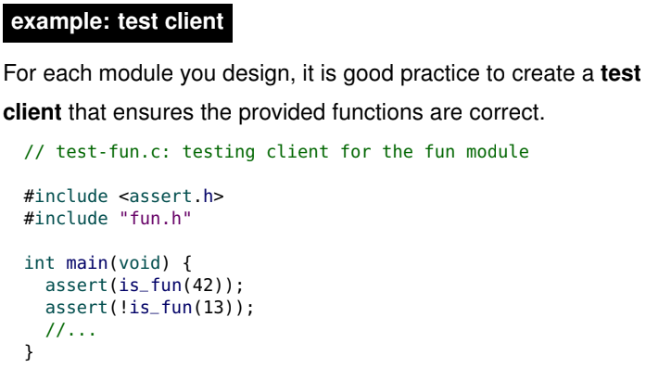
* The above is run to test our modules. We don’t give this module to the client (it is not part of the interface or implementation), this is a seperate test client.
* Do NOT add a main function to your implementation (e.g.,fun.c) since every program must have exactly 1 main function. Create a new test client with a main function.
* 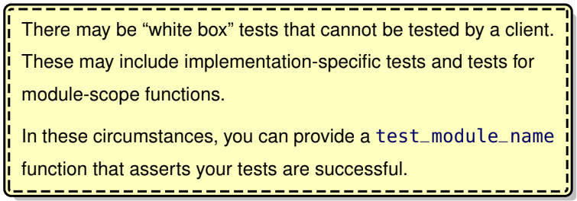
* Sometimes we need to test things that are hidden from the client. To do so, we add a separate test function called test_module_name to the interface to test it

Designing modules

* The ability to break a big programming project into smaller modules, and to define the interfaces between modules, is an important skill that will be explored in later courses.
* Unfortunately, due to the nature of the assignments in this course, there are very few opportunities for you to design any module interfaces.
* For now, we will have a brief discussion on what constitutes a good interface design.

Cohesion and coupling

* When designing module interfaces, we want to achieve high cohesion and low coupling.
* High cohesion means that all of the interface functions are related and working toward a “common goal”. A module with many unrelated interface functions is poorly designed.
* Low coupling means that there is little interaction between modules. (we want modules to have as few dependencies as possible) It is impossible to completely eliminate module interaction, but it should be minimized.
* 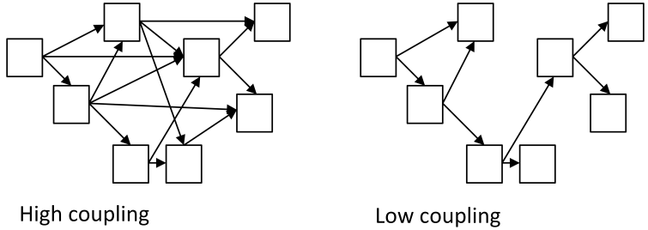

Interface vs. implementation

* We emphasized the distinction between the module interface and the module implementation.
* Another important aspect of interface design is information hiding, where the interface is designed to hide any implementation details from the client.

Information hiding

* The two key advantages of information hiding are security and flexibility.
* Security is important because we may want to prevent the client from tampering with data used by the module. Even if the tampering is not malicious, we may want to ensure that the only way the client can interact with the module is through the interface. We may need to protect the client from themselves (they could break stuff in the module which is bad since the client also needs the module).
* By hiding the implementation details from the client, we gain the flexibility to change the implementation in the future.

Information hiding in C

* With C modules, it is easy to hide the implementation details from the client.
* Instead of providing the client with the implementation source code(.c file) you can provide a machine code (e.g., a .ll file). This is what we did with our cs136 module.
* While C is good at hiding the implementation code, it is not very good at hiding data.
* If a malicious client obtains (or “guesses”) the memory address of some data they can access it directly.
* Thus, most people don’t like C’s information hiding since it cannot hide it well.

Opaque structures in C

* Fortunately, C supports opaque structures, which are “good enough” to hide data from a friendly client.
* An opaque structure is like a “black box” that the client cannot “see” inside of.
* Opaque structures (aka incomplete declarations) tell the client there is a structure, but we don’t tell them what the fields are.
* They are implemented in C using incomplete declarations, where a structure is declared without any fields.
* 
* With an incomplete declaration only pointers to the structure can be defined.
* 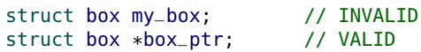
* If a module only provides an incomplete declaration in the interface, the client can not create an instance of the struct or access any of the fields.
* The module must provide a function to create (and destroy) an instance of the structure. This is explored more in Section 10.
* Of course, if we want a transparent structure the client can use, we simply put the complete definition of the struct in the interface file (.h file).
* 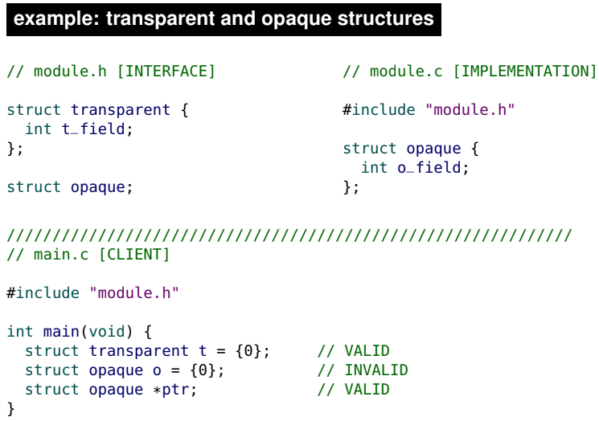
* In the above example, assume the create/destroy instance of a structure is already given as magic functions.
* Notice the opaque structure is defined in the implementation and declared in the interface. In doing so, the client cannot create an instance of the opaque structure.
* Ex: Stopwatch module
  + To illustrate the principles of information hiding, we will create a small stopwatch module.
  + For narrative purposes, we can imagine this module is for keeping track of race times and we do not want clients to be able to tamper with the times (this is an example of security).
  + In the interface, we have an incomplete declaration.
  + The client cannot define a struct stopwatch, so we need to provide create and destroy functions.
  + 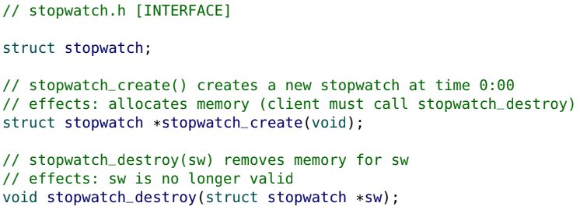
  + In the above example, we create an opaque stopwatch structure. The client does not know what fields are inside, the client can only know that such a structure exists.
  + Recall in the contents of the interface include:
    - • an overall description of the module
    - • a function declaration (not the function definition) for each provided function
    - • documentation (e.g., a purpose) for each provided function
  + Since we are providing an opaque interface, we need to provide functions to the client so that they can create and destroy a stopwatch (learn more about this in sec 10). stopwatch_create returns a pointer to a stopwatch. stopwatch_destroy is passed a pointer to a stopwatch.
  + The rest of the interface provides some simple stopwatch functions.
  + 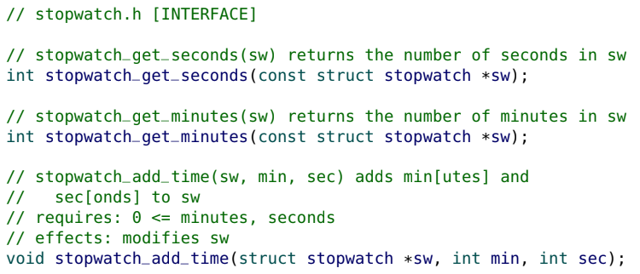
  + Notice the const in the stopwatch pointer parameters of stopwatch_get_seconds and stopwatch_get_minutes. This means we cannot change the value of the stopwatch. This is good since we don’t want to be able to change the value of the stopwatch when all we’re asking for is what the stopwatch seconds/minutes are.
  + Notice stopwatch_add_time takes in a pointer to a stopwatch and it is not a constant. This is because we want to be able to change the stopwatch value that the pointer is pointing at.
  + The implementation fully defines a struct stopwatch and simple functions to access the fields of the structure.
  + 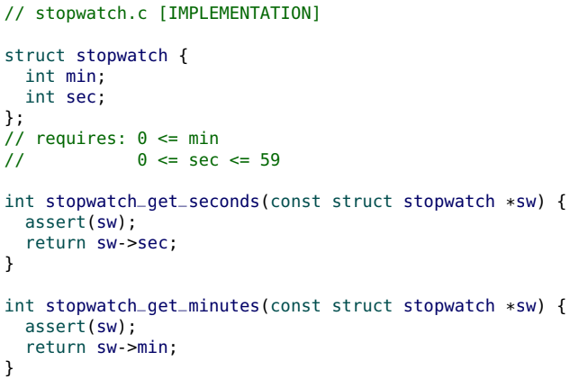
  + The only non-trivial function is the stopwatch_add_time function. In this function, we make sure parameters are valid, we change the stopwatch field values, and then we make sure the stopwatch doesn’t say a time like 3 minutes 74 seconds.
  + 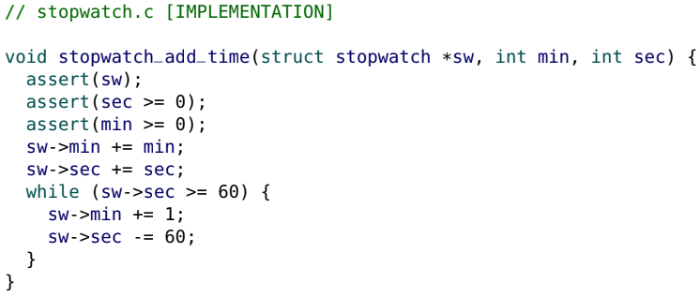
  + This simple client illustrates the use of the stopwatch module.
  + 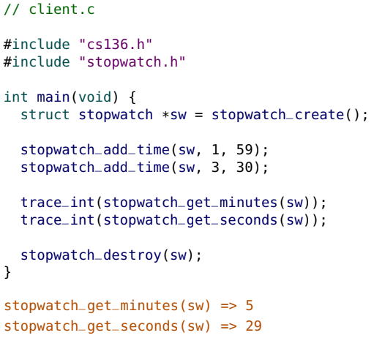

Maintainability

* We can improve our stopwatch module without changing the client. This is an example of maintainability.
* There were a few things in our code that weren't great and we wanted to change. For instance, we had 60 as a magic number when we should define a new constant called seconds_per_minute. We also make this constant static (so it doesn’t appear in the interface) since we don’t want to provide it to the client. As well, we can do math to overcome the problem of 3 minutes 74 seconds.
* 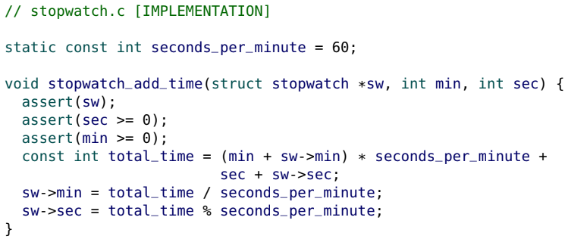
* In this example, we improved the style of our code along with its efficiency.
* As well, since we didn’t change the interface, the client is oblivious to these changes so this is good maintainability.

Flexibility

* Because we have used information hiding to design our interface, our implementation is not only maintainable, but also flexible.
* We can change the design of our struct stopwatch and the client will be completely unaware.
* The client only accesses our structure through the provided functions. As long as we do not change the function behaviour, we have the flexibility to change our design.
* For example, we can change our struct stopwatch to contain a single field (seconds) instead of storing the information in two fields (sec and min).
* 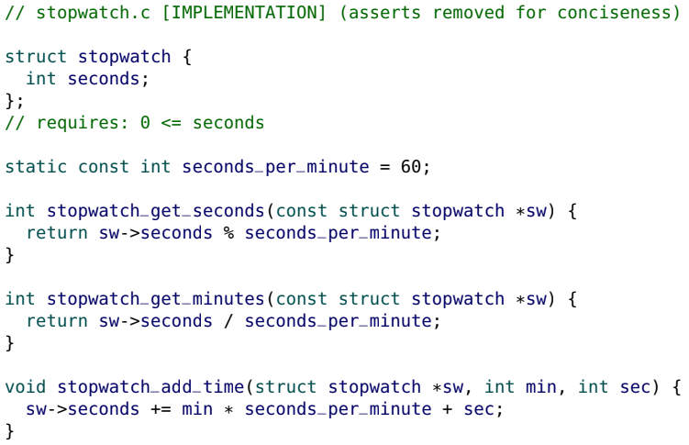
* Look at how much cleaner the add_time function is

Data structures & abstract data types

* In the previous stopwatch example, we demonstrated two implementations with different data structures:
  + • a struct with two fields (sec and min)
  + • a struct with one field (seconds)
* For each data structure we knew how the data was “structured”.
* However, the client doesn’t need to know how the data is structured. The client only requires an abstract understanding that a stopwatch stores time information.
* The stopwatch module is an implementation of a stopwatch Abstract Data Type (ADT).
* Formally, an ADT is a mathematical model for storing and accessing data through operations. As mathematical models they transcend any specific computer language or implementation.
* However, in practice (and in this course) ADTs are implemented as data storage modules that only allow access to the data through interface functions (ADT operations). The underlying data structure and implementation of an ADT are hidden from the client (which provides flexibility and security).

Data structures vs. ADTs

* The difference between a data structure and an ADT is subtle and worth reinforcing.
* As the client, if you have a data structure, you know how the data is “structured” and you can access the data directly in any manner you desire.
* With an ADT, the client does not know how the data is structured and can only access the data through the interface functions (operations) provided by the ADT.
* The terminology is especially confusing because ADTs are implemented with a data structure.
* Our stopwatch module was an ADT and it used data structures to store the data. But the key difference is that we hid that information from the client. The stopwatch is an ADT since the client doesn’t know how the data is structured. We implemented the stopwatch so we know how the data is structured and we used a data structure to store that information in the stopwatch. But the client did not know how that was working and that’s why it’s an ADT.

Collection ADTs

* The stopwatch ADT is not a “typical” ADT because it stores a fixed amount of data and it has limited use.
* A Collection ADT is an ADT designed to store an arbitrary number of items. Collection ADTs have well-defined operations and are useful in many applications.
* In CS 135 we were introduced to our first collection ADT: a dictionary.
* In most contexts, when someone refers to an ADT they implicitly mean a “collection ADT”. By some definitions, collection ADTs are the only type of ADT.

Dictionary (revisited)

* The dictionary ADT (also called a map, associative array, key-value store or symbol table), is a collection of pairs of keys and values.
* Each key is unique and has a corresponding value, but more than one key may have the same value.
* Typical dictionary ADT operations:
* • lookup: for a given key, retrieve the corresponding value or “not found”
* • insert: adds a new key/value pair (or replaces the value of an existing key)
* • remove: deletes a key and its value
* 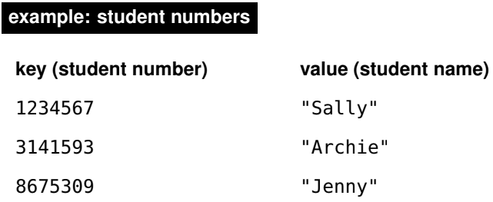
* In CS 135 we implemented a dictionary with an association list data structure (a list of key/value pairs with each pair stored as a two-element list).
* 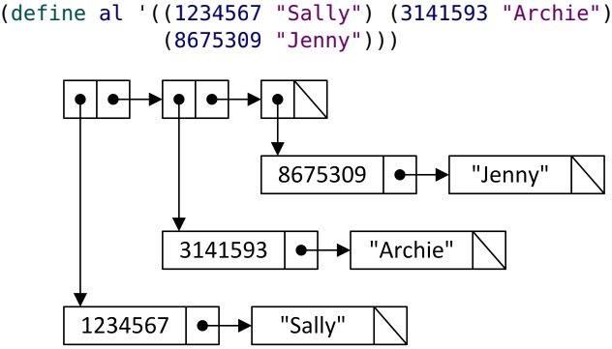
* We also implemented a dictionary with a Binary Search Tree (BST) data structure.
* 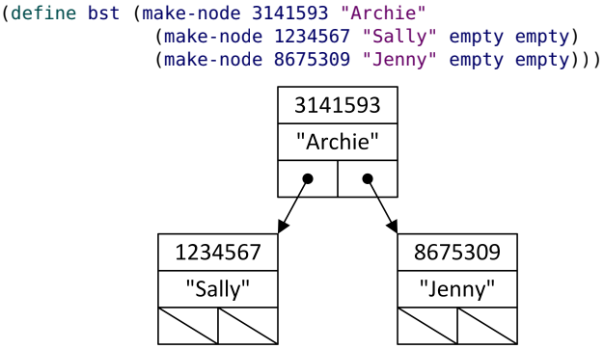
* To implement a dictionary, we have a choice: use an association list, a BST or perhaps something else?
* This is a design decision that requires us to know the advantages and disadvantages of each choice.
* Regardless, the client would never know which implementation was being used.
* You likely have an intuition that BSTs are “more efficient” than association lists. In Section 08 we introduce a formal notation to describe the efficiency of an implementation.

More collection ADTs

* Three additional collection ADTs that are explored in this course:
* • stack
* • queue
* • sequence

Stack ADT

* We have already been exposed to the idea of a stack when we learned about the call stack.
* The stack ADT is a collection of items that are “stacked” on top of each other. Items are pushed onto the stack and popped off of the stack. A stack is known as a LIFO (last in, first out) system. Only the “top” item is accessible.
* Stacks are often used in browser histories (“back”) and text editor histories (“undo”).
* Typical stack ADT operations:
  + • push: adds an item to the top of the stack
  + • pop: removes the top item from the stack
  + • top: returns the top item on the stack
  + • is_empty: determines if the stack is empty

Queue ADT

* A queue is like a “lineup”, where new items go to the “back” of the line, and the items are removed from the “front” of the line. While a stack is LIFO, a queue is FIFO (first in, first out).
* Typical queue ADT operations:
  + • add_back: adds an item to the end of the queue
  + • remove_front: removes the item at the front of the queue
  + • front: returns the item at the front
  + • is_empty: determines if the queue is empty

Sequence ADT

* The sequence ADT is useful when you want to be able to retrieve, insert or delete an item at any position in a sequence of items.
* Typical sequence ADT operations:
* • item_at: returns the item at a given position
* • insert_at: inserts a new item at a given position
* • remove_at: removes an item at a given position
* • length: return the number of items in the sequence
* The insert_at and remove_at operations change the position of items after the insertion/removal point.

**Section 7**

Arrays

* C only has two built-in types of “compound” data storage:
* • structures (can have fields of different datatypes)
* • arrays (can only contain 1 datatype)
* 
* An array is a data structure that contains a fixed number of elements that all have the same type.
* Because arrays are built-in to C, they are used for many tasks where lists are used in Racket, but arrays and lists are very different. In Section 11 we construct Racket-like lists in C.
* 
* To define an array we must know the length of the array in advance (we address this limitation in Section 10).
* Each individual value in the array is known as an element. To access an element, its index is required.
* The first element of my_array is at index 0, and it is written as my_array[0].
* The second element is my_array[1] and the last is my_array[5].
* Each individual array element can be used in an expression as if it was a variable. In addition, the index of the array can be an expression.
* a[-1] might raise an error, it depends one comes before the array in memory
* Ex:
  + 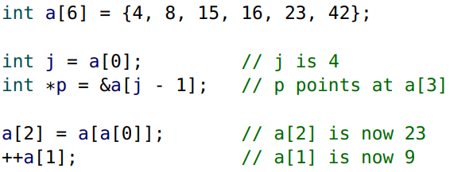
* Arrays and iteration are a powerful combination.
* Ex:
  + 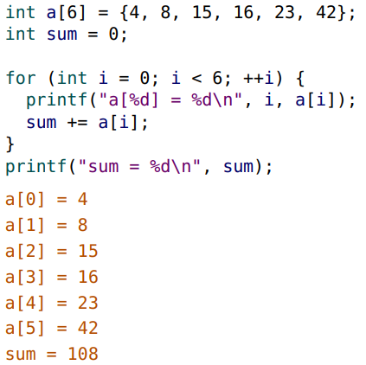

Array initialization

* Arrays can only be initialized with braces ({}).
* 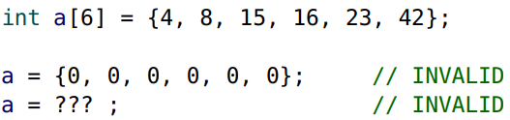
* Once an array is defined, we cannot use the {} to change it.
* Once defined, the entire array cannot be mutated at once, and the length cannot change. Only individual elements can be mutated.
* If there are not enough elements in the initialization braces, the remaining values are initialized to zero.
* 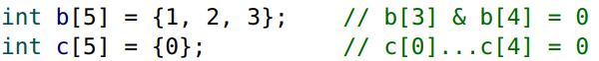
* Character arrays can be initialized with double quotes (") for convenience.
* The following two definitions are equivalent:
* 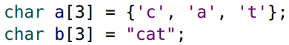
* If we did char a[5] = {‘c’, ‘a’, ‘t’}; a[3] and a[4] would be the number 0 which is valid since 0 can be mapped to a character using ASCII (The null character).
* 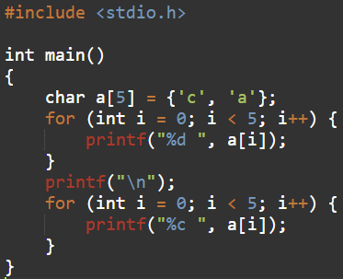 => 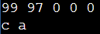
* In this example, a and b are character arrays and are not valid strings.
* Like variables, the value of an uninitialized array depends on the scope of the array:
  + (uninitialized is still a valid definition since it will be filled with 0’s or garbage values depending on if it has global or local scope)
  + uninitialized global arrays are zero-filled.
  + uninitialized local arrays are filled with arbitrary (“garbage”) values from the stack.

Array length

* C does not explicitly keep track of the array length as part of the array data structure.
* You must keep track of the array length separately.
* To improve readability, the array length is often stored in a separate variable
* 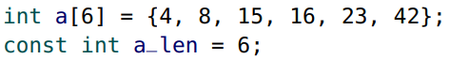
* It might seem better to use a constant to specify the length of an array
* 
* This would appear to be a “better style”.
* However, the syntax to do this properly is outside of the scope of this course (see following slide).
* In this course, always define arrays using numbers. It is okay to have these “magic numbers” appear in your assignments.
* 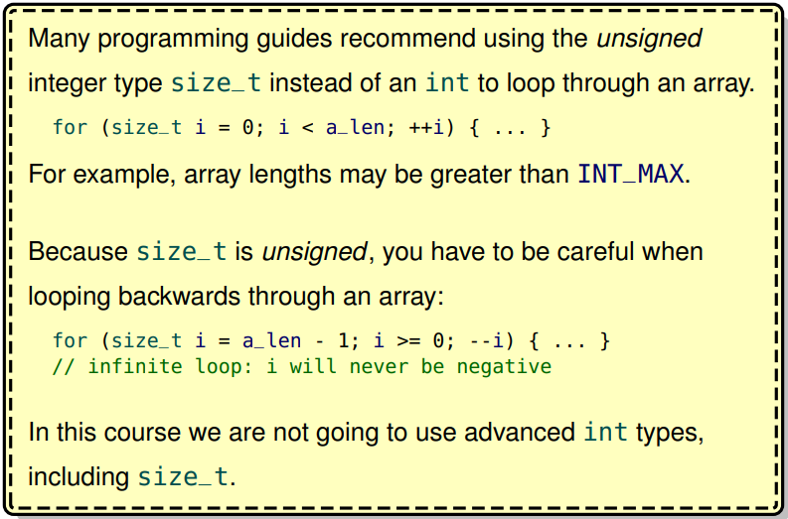
* 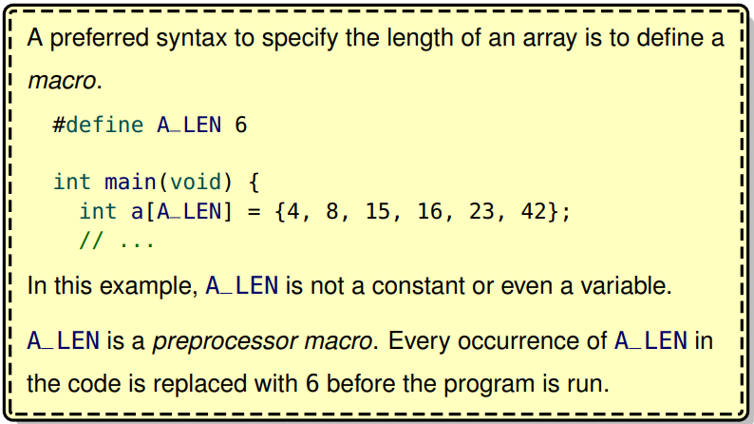
* 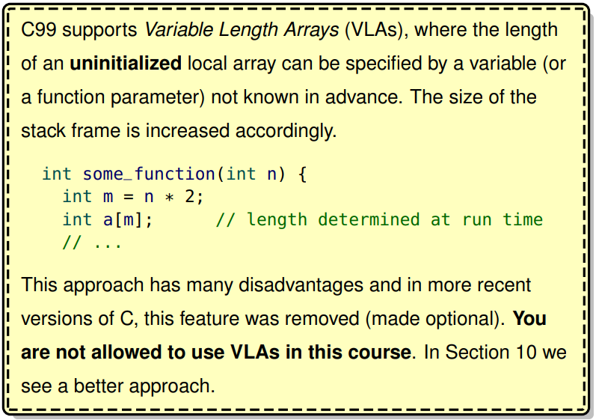
* 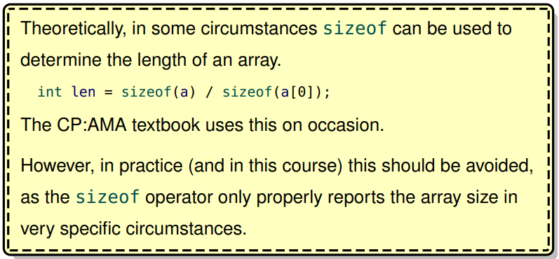

Array Size

* The length of an array is the number of elements in the array.
* The size of an array is the number of bytes it occupies in memory.
* An array of k elements, each of size s, requires exactly k × s bytes.
* In the C memory model, array elements are adjacent to each other. Each element of an array is placed in memory immediately after the previous element.
* If a is an integer array with six elements (int a[6]) the size of a is: (6 × sizeof(int)) = 6 × 4 = 24
* Ex:
  + 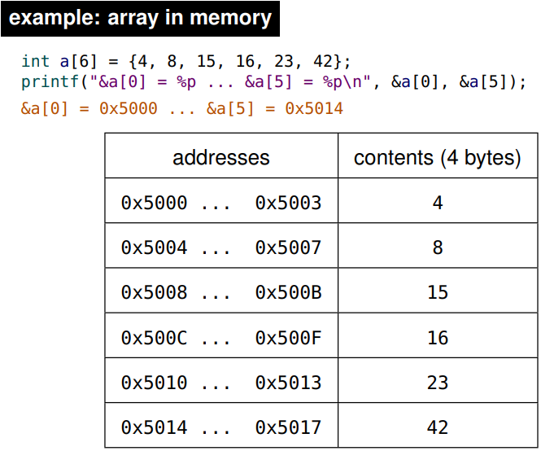

Array Identifier

* An array does not have a “value” in C. When an array is used by itself in an expression, it evaluates (“decays”) to the address of the array (&a), which is also the address of the first element (&a[0]).
* 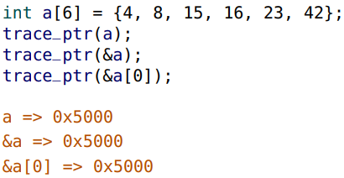
* Note: print(a[]) wil give an error
* Even though a and &a have the same value, they have different types, and cannot always be used interchangeably.
* Dereferencing the array (*a) is equivalent to referencing the first element (a[0]).
* 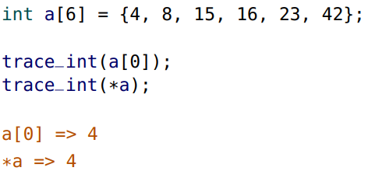

Passing arrays to functions

* When an array is passed to a function, only the address of the array is copied into the stack frame.
* This is more efficient than copying the entire array to the stack.
* Typically, the length of the array is unknown to the function, and is a separate parameter.
* There is no method of “enforcing” that the length passed to a function is valid.
* Functions should require that the length is valid, but there is no way for a function to assert that requirement.
* 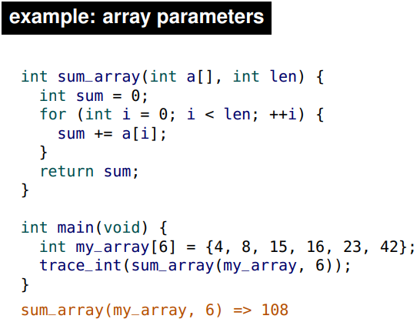
* In the above function, instead of int a[] as the parameter, we could have int *a and they would be the same for C since they are both pointers. But it’s better for the programmer to use int a[] instead since we not only know it’s a pointer, but it’s an array.
* Note the parameter syntax: int a[] and the calling syntax: sum_array(my_array, 6).
* 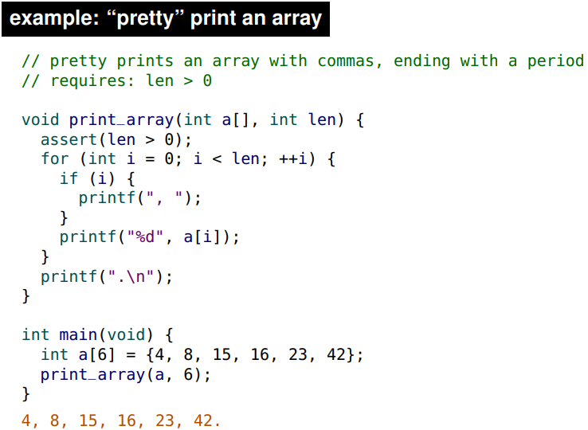
* 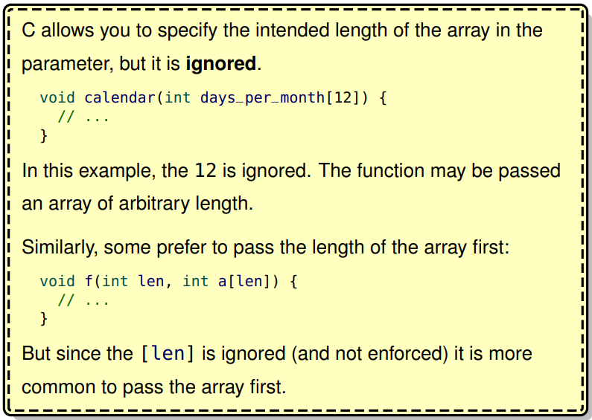
* As we have seen before, passing an address to a function allows the function to change (mutate) the contents at that address.
* 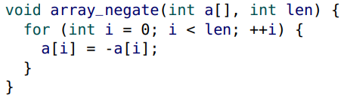
* It’s good style to use the const keyword to both prevent mutation and communicate that no mutation occurs (if we don’t want to mutate the array).
* 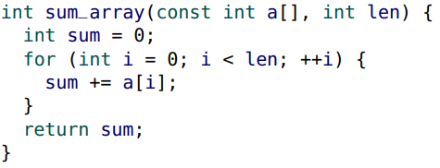

Array within a structure

* Because a structure can contain an array:
* 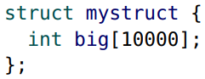
* Note: if we did struct mystruct s; we would have to allocate exactly 10 000 * sizeof(int) = 10 000 * 4 bytes = 40 000 bytes
* It is especially important to pass a pointer to such a structure, otherwise, the entire array is copied to the stack frame.
* 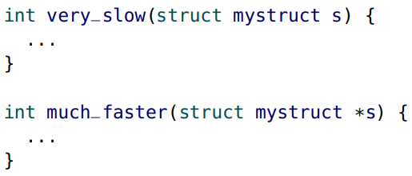

Pointer arithmetic

* We have not yet discussed any pointer arithmetic.
* C allows an integer to be added to a pointer, but the result may not be what you expect.
* If p is a pointer, the value of (p+1) depends on the type of the pointer p.
* If p is a pointer to a character, p+1 points to the next byte in memory.
* If p is a pointer to an integer, p+1 points to the next integer in memory.
* (p+1) adds the sizeof whatever p points at. Recall when we defined a pointer, we specified the type of what the pointer was pointing at (static typing). So if we have p pointing at something in memory, we know its type. So when c adds 1 to the pointer p, it skips over to the next thing in memory.
* According to the official C standard, pointer arithmetic is only valid within an array (or a structure) context. This becomes clearer later.
* If a points at a[0], then (a+1) points at a[1]

Pointer arithmetic rules

* When adding an integer i to a pointer p, the address computed by (p + i) in C is given in “normal” arithmetic by:

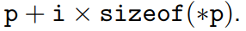(this is why a[-1] makes sense)

* Subtracting an integer from a pointer (p - i) works in the same way
* Mutable pointers can be incremented (or decremented). ++p is equivalent to p = p + 1.
* You cannot add two pointers.
* A pointer q can be subtracted from another pointer p if the pointers are the same type (point to the same type). The value of (p-q) in C is given in “normal” arithmetic by 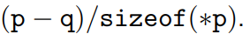In other words, if p = q + i then i = p - q. (i can be negative)
* Pointers (of the same type) can be compared with the comparison operators: <, <=, == , !=, >=, >

(e.g., if (p < q) ...).

Pointer arithmetic and arrays

* Pointer arithmetic is useful when working with arrays.
* Recall that for an array a, the value of a is the address of the first element (&a[0]).
* Using pointer arithmetic, the address of the second element &a[1] is (a + 1), and it can be referenced as *(a + 1)
* 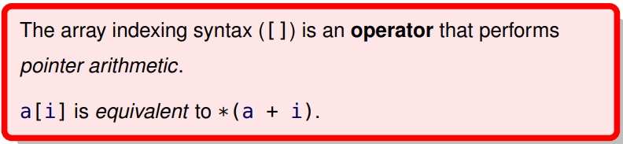.
* Note: this means a[3] is equivalent to 3[a] since *(a+3) = *(3+a)
* 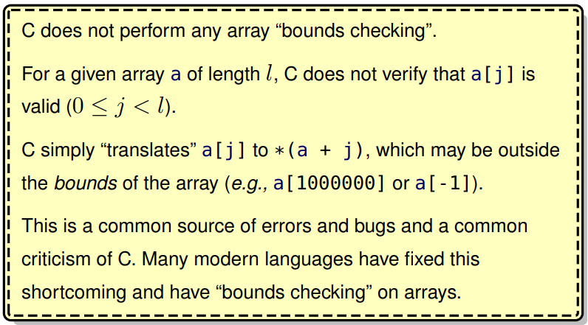
* In array pointer notation, square brackets ([]) are not used, and all array elements are accessed through pointer arithmetic.
* 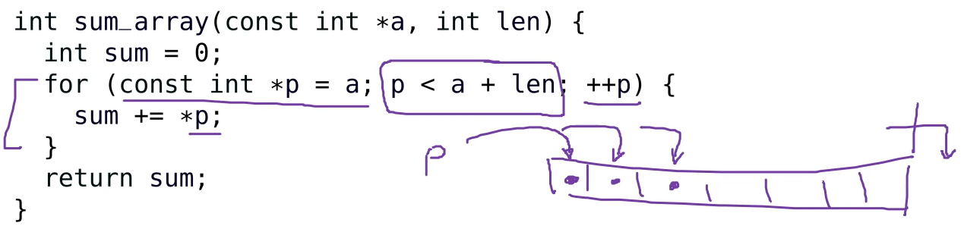
* Recall that const int *p = a means that p can point at anything (hence we assign it to take on the value of a), but we cannot change the value of what p points at.
* Note that the above code behaves identically to the previously defined sum_array:

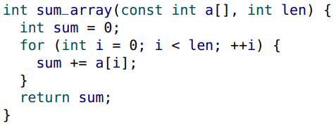

* 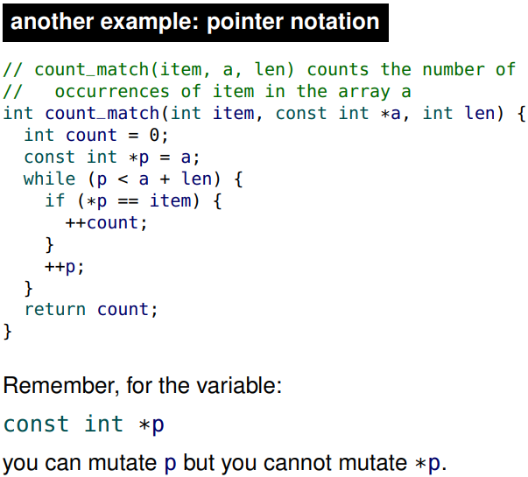
* The choice of notation (pointers or []) is a matter of style and context. You are expected to be comfortable with both.
* C makes no distinction between the following two function declarations:
* 
* It turns out the above two are the same since when C sees the a[] notation, it converts it to *a. That is why in the earlier example, if we define the parameter to be a[3] to try and specify the length of 3, the 3 doesn't matter. Since there is no way to capture the number after C translates it to *a.
* In most contexts, there is no practical difference between an array identifier and an immutable pointer.

Array map

* Aside from the awkward function pointer parameter syntax, the implementation of array_map is straightforward.
* 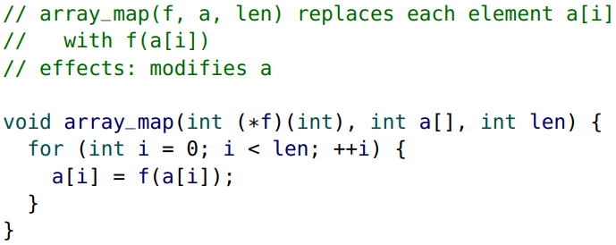
* 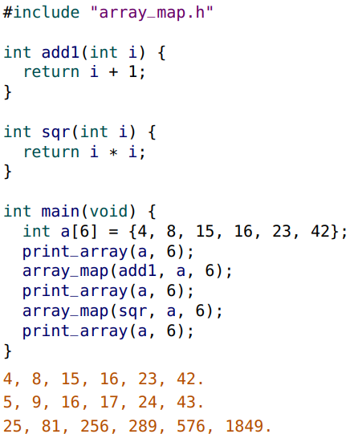

Selection sort

* In selection sort, the smallest element is selected to be the first element in the new sorted sequence, and then the next smallest element is selected to be the second element, and so on.
* 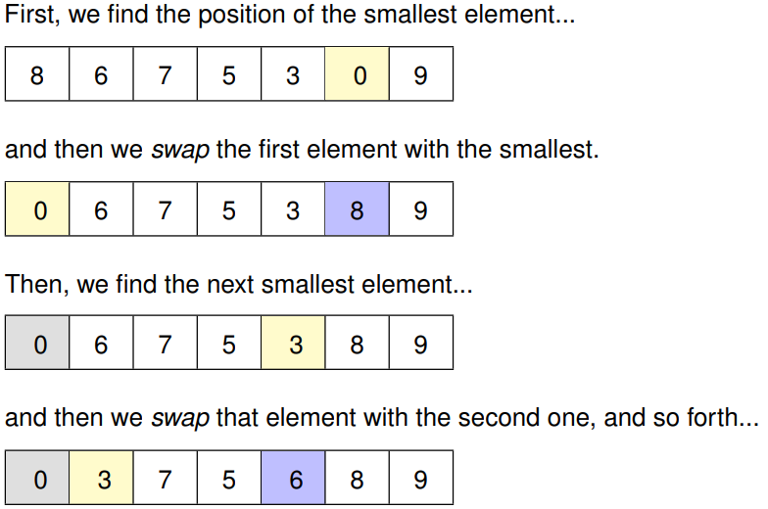
* 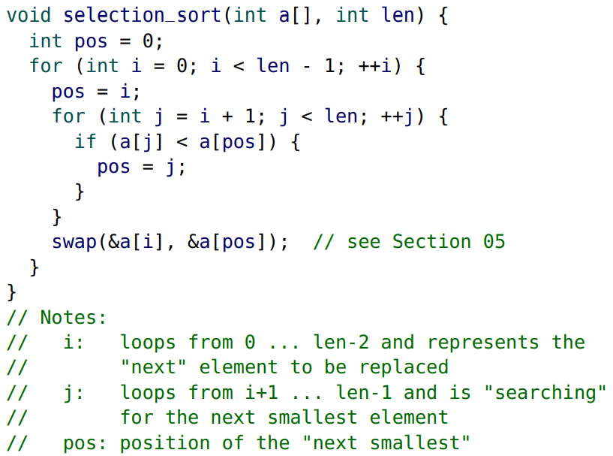

Insertion sort

* In Insertion sort, we consider the first element to be a sorted sequence (of length one).
* We then “insert” the second element into the existing sequence into the correct position, and then the third element, and so on.
* For each iteration of Insertion sort, the first i elements are sorted.
* We then “insert” the element a[i] into the correct position, moving all of the elements greater than a[i] one to the right to “make room” for a[i]
* 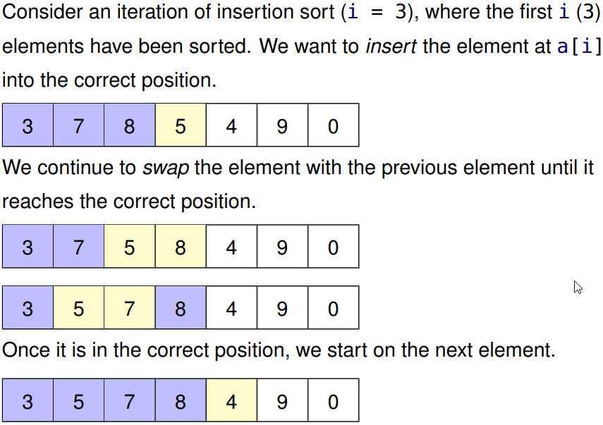
* 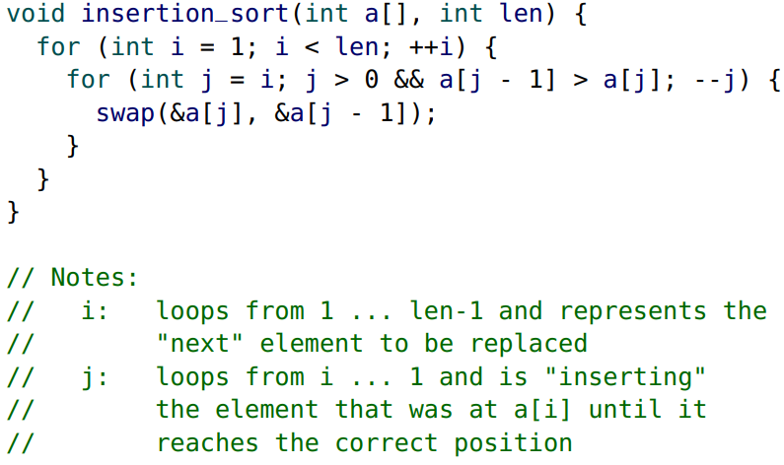

Quicksort

* Quicksort is an example of a “divide & conquer“ algorithm.
* First, an element is selected as a “pivot” element.
* The list is then partitioned (divided) into two sub-groups: elements less than (or equal to) the pivot and those greater than the pivot.
* Finally, each sub-group is then sorted (conquered).
* Quicksort is also known as partition-exchange sort or Hoare’s quicksort (named after the author)
* 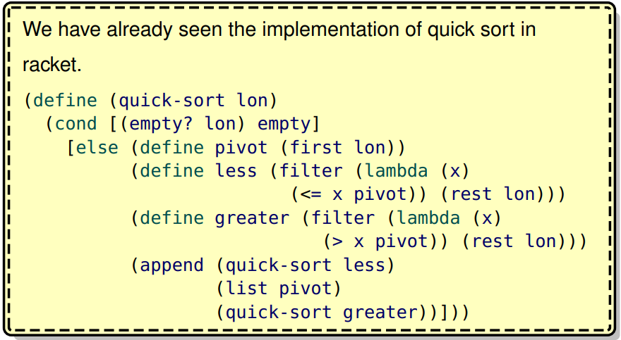
* For simplicity, we select the first element as the “pivot”. A more in-depth discussion of pivot selection occurs in CS 240.
* In our C implementation of quick sort, we:
  + • select the first element of the array as our “pivot”
  + • move all elements that are larger than the pivot to the back of the array
  + • move (“swap”) the pivot into the correct position
  + • recursively sort the “smaller than” sub-array and the “larger than” sub-array
* The core quick sort function quick_sort_range has parameters for the range of elements (first and last) to be sorted, so a wrapper function is required.
* 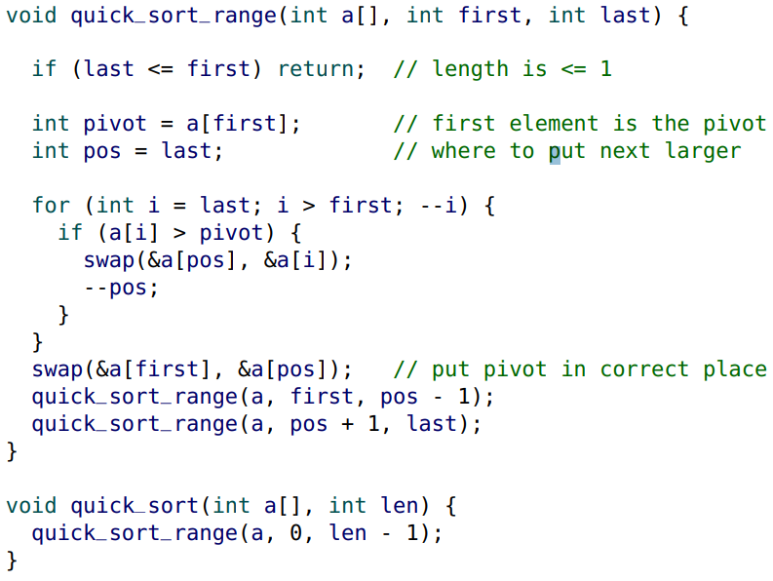

Linear Search

* In Racket, the built-in function member can be used to determine if a list contains an element.
* We can write a similar function in C that finds the index of an element in an array:
* 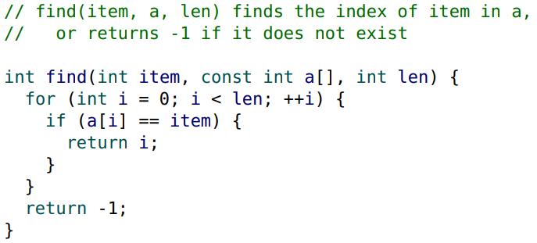

Binary Search

* If the array is sorted, we can use binary search
* 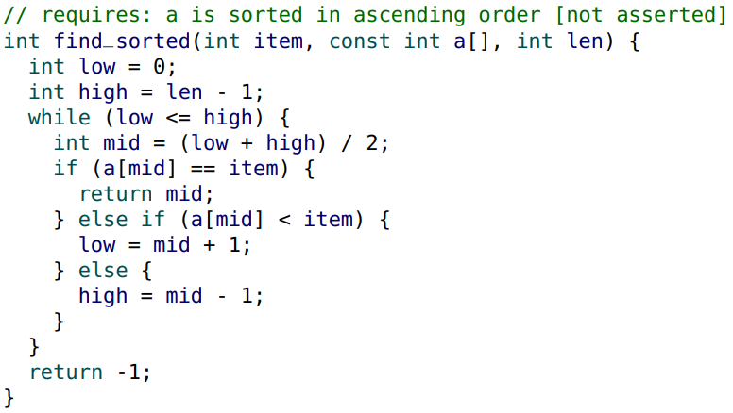

Multi-dimensional data

* All of the arrays seen so far have been one-dimensional (1D) arrays.
* You cannot have an array of arrays in c, that is not valid syntax
* We can represent multi-dimensional data by “mapping” the higher dimensions down to one.
* For example, consider a 2D array with 2 rows and 3 columns.

1 2 3

7 8 9

* We can represent the data in a simple one-dimensional array. int data[6] = {1, 2, 3, 7, 8, 9};
* To access the entry in row r and column c, we simply access the element at data[r*3 + c].
* In general, it would be data[row * NUMCOLS + col]
* 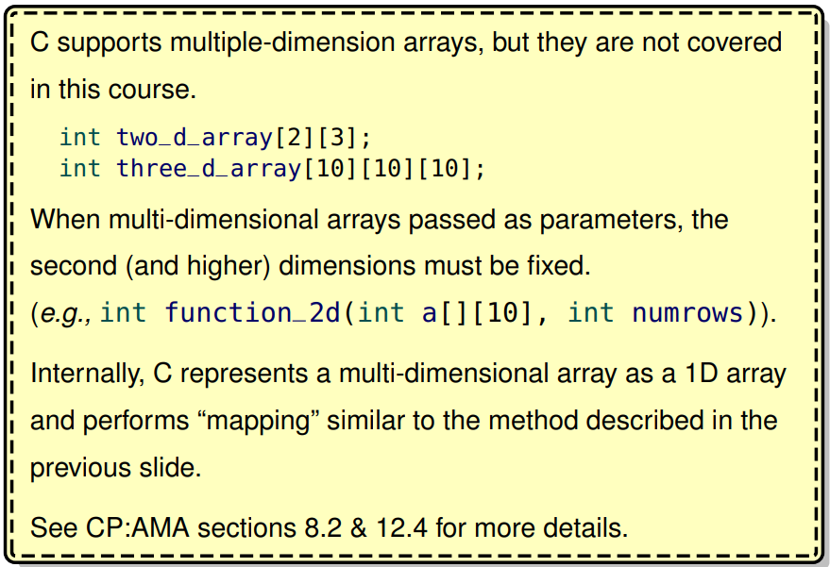

Oversized Arrays

* A significant limitation of an array is that the length of the array must be known in advance.
* In Section 10 we introduce dynamic memory which can be used to circumvent this limitation, but first we explore a less sophisticated approach.
* In some applications, it may be “appropriate” (or “easier”) to have an oversized array with a “maximum” length.
* In general, oversized arrays should only be used when appropriate:
* • They are wasteful if the maximum length is excessively large.
* • They are restrictive if the maximum length is too small.
* When working with oversized arrays, we need to keep track of
* • the “actual” length of the array (the actual number of elements), and
* • the maximum possible length
* To illustrate oversized arrays, we implement an integer stack structure with a maximum length of 100 elements.
* The len field keeps track of the actual length of the stack.
* 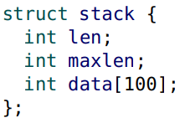
* We need to provide a stack_init function to initialize the structure:
* 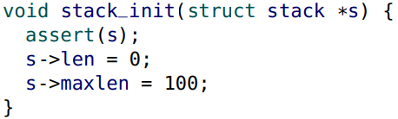
* Ignoring the push operation for now, we can write the rest of the stack implementation:
* 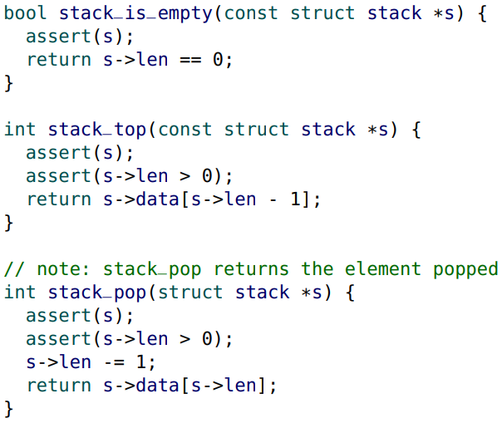
* Be careful of the off-by-1 error above. As well, make sure that when we do peep or pop, the stack cannot be empty.
* What happens if we exceed the maximum length when we try to
* push an element?
* There are a few possibilities:
  + • the stack is not modified and an error message is displayed
  + • a special return value can be used
  + • an assertion fails (terminating the program)
  + • the program explicitly terminates with an error message
* Any approach may be appropriate as long as the contract properly documents the behaviour.
* The exit function (part of <stdlib.h>) stops program execution. It is useful for “fatal” errors.
* The argument passed to exit is equivalent to the return value of main.
* For convenience, <stdlib.h> defines EXIT_SUCCESS which is 0 and EXIT_FAILURE which is non-zero.
* For convenience, <stdlib.h> defines EXIT_SUCCESS which is 0 and EXIT_FAILURE which is non-zero.
* 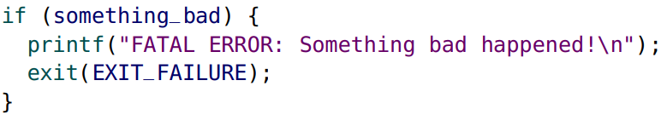
* 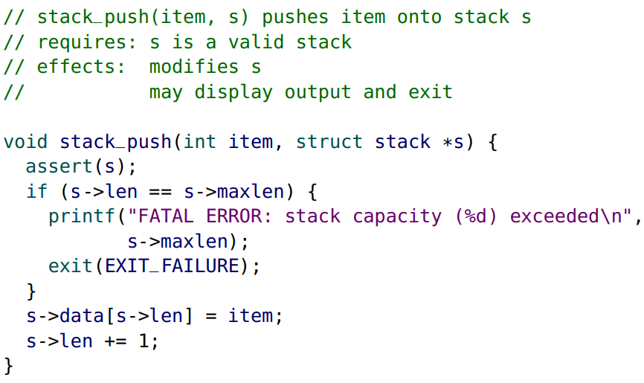
* Note this means if we do pop (not push), the element we added is still available in memory.

**Section 8**

Algorithms

* An algorithm is step-by-step description of how to solve a “problem”.
* Algorithms are not restricted to computing. For example, every day you might use an algorithm to select which clothes to wear.
* For most of this course, the “problems” are function descriptions (interfaces) and we work with implementations of algorithms that solve those problems.
* There are many objective and subjective methods for comparing algorithms:
  + • How easy is it to understand?
  + • How easy is it to implement?
  + • How accurate is it?
  + • How robust is it? (Can it handle errors well?)
  + • How adaptable is it? (Can it be used to solve similar problems?)
  + • How fast (efficient) is it?
* In this course, we use efficiency to objectively compare algorithms. However, in the real world some of the other factors may be more important than efficiency

Efficiency

* The most common measure of efficiency is time efficiency, or how long it takes an algorithm to solve a problem. Unless we specify otherwise, we always mean time efficiency.
* Another efficiency measure is space efficiency, or how much space (memory) an algorithm requires to solve a problem.
* Power efficiency (power consumption) is also becoming an important measure.
* The efficiency of an algorithm may depend on its implementation.
* To avoid any confusion, we always measure the efficiency of a specific implementation of an algorithm.

Running time

* To quantify efficiency, we are interested in measuring the running time of an algorithm.
* What unit of measure should we use? Seconds?
* “My algorithm can sort one billion integers in 9.037 seconds”.

• What year did you make this statement?

• What machine & model did you use? (With how much RAM?) (running the algorithm on the world’s fastest supercomputer is less impressive than on your phone)

• What computer language & operating system did you use?

• Was that the actual CPU time, or the total time elapsed?

• How accurate is the time measurement? Is the 0.037 relevant?

* Measuring running times in seconds can be problematic.
* What are the alternatives?
* Typically, we measure the number of elementary operations required to solve the problem.
* • In C, we can count the number of operations, or in other words, the number of operators executed. (data operators, addition operators, etc). This is effective since it doesn’t matter what year it is (which affects the hardware), the number of operations for the algorithm will be the same.
* • In Racket, we can count the total number of (substitution) steps required, although that can be deceiving for built-in functions. We revisit the issue of built-in functions later.
* You are not expected to count the exact number of operations. We only count operations in these notes for illustrative purposes. We will introduce some simplification shortcuts soon.

Data size

* What is the number of operations executed for this implementation?
* 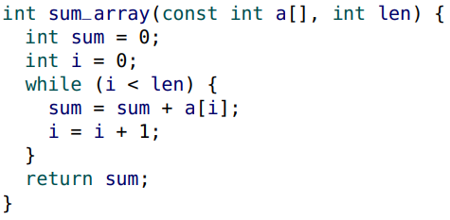
* The running time depends on the length of the array.
* If there are n items in the array, it requires 7n + 3 operations.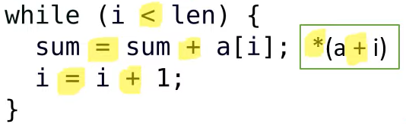
* Inside the while loop, there are 7 operations as shown above. Remember that a[i] is turned into *(a + i). We loop n times to get 7n times. However, we also have to check the condition of the while loop 1 last time to break the loop which gives 7n+1. Then we have to account for initializing sum and i which is two extra operations, giving 7n+3.
* Traditionally, the variable n is used to represent the size (or length) of the data. m and k are also popular when there is more than one parameter.
* Often, n is obvious from the context, but if there is any ambiguity clearly state what n represents.
* For example, with lists of strings, n may represent the number of strings in the list, or it may represent the length of all of the strings in the list.
* The running Time of an implementation is a function of n and is written as T(n).
* There may also be another attribute of the data that is also important.
* For example, with trees, we use n to represent the number of nodes in the tree and h to represent the height of the tree.

Algorithm Comparison

* Problem: Write a function to determine if an array of positive integers contains at least e even numbers and o odd numbers.
* 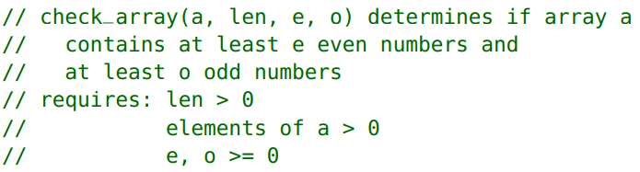
* Homer and Bart are debating the best algorithm (strategy) for implementing check_array.
* Bart just wants to count the total number of odd numbers in the entire array.
* 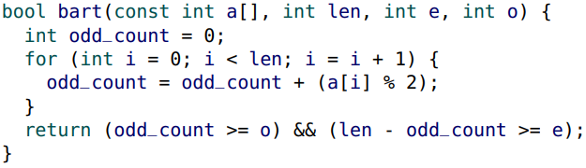
* If there are n elements in the array, T(n) = 8n + 7
* Homer is lazy, and he doesn’t want to check all of the elements in the array if he doesn’t have to.
* 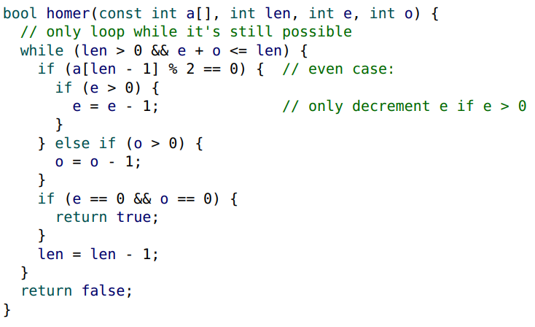
* The problem with analyzing Homer’s code is that it depends not just on the length of the array, but on the contents of the array and the parameters e and o.
* 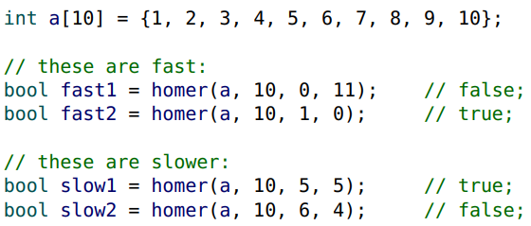
* For Homer’s code, the best case is when it can return immediately, and the worst case is when all of the array elements are visited.
* For Bart’s code, the best case is the same as the worst case.
* 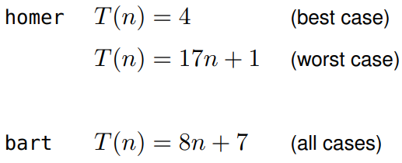
* Which implementation is more efficient?
* Is it more “fair” to compare against the best case or the worst case?

Worst case running time

* Typically, we want to be conservative (pessimistic) and use the worst case.
* Unless otherwise specified, the running time of an algorithm is the worst case running time.
* Comparing the worst case, Bart’s implementation (8n + 7) is more efficient than Homer’s (17n + 1).
* We may also be interested in the average case running time, but that analysis is typically much more complicated. (is the number of even and odds half the length, a quarter of the length, we have no clue and it can be hard to determine).

Big O notation

* In practice, we are not concerned with the difference between the running times (8n + 7) and (17n + 1).
* We are interested in the order of a running time. The order is the “dominant” term in the running time without any constant coefficients.
* The dominant term in both (8n + 7) and (17n + 1) is n, and so they are both “order n”.
* To represent orders, we use Big O notation.
* Instead of “order n”, we use O(n).
* We define Big O notation more formally later
* The “dominant” term is the term that grows the largest when n is very large (n → ∞). The order is also known as the “growth rate”.
* In this course, we encounter only a few orders (arranged from smallest to largest):
* O(1), O(log n), O(n), O(n log n), O(n^2), O(n^3), O(2^n)
* 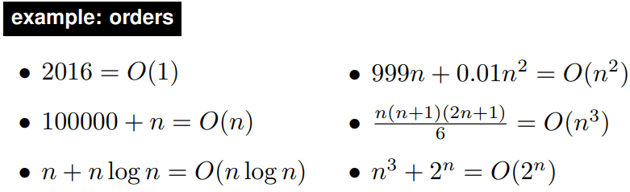
* When comparing algorithms, the most efficient algorithm is the one with the lowest order.
* For example, an O(n log n) algorithm is more efficient than an O(n^2) algorithm.
* If two algorithms have the same order, they are considered equivalent.
* Both Homer’s and Bart’s implementations are O(n), so they are equivalent.

Big O arithmetic

* When adding two orders, the result is the largest of the two orders.
* • O(log n) + O(n) = O(n)
* • O(1) + O(1) = O(1)
* When multiplying two orders, the result is the product of the two orders.
* • O(log n) × O(n) = O(n log n)
* • O(1) × O(n) = O(n)
* 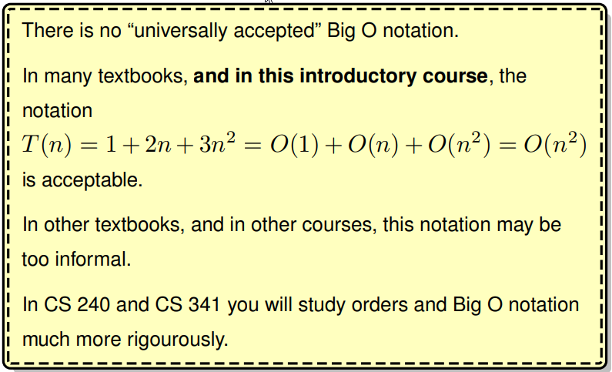

Algorithm analysis

* An important skill in Computer Science is the ability to analyze a function and determine the order of the running time.
* In this course, our goal is to give you experience and work toward building your intuition:
* 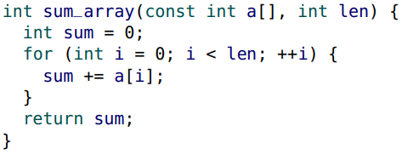
* “Clearly, each element is visited once, so the running time of sum_array is O(n)”

Contract update

* Include the time (efficiency) of each function that is not O(1) or is O(1) and not obviously O(1).
* If there is any ambiguity as to how n is measured, specify it.
* 
* For a function with a single array, it is obvious:
* 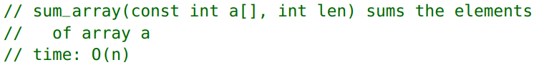

Analyzing simple functions

* First, consider simple functions (without recursion or iteration).
* 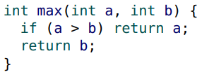
* If no other functions are called, there must be a fixed number of operators. Each operator is O(1), so the running time is:
* 
* If a simple function calls other functions, its running time depends on those functions.

Iterative analysis

* Iterative analysis uses summations.
* 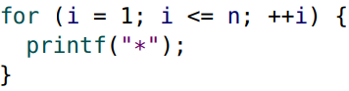
* 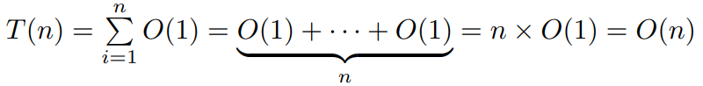
* Because we are primarily interested in orders,
* 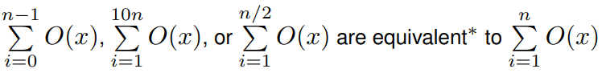
* 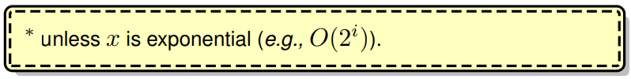

Procedure for iteration

* 1. Work from the innermost loop to the outermost
* 2. Determine the number of iterations in the loop (in the worst case) in relation to the size of the data (n) or an outer loop counter
* 3. Determine the running time per iteration
* 4. Write the summation(s) and simplify the expression
* 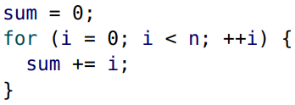 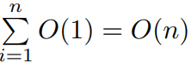

Common summations

* 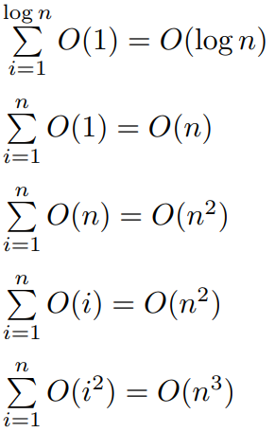
* The summation index should reflect the number of iterations in relation to the size of the data and does not necessarily reflect the actual loop counter values.
* 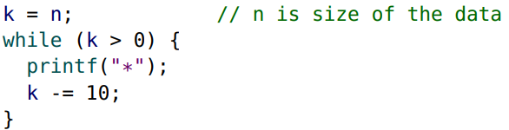
* There are n/10 iterations. Because we are only interested in the order, n/10 and n are equivalent.
* 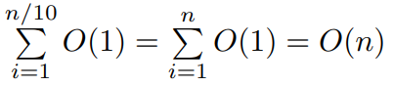
* When the loop counter changes geometrically, the number of iterations is often logarithmic
* 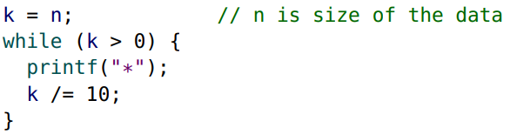
* 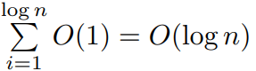
* When working with nested loops, evaluate the innermost loop first.
* 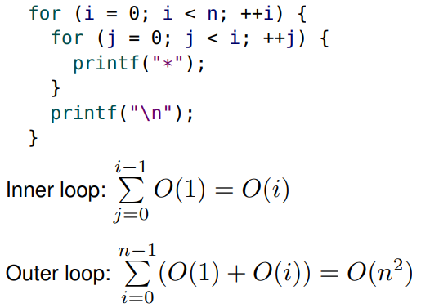

Recurrence relations

* To determine the running time of a recursive function we must determine the recurrence relation. For example,
* T(n) = O(n) + T(n − 1)
* We can then look up the recurrence relation in a table to determine the closed-form (non-recursive) running time.
* T(n) = O(n) + T(n − 1) = O(n^2)
* In later courses, you derive the closed-form solutions and prove their correctness.
* The recurrence relations we encounter in this course are:
* 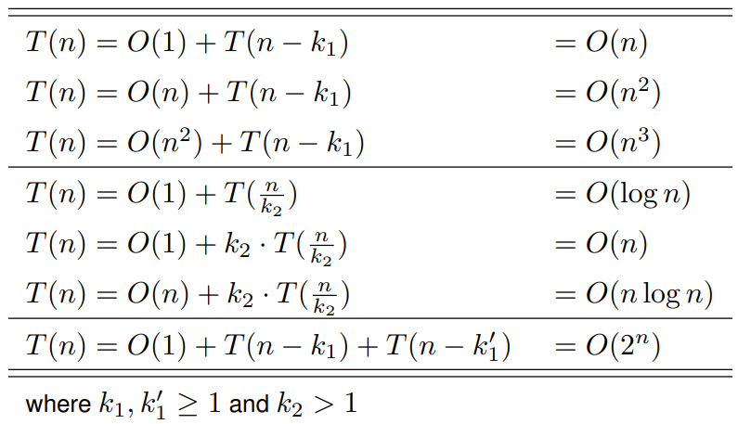
* This table will be provided on exams.

Procedure for recursive functions

* 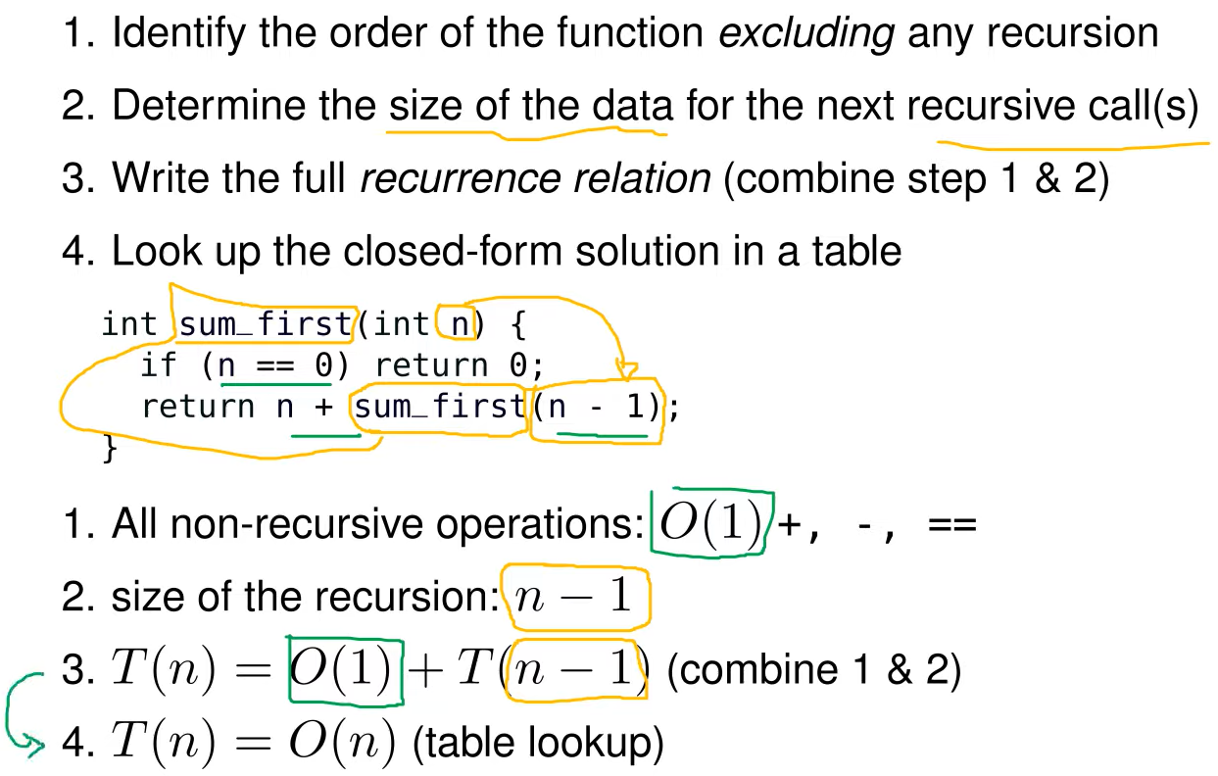

Revisiting sorting algorithms

* No introduction to efficiency is complete without a discussion of sorting algorithms.
* For simplicity, we only consider sorting numbers.
* When sorting strings or large data structures, include the time to compare each element.
* When analyzing sorting algorithms, one measure of running time is the number of comparisons.

Selection sort

* Recall our C implementation of selection sort:
* 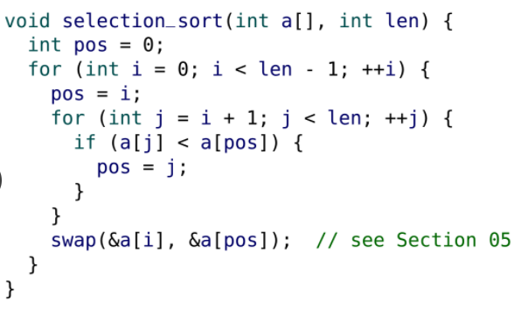
* 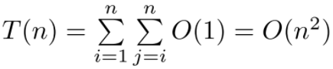
* The inner loop takes O(n-i) time but you’re doing that n times so it’s sigma from i = 1 to i = n of i which is O(n^2).
* It will always be an O(n^2) algorithm

Insertion sort

* The analysis for the worst case of insertion sort is also O(n^2).
* 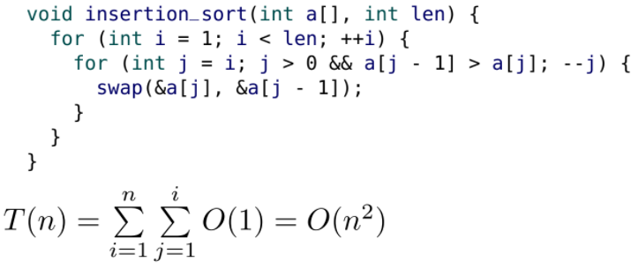
* The inner loop takes O(i) time but we are doing that n times so we get O(n^2)
* However, in the best case, the array is already sorted, and the inner loop terminates immediately. The best case running time is O(n).

Quick sort

* In our C implementation of quick sort, we:
* 1. select the first element of the array as our “pivot”. O(1)
* 2. move all elements that are larger than the pivot to the back of the array. O(n).
* 3. move (“swap”) the pivot into the correct position. O(1).
* 4. recursively sort the “smaller than” sub-array and the “larger than” sub-array. T(?). The time it takes to sort the left and right subarrays depend on where the pivot is.
* The analysis of step 4 is a little trickier.
* When the pivot is in “the middle” it splits the sublists equally, so T(n) = O(n) + 2T(n/2) = O(n log n)
* But that is the best case. In the worst case, the “pivot” is the smallest (or largest element), so one of the sublists is empty and the other is of size (n − 1). T(n) = O(n) + T(n-1) = O(n^2).
* Despite its worst case behaviour, quick sort is still popular and in widespread use. The average case behaviour is quite good and there are straightforward methods that can be used to improve the selection of the pivot. It is part of the C standard library (see Section 12).

Sorting summary

* 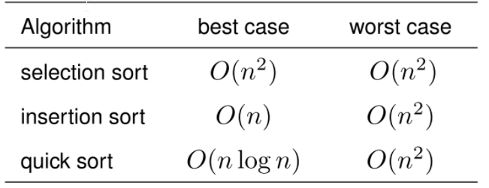
* From this table, it might appear that insertion sort is the best choice.
* However, as mentioned with quick sort, the “typical” or “average” case for quick sort of O(nlogn) is much better than insertion sort’s average case of O(n^2).
* In Section 10, we will see merge sort, which is O(n log n) in the worst case.

Binary Search

* In Section 07, we implemented binary search on a sorted array.
* 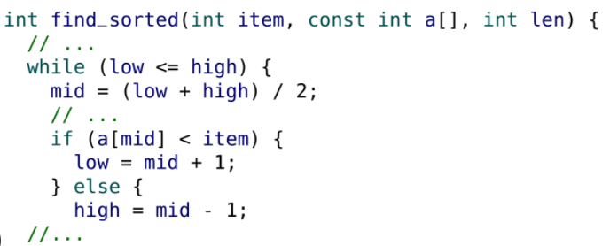
* In each iteration, the size of the search range (n = high-low) was halved, so the running time is:
* 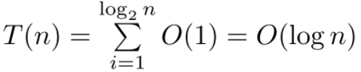

Algorithm Design

* In this introductory course, the algorithms we develop are mostly straightforward.
* To provide some insight into algorithm design, we introduce a problem that is simple to describe, but hard to solve efficiently.
* We present four different algorithms to solve this problem, each with a different running time.

The maximum subarray problem

* Problem: Given an array of integers, find the maximum sum of any contiguous sequence (subarray) of elements.
* For example, for the following array has a maximum sum of 187:
* 
* This problem has many applications, including pattern recognition in artificial intelligence. We can also think of these as stock prices that go up and down and this max subarray problem relates to when we should buy/sell a stock.
* Two trivial solutions are if all the numbers are positive (add them all up) or all negative (add none to have a max sum of 0)
* 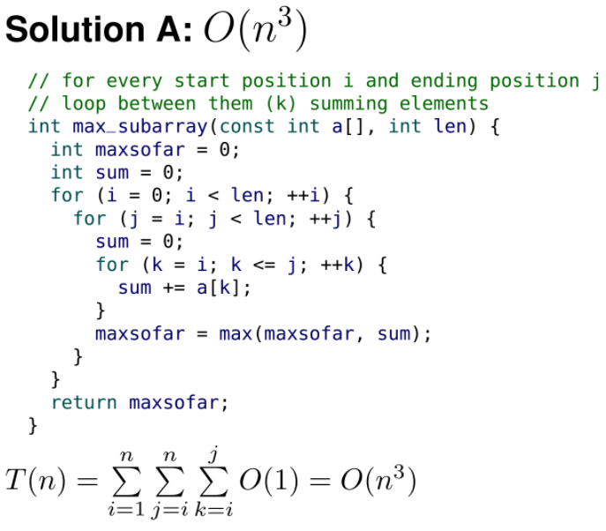
* The most inner sum results in O(j - i) time. We then do this (n - i) times because of the middle loop.
* 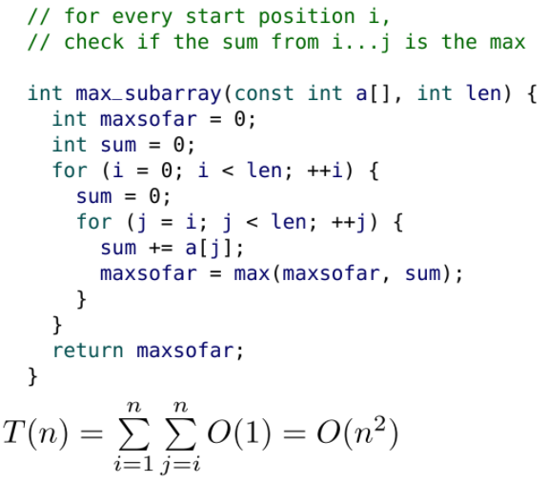
* 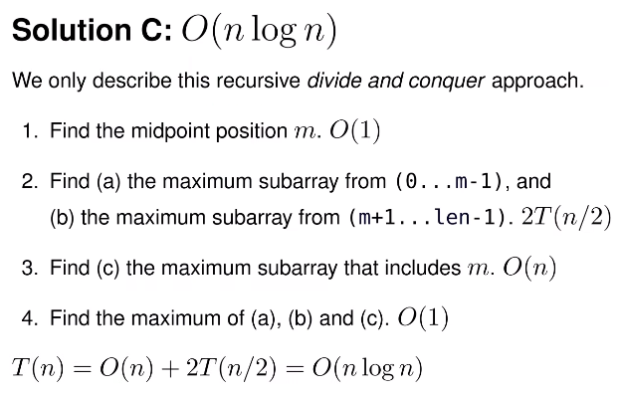
* <https://www.youtube.com/watch?v=u7YMFRUFqe0&t=5s>
* 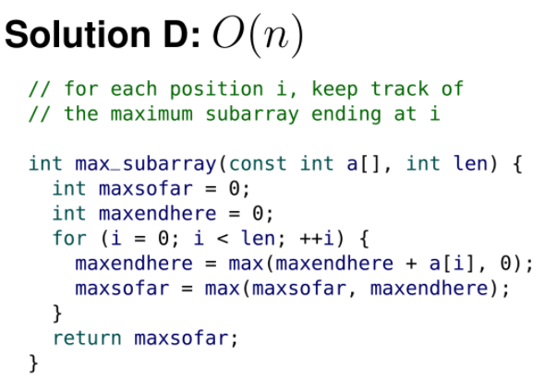
* In this introductory course, you are not expected to be able to come up with this solution yourself.

Big O revisited

* We now revisit Big O notation and define it more formally.
* O(g(n)) is the set of all functions whose “order” is less than or equal to g(n).
* 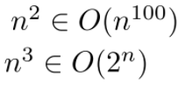
* n, 2n+3, 5n+7, are all in the set O(n)
* While you can say that n^2 is in the set O(n^100), it’s not very useful information.
* In this course, we always want the most appropriate order, or in other words, the smallest correct order.
* Big O describes the asymptotic behaviour of a function.
* This is different than describing the worst case behaviour of an algorithm.
* Many confuse these two topics but they are completely separate concepts. The best case and the worst case can both be described asymptotically.
* For example, the best case insertion sort is O(n), while the worst case is O(n^2).

**Section 9**

Strings

* There is no built-in C string type. The “convention” is that a C string is an array of characters, terminated by a null character.
* 
* The null character, also known as a null terminator, is a char with a value of zero. It is often written as '\0' instead of just 0 to improve communication and indicate that a null character is intended.
* '\0' is equivalent to 0. That is different from '0', which is equivalent to 48 (the ASCII character for the symbol zero). This null character is not a printable character.

String initialization

* The following definitions create equivalent 4-character arrays:
* 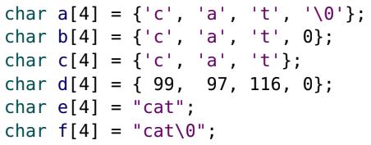
* Because they all have a null terminator, they are also strings.
* C supports an automatic length declaration ([]), where the length is determined by the initialization.
* 
* If you combine the automatic length declaration with double quote("), initialization, it adds the null terminator for you.
* 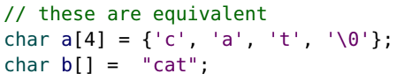
* C knows that the array b should be a string so it makes it an array of length 4 with the index-3 element being the null terminator which is automatically added.
* As we will explain later, the double quotes used in array initialization is different than the quotes used in expressions (e.g., in printf("string")).

Null termination

* When we pass arrays to functions, we normally have to pass the length of the array as well.
* With null terminated strings, we do not need to pass the length to functions. It is determined by the location of the '\0'.
* 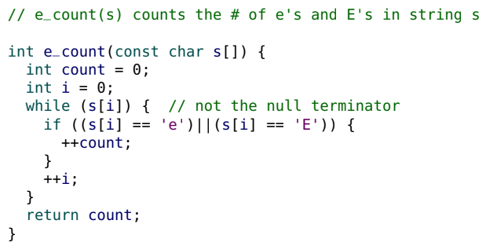
* Recall any non-zero value will be considered true. Thus, while(s[i]) only stops when we get to the null terminator since the null terminator has a value of 0. The other elements in s are characters and are not the null character so they will cause while(s[i]) to be true.
* It is good style to have const parameters to communicate that no changes (mutation) occurs to the string.

strlen

* The string library (#include <string.h>) provides many useful functions for processing strings (more on this library later).
* The strlen function returns the length of the string, not necessarily the length of the array. You could have an array with a length of 100, but if the 2nd character is a null terminator, then the length of the string would be 1.
* strlen does not include the null character.
* 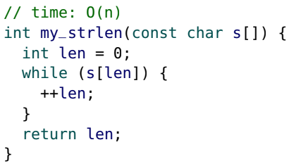
* Note checking the length takes linear time and not constant time like other languages.
* Here is an alternative implementation of my_strlen that uses pointer arithmetic.
* 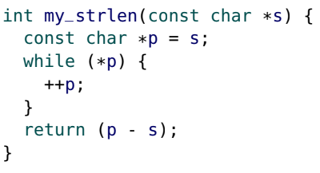
* Traditionally, string functions often used pointer notation. It is slightly faster than array index notation (s[i]), which requires an extra addition per iteration. In modern environments, the speedup is negligible.
* Do NOT put the strlen function within a loop unnecessarily.
* 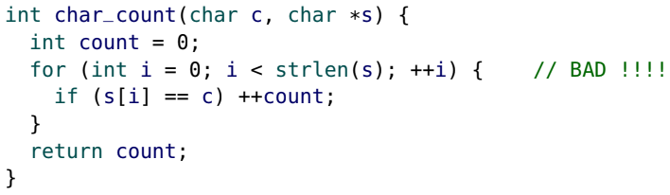
* By using an O(n) function (strlen) inside of the loop, the function becomes O(n^2) instead of O(n).
* To fix this, we could have a new variable to store the length of s and use the local variable in the condition of the for loop.
* Unfortunately, this mistake is common amongst beginners. This will be harshly penalized on assignments & exams.

Lexicographical order

* Characters can be easily compared (c1 < c2) as they are numbers, so the character order is determined by the ASCII table. For example, ‘c’ = 67 and ‘a’ = 65 and since 65 < 67, ‘a’ < ‘c’.
* If we try to compare two strings (s1 < s2), C compares their addresses (pointers), which is not helpful.
* To compare strings we are typically interested in using a lexicographical order.
* Strings require us to be more careful with our terminology, as “smaller than” and “greater than” are ambiguous: are we considering just the length of the string? To avoid this problem we use precedes (“before”) and follows (“after”).
* To compare two strings using a lexicographical order, we first compare the first character of each string. If they are different, the string with the smaller first character precedes the other string.
* Otherwise (the first characters are the same), the second characters are compared, and so on.
* If the end of one string is encountered, it precedes the other string. (This is because the null character at the end of the string will be compared to the character in the other string. The null character has an ASCII value of 0 which is the smallest so it always precedes (and possibly tie if the other character is also a null character which means the two strings have the same length)).
* Two strings are equal (the same) if they are the same length and all of their characters are identical.
* The following strings are in lexicographical order:
* 
* In this example, “cabin” precedes “cat” and “cat” follows “cabin” since despite the tie in the first two characters, ‘b’ < ‘t’.
* The <string.h> library function strcmp (abbreviated for string compare) uses lexicographical ordering.
* strcmp(s1, s2) returns zero if the strings are identical. If s1 precedes s2, it returns a negative integer. Otherwise (s1 follows s2) it returns a positive integer.
* 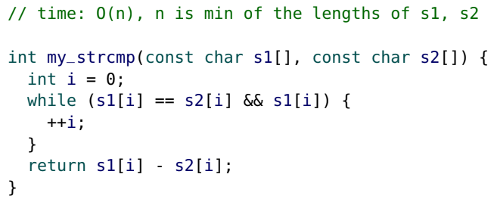
* Note we can use == to compare string elements (characters) as shown above with s1[i] == s2[i], but we cannot use == to compare strings since strings are pointers that have a memory address as its value so it would compare memory addresses.
* To compare if two strings are equal (identical), use the strcmp function and check for zero (false).
* char a[] = "the same?";
* char b[] = "the same?";
* char c[] = "different";
* trace_bool(strcmp(a, b) == 0);
* trace_bool(!strcmp(a, b));
* trace_bool(!strcmp(a, c));
* strcmp(a, b) == 0 => true
* !strcmp(a, b) => true
* !strcmp(a, c) => false
* Never use the equality operator (==) to compare strings. It compares the addresses of the strings, not their contents.
* To check if two strings a, b have identical contents, use !strcmp(a,b) since strcmp(a,b) will return 0 if a and b have equal contents. 0 is false so we negate it to be true.

String I/O

* The printf format specifier for strings is %s.
* 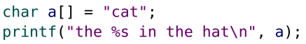
* printf prints out characters until the null character is encountered.
* printf does not print out the null character.
* When using %s with scanf, it stops reading the string when a whitespace character is encountered (e.g., a space or \n).
* scanf("%s", ...) is useful for reading in one “word” at a time.
* 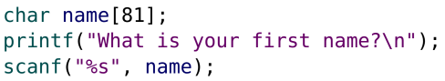
* Be very careful to reserve enough space for the string to be read in. For example, on assignments if we say strings are no longer than 80 characters, we should create an array of length 81 since we also have to account for the null terminator. Do not forget the null character.
* scanf("%s", ...) automatically adds the null character.
* The running time of printf and scanf with "%s" is O(n).
* 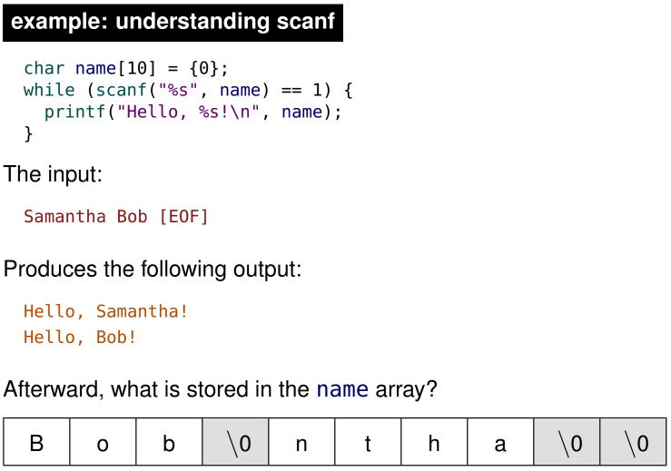
* Since the array name has length 10, we can store names up to length 9 since we have to account for the null terminator. We initialize name to be all 0’s as shown above with = {0}.
* Recall the return value of scanf is the number of things it successfully read in. Also recall we don’t do &name and just pass name into scanf since name itself is a memory address as arrays are just pointers that have a value of a memory address.
* (scanf("%s", name) == 1) reads in a string and stores the input in the character array name, and also checks that it read in 1 input successfully.
* Note when we first initialize the array, its contents are [0,0,0,0,0,0,0,0,0,\0]. (9 zero’s followed by null terminator)
* When we read in Samantha, name’s contents become [S,a,m,a,n,t,h,a,\0,\0]. Notice the input Samantha only affected the first 9 elements of the array, so the last element is unchanged and still left as \0.
* Similarly, when we read in Bob, name’s contents become [B,o,b,\0,n,t,h,a,\0,\0]. Notice the input Bob only affected the first 4 elements of the array, so the last 6 elements are unchanged.
* Since we are reusing the array, name, to store many names over and over, we could have garbage values as shown above.
* In the following example, the name array is 81 characters and can accommodate first names with a length of up to 80 characters.
* 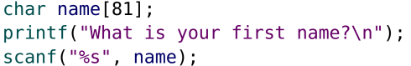
* What if someone has a really long first name (longer than 80 characters)?
* 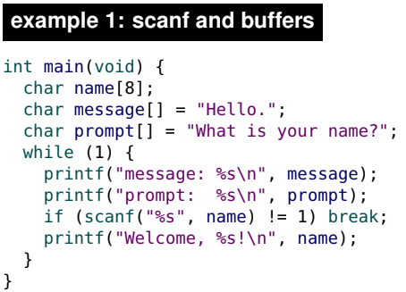
* In this above example, the array name only holds 8 elements which is very short. What happens if the input string is longer than or equal to 8 elements.
* A buffer is an array or area of memory that is used to store input and output. In this example, the array, name, is called a buffer.
* In this example, entering a long name causes C to write characters beyond the length of the name array. This is because C doesn’t know when the end of the array is. It’ll just go to the next memory address and write in it.
* If the long name is long enough, it will eventually overwrite the memory where message is stored, and if long enough, where prompt is stored.
* In this introductory course, having an array with an appropriate length and using scanf is “good enough”.
* In practice you would never use this insecure method for reading in a string.
* 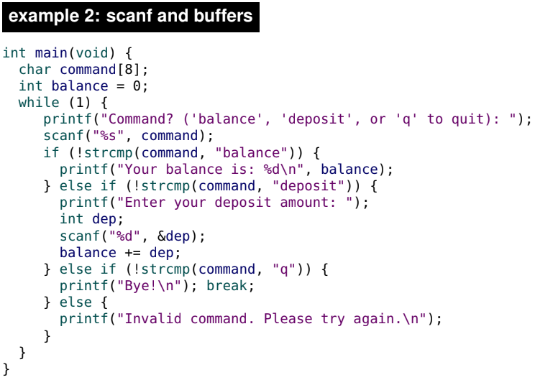
* In this banking example, entering a long command causes C to write characters beyond the length of the command array. Eventually, it overwrites the memory where balance is stored.
* It writes four chars into the four bytes where balance is stored. The value of balance is a “re-interpretation” of those four bytes as an int, instead of four chars.
* 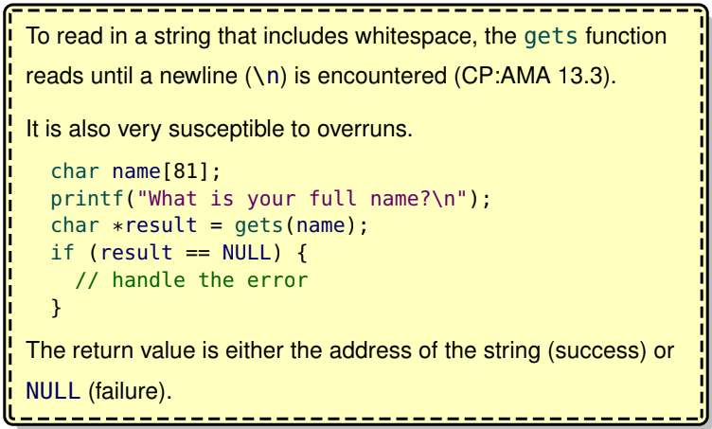
* 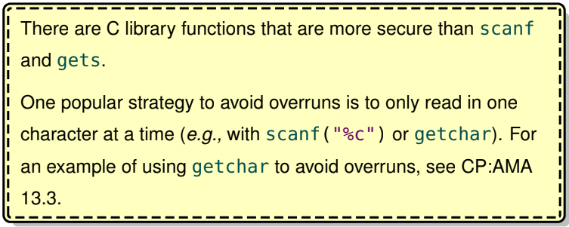
* While writing to a buffer can cause dangerous buffer overruns, reading from an improperly terminated string can also cause problems.
* 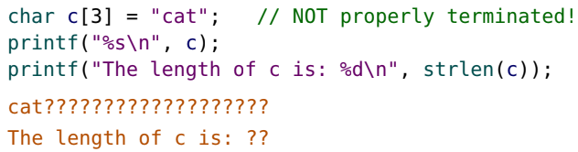
* Notice c[3] means it should hold 3 elements including the null terminator. Thus, if we try to print the array c, C will keep printing the next thing in memory (random garbage) until it hits a 0 which is the value of the null terminator.
* 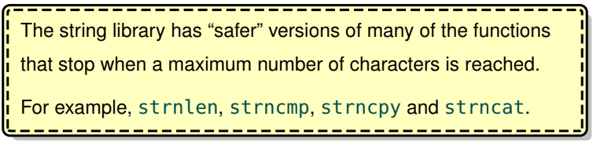

strcpy

* The strcpy(dest, src) function (part of <string.h>) overwrites the contents of dest (up to an including the null terminator) with the contents of src.
* strcopy is short for string copy
* Dest should be equal in length or longer than src
* 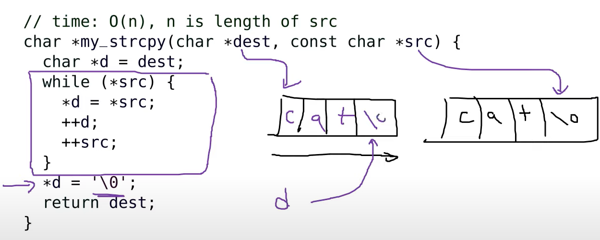
* For historical reasons, the return value of strcpy is the address of dest. This is not useful and typically ignored.
* strcpy can be a source of buffer overrun: always ensure that the dest array is large enough (and don’t forget the null terminator).
* strcpy can also cause problems if the dest and src regions overlap.
* Consider this dangerous call:

char s[9] = "spam";

my_strcpy(s + 4, s);

* The null terminator of src is overwritten, so it will continue to fill up
* memory with spamspamspam... until a crash occurs.

strcat

* strcat(dest, src) is similar to strcpy, except it copies (appends or concatenates) src to the end of dest.
* strcopy is short for string concatenate
* 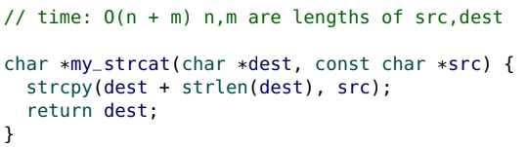
* It takes O(n) time to find strlen(dest) and O(m) time to copy the contents of src and append to dest
* Again, ensure that the dest array is large enough.

String literals

* C strings in quotations (e.g., "string") that are in an expression (i.e., not part of an array initialization) are known as string literals.
* 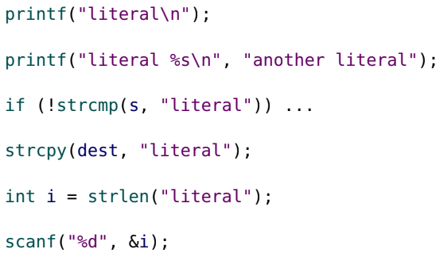
* We know how arrays and strings are stored in memory, printf(“literal\n”) seems a bit odd. Normally, when we try to use an array in an expression, the memory address of the array is used. Thus, a string is not normally passed into printf, but rather an address of a string is passed to printf. So why can we have a string and not a memory address of a string passed to printf as shown above. Basically, we want to know where the string literals are stored since they need to be stored in memory somewhere.

String literal storage

* Where are string literals stored?
* For each string literal, a null-terminated const char array is created in the read-only data section.
* In the code, the occurrence of the string literal is replaced with the address of the corresponding array.
* The “read-only” section is also known as the “literal pool” since oftentimes, the things that end up in the ‘read-only’ section are string literals or integer literals.
* 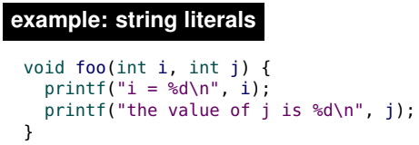
* Notice we have two string literals in the code above “i = %d\n” and “the value of j is %d\n”.
* Although no name is actually given to each literal, it is helpful to imagine that one is:
* 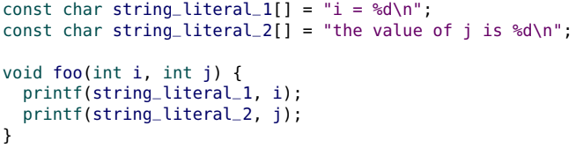
* Notice it has the effect of replacing the string literally with the memory address of the const character array that has contents which are the string literal. This is what happens behind the scenes whenever we use string literals.
* Do not try to modify a string literal. The behaviour is undefined, and it causes an error in Seashell.
* Note the subtle difference between the following two definitions:
* 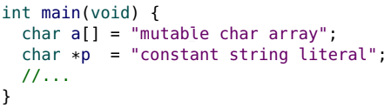
* Once again, it is helpful to think of the string literal as a separately defined const char array.
* 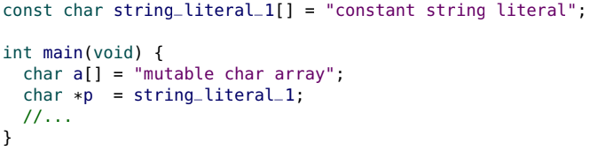
* a is stored in the stack frame while string_literal_1 is stored in the read-only section of memory.

Arrays vs. pointers

* Earlier, we said arrays and pointers are similar but different.
* Consider again two similar string definitions:
* 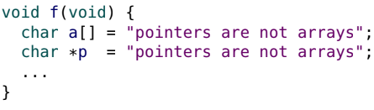
* The first reserves space for an initialized 24 character array (a) in the stack frame (24 bytes).
* The second reserves space for a char pointer (p) in the stack frame (8 bytes), initialized to point at a string literal (const char array) created in the read-only data section.
* The stack frame might look something as shown below
* 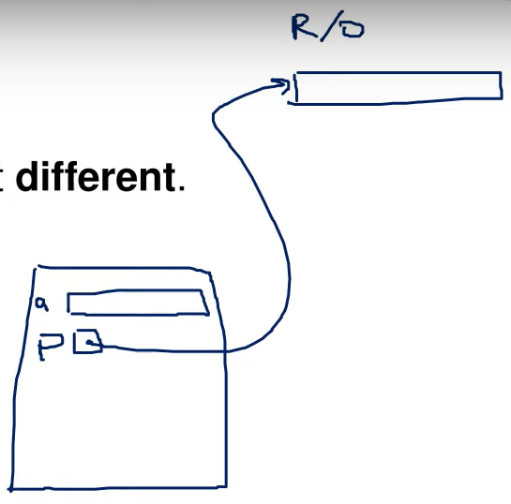
* Note: when arrays and pointers are passed as parameters into a function, they are equivalent. However, when they are defined as variables, they are different.
* 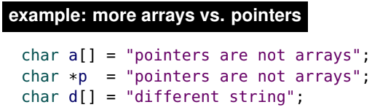
* a is a char array. The identifier a has a constant value (the address of the array), but the elements of a can be changed.
* 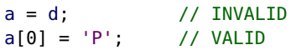
* p is a char pointer. p is initialized to point at a string literal, but p can be changed to point at any char.
* 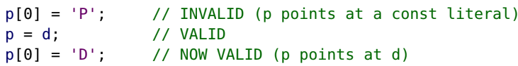
* 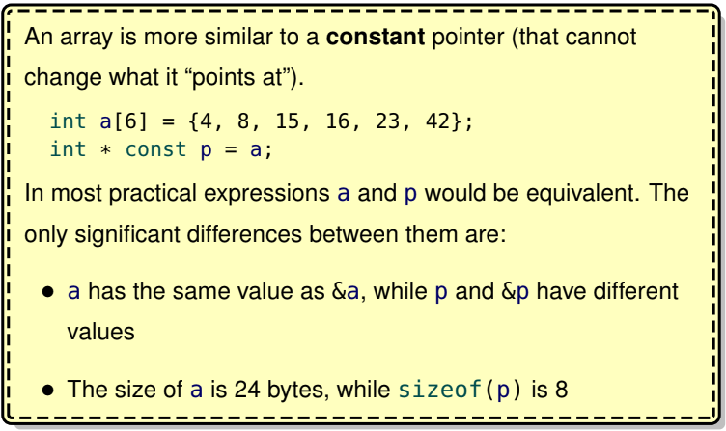

Arrays of Strings

* An array of strings can be defined as a 2D array of chars, but this approach is awkward and rarely used.
* Instead, an array of pointers is more common.
* 
* In the above example, aos is an array of pointers, with each pointer pointing to a string literal.
* Even though it is not a “proper” 2D array, any char can be accessed as if it was in a 2D array of chars.
* For example, aos[0][1] is (aos[0])[1], which is 'y'.
* 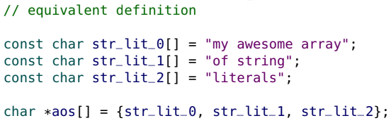
* This array of pointers can be passed to a function, but as with all arrays, also pass the array length:
* 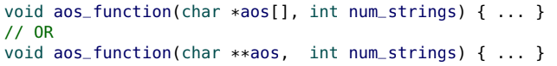
* For complicated technical reasons, do not worry about adding const to parameters/definitions that are arrays of pointers.
* Until we learn how to use dynamic memory, defining an array of mutable strings is a little more awkward.
* Define each mutable string separately.
* 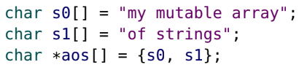
* 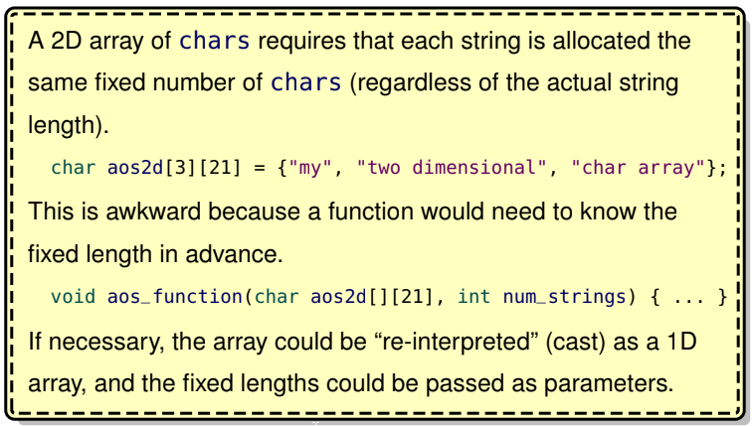

**Section 10**

The heap

* The heap is the final section in the C memory model.
* It can be thought of as a big “pile” (or “pool”) of memory that is available to a program.
* Memory is allocated from the heap upon request.
* This memory is “borrowed”, and can be “returned” (“freed”) back to the heap when it is no longer needed (deallocation).
* Returned memory may be reused (“recycled”) for a future allocation.
* If too much memory has already been allocated, attempts to borrow additional memory fail.

Advantages of heap-allocated memory

* Dynamic: The allocation size can be determined at run time (while the program is running).
* Resizable: A heap allocation can be “resized”.
* Duration: Heap allocations persist until they are “freed”. A function can create a data structure (one or more allocations) that continues to exist after the function returns.
* Safety: If memory runs out, it can be detected and handled properly (unlike stack overflows)
* 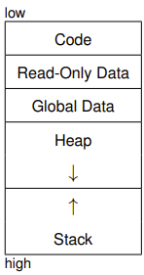
* Stacks start at very high memory addresses and heaps start at very low memory addresses. Heaps grow towards higher memory addresses and stacks grow towards lower memory addresses. By starting the stack with very high memory addresses and heaps with very low memory addresses, it is less likely their memory collides.
* Unfortunately, there is also a data structure known as a heap, and the two are unrelated. To avoid confusion, prominent computer scientist Donald Knuth campaigned to use the name “free store” or the “memory pool”, but the name “heap” has stuck. A similar problem arises with “the stack” region of memory because there is also a Stack ADT. However, their behaviour is very similar so it is far less confusing.

malloc

* The malloc (memory allocation) function obtains memory from the
* heap. It is provided in <stdlib.h>.
* 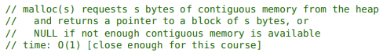
* For example, for an array of 100 ints:
* 
* or a single struct posn:
* 
* These two examples illustrate the most common use of dynamic memory: allocating space for arrays and structures.

Uninitialized

* The heap memory provided by malloc is uninitialized
* 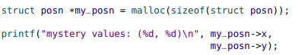

Dynamic Arrays

* With pointer notation, the syntax for accessing a heap array is nearly identical to the syntax for a stack (or global) array.
* int *my_array = malloc(n * sizeof(int));
* // initialize the array

for (int i = 0; i < n; ++i) {

my_array[i] = 0;

}

* We could use malloc(n * 4), but malloc(n * sizeof(int)) is clearer and better style.
* Strictly speaking, the type of the malloc parameter is size_t, which is a special type produced by the sizeof operator. size_t and int are different types of integers.
* The declaration for the malloc function is: void *malloc(size_t s);
* The return type is a (void *) (void pointer), a special pointer that can point at any type.
* int *my_array = malloc(100 * sizeof(int));
* struct posn *my_posn = malloc(sizeof(struct posn));
* For this course, we assume malloc is O(1).
* In practice, the constant time may be quite large.
* In addition, the running time for malloc depends on the state of the heap.
* After multiple allocations and deallocations, the heap can become fragmented, which may affect the performace of malloc.
* This is one of the disadvantages of heap memory.

example: visualizing the heap

* 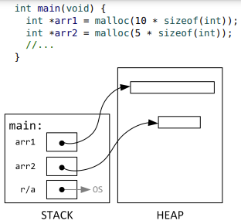
* Note that there are no labels in the heap. arr1 is a pointer that exists in the stack and points to a memory location in the heap.

Out of memory

* An unsuccessful call to malloc returns NULL.
* In practice it’s good style to check every malloc return value and gracefully handle a NULL instead of crashing.
* 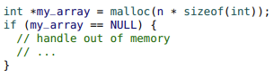
* In the “real world” you should always perform this check, but in this course, you do not have to check for a NULL return value unless instructed otherwise. In these notes, we omit this check to save space.

free

* Every block of memory obtained through malloc must eventually be freed (when the memory is no longer in use)
* 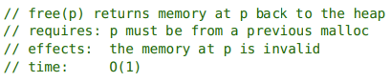
* In the Seashell environment, every block must be freed, otherwise there will be an error.
* int *my_array = malloc(n * sizeof(int));
* // ...
* // ...
* free(my_array);’

Dangling pointers

* Once a block of memory is freed, accessing that memory is invalid and may cause errors (or unpredictable results).
* Consider this example:

int *my_array = malloc(10 * sizeof(int));

free(my_array);

* The memory my_array is pointing at has been freed and is now invalid, but my_array is still pointing at it.
* free(my_array) does not modify the pointer my_array.
* A pointer to a freed allocation is known as a “dangling pointer”. It is often good style to assign NULL to a dangling pointer.

Invalid behaviour with free

* It is invalid to free memory that was not returned by a malloc or that has already been freed. free(NULL) is okay and simply ignored.
* 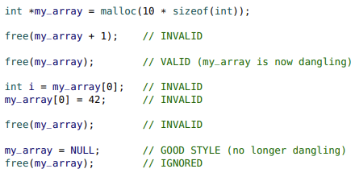
* Note above that free(my_array + 1) is invalid. my_array + 1 points to the memory address of the second element in the array. Even though that memory address is also in the heap, it wasn’t returned as a previous malloc so it is invalid it free it.
* Note that int i = my_array[0] and the line below are invalid. This is because we freed the memory that my_array used so the memory is now invalid. Since my_array is invalid, trying to access/assign elements will also be invalid.
* We also cannot free my_array again. Thus, don’t just write free(my_array) in the program over and over thinking it’ll make things better. Instead, defined the dangling pointer to NULL and then free it as shown in the last 2 lines.

Memory leaks

* A memory leak occurs when allocated memory is not eventually freed.
* Programs that leak memory may suffer degraded performance or eventually crash.

int *my_array = NULL;

my_array = malloc(10 * sizeof(int));

my_array = malloc(10 * sizeof(int)); // Memory Leak!

* In this example, the address from the original malloc has been overwritten.
* That memory is now “lost” (or leaked) and so it can never be freed

Garbage collection

* Many modern languages (including Racket) have a garbage collector.
* A garbage collector detects when memory is no longer in use and automatically frees memory and returns it to the heap.
* One disadvantage of a garbage collector is that it can be slow and affect performance, which is a concern in high performance computing.
* C does not have a garbage collector, so you will have to ensure your programs have no memory leaks.

Merge Sort

* In merge sort, the array is split (in half) into two separate arrays.
* The two arrays are sorted and then they are merged back together into the original array.
* This is another example of a divide and conquer algorithm.
* The arrays are divided into two smaller problems, which are then sorted (conquered). The results are combined to solve the original problem.
* To simplify our implementation, we use a merge helper function.
* 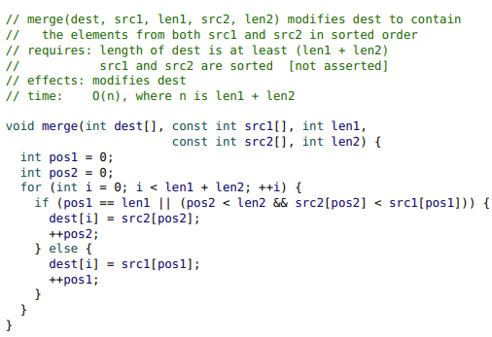
* 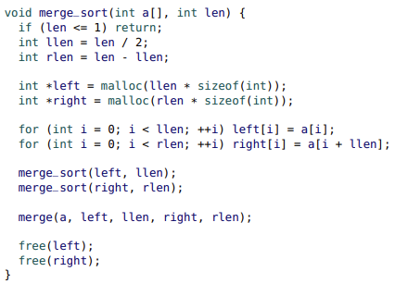
* Merge sort is O(n log n) even in the worst case

Duration

* A significant advantage of dynamic memory is that a function can obtain memory that persists after the function has returned.
* 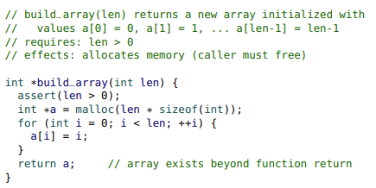

Dynamic memory side effect

* Allocating (and deallocating) memory has a side effect: it modifies the “state” of the heap.
* A function that allocates persistent memory (i.e., not freed) has a side effect and must be documented.
* The caller (client) is responsible for freeing the memory (communicate this).
* 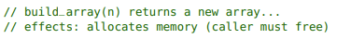
* A function could also free memory it did not allocate.
* That would also be a side effect:
* 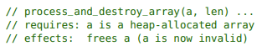
* 
* example: strdup
  + The strdup function makes a duplicate (copy) of a string.
  + 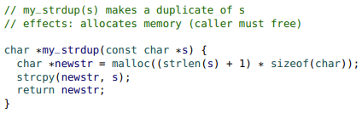
  + Recall that the strcpy(dest, src) copies the characters from src to dest, and that the dest array must be large enough.
  + When allocating memory for strings, don’t forget to include space for the null terminator.

Resizing arrays

* Because malloc requires the size of the block of memory to be allocated, it does not seem to solve the problem: “What if we do not know the length of an array at allocation time?”
* To solve this problem, we can resize an array by:
  + • creating a new array
  + • copying the items from the old to the new array
  + • freeing the old array
* Ex: resizing an array
* 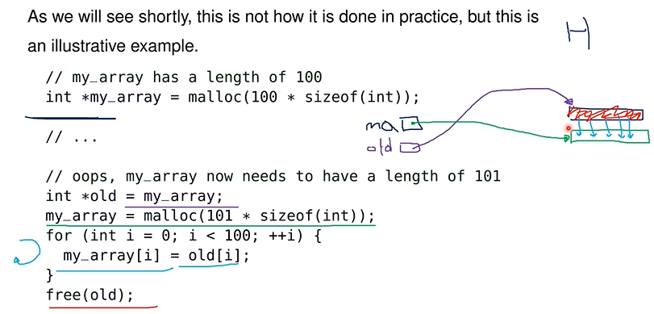

realloc

* To make resizing arrays easier, there is a realloc function
* 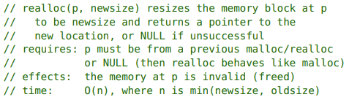
* Similar to our previous example, realloc preserves the contents from the old array location.
* 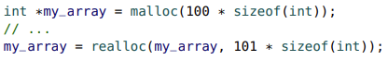
* If my_array in the argument in line 2 was null, then line 2 would be the same as doing malloc instead of realloc
* If the newsize is less than the oldsize, we’ll copy just up to the newsize (just the front of the old memory block)
* The pointer returned by realloc may actually be the original pointer, depending on the circumstances (when there is space available right after)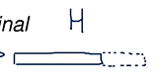
* Regardless, after realloc only the new returned pointer can be used.
* Thus, assume that the address passed to realloc was freed and is now invalid.
* Always think of realloc as a malloc, a “copy”, then a free. (malloc to create a new array, copy the items from the old array into the newly malloc’ed array, and then free the old array)
* Typically, realloc is used to request a larger size and the additional memory is uninitialized.
* If the size is smaller, the extraneous memory is discarded
* Be careful using realloc inside of a helper function
* 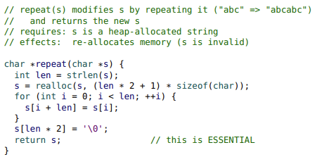
* Not we need to use repeat in this way: x = repeat(x);
* A common mistake is to make repeat a void function (not return the new address for s).
* If the address of s (local to the repeat function frame) is not returned, it can never be accessed which leads to a memory leak.
* As well, the variable that was passed as a parameter to repeat (exists on another frame, main frame) would become a dangling variable since in the repeat function, we made its memory address invalid.
* 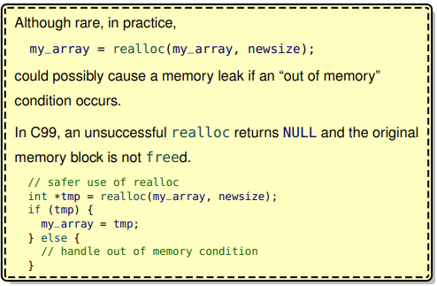

String I/O: strings of unknown length

* In Section 07 we saw how reading in strings can be susceptible to buffer overruns.

char str[81];

int retval = scanf("%s", str);

* The target array is often oversized to ensure there is capacity to store the string. Unfortunately, regardless of the length of the array, a buffer overrun may occur.
* To solve this problem we can continuously resize (realloc) an array while reading in only one character at a time.
* 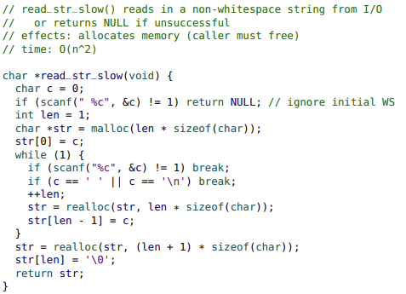
* If we also check malloc and realloc to make sure available memory exists, this function will be bulletproof.
* However, it’s slow.

Improving the efficiency

* Unfortunately, the running time of read_str_slow is O(n^2), where n is the length of the string.
* This is because realloc is O(n) and occurs inside of the loop.
* A better approach might be to allocate more memory than necessary and only call realloc when the array is “full”.
* A popular strategy is to double the length of the array when it is full. Similar to working with oversized arrays, we need to keep track of the “actual” length in addition to the allocated length.
* 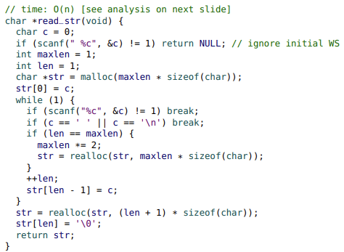
* With our “doubling” strategy, most iterations are O(1), unless it is necessary to resize (realloc) the array.
* The resizing time for the first 32 iterations would be:
* 1,2,0,4,0,0,0,8,0,0,0,0,0,0,0,16,0,0,0,0,0,0,0,0,0,0,0,0,0,0,0,32
* 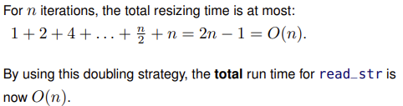

Reading in an array of strings

* In Section 09, we discussed how an array of strings is often stored as an array of pointers (of type char **).
* The following example repeatedly calls read_str to generate an array of strings.
* 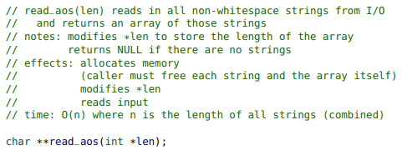
* Note that each string is a char pointer. So an array of strings is a pointer to the first string in the array. Thus the array of strings is a pointer to a char pointer so it has the type (char **)
* 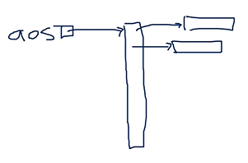
* 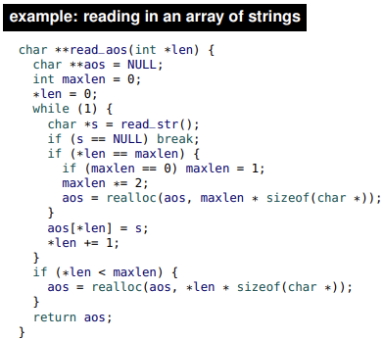
* The read_aos function uses the array doubling strategy on the array of pointers.
* Each element in the array (e.g., aos[i]) is a pointer to a string.
* To properly free the array of strings, each string must be freed in addition to the array itself.
* 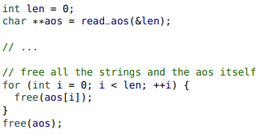

ADTs in C

* With dynamic memory, we now have the ability to implement an Abstract Data Type (ADT) in C.
* In Section 06, the first ADT we saw was a simple stopwatch ADT. It demonstrated information hiding, which provides both security and flexibility.
* It used an opaque structure, which meant that the client could not create a stopwatch.
* 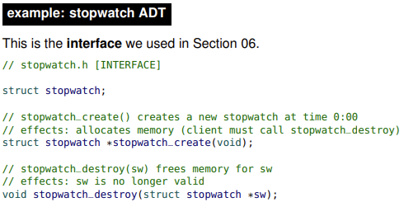
* Now, we know that the stopwatch_create used malloc and stopwatch_destroy used free
* We can now complete our implementation.
* 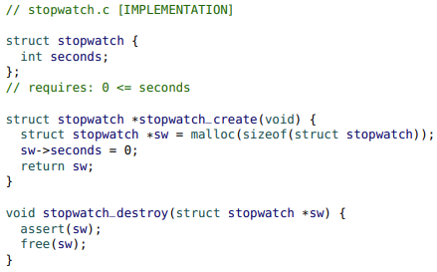

Implementing a Stack ADT

* As discussed in Section 06, the stopwatch ADT illustrates the principles of an ADT, but it is not a typical ADT.
* The Stack ADT (one of the Collection ADTs) is more representative.
* The interface is nearly identical to the stack implementation from Section 07 that demonstrated oversized arrays.
* The only differences are: it uses an opaque structure, it provides create and destroy functions, and there is no maximum: it can store an arbitrary number of integers.
* 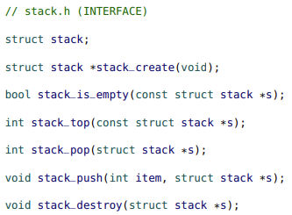
* The Stack ADT uses the “doubling” strategy.
* 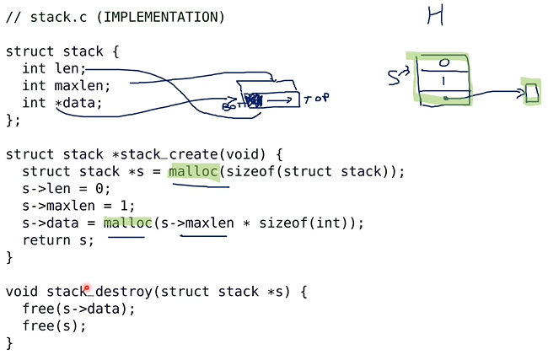
* Note when we free, we have toe free s->data first since if we free s first, we have the location of s->data so it cannot be freed
* Most of the operations are identical to the oversized array implementation.
* The doubling strategy is implemented in push.
* 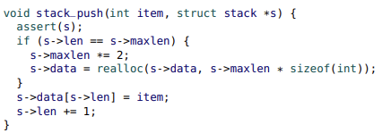
* What is the running time of a single call to stack_push?
* 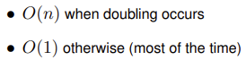

Amortized analysis

* To understand amortized analysis, we first consider a more abstract example than stack_push.
* Homer wants to do some “push-ups” to get some exercise.
* His strategy is that on day k, when k is a power of 2, he will do k push-ups. He will then skip (k − 1) days until it is another power of 2.
* So the number of push-ups Homer does on the first 31 days is:
* 1,2,0,4,0,0,0,8,0,0,0,0,0,0,0,16,0,0,0,0,0,0,0,0,0,0,0,0,0,0,0
* After 31 days, he has done exactly 31 push-ups. So, on average, he is doing one push-up per day.
* The analysis for stack_push is very similar.
* Ignoring any pop operations, the total time for n calls to stack_push is O(n).
* The amortized (“average”) time for each call is: O(n)/n = O(1).
* In other words, we can say that the amortized running time of stack_push is O(1).
* 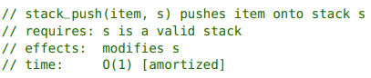
* 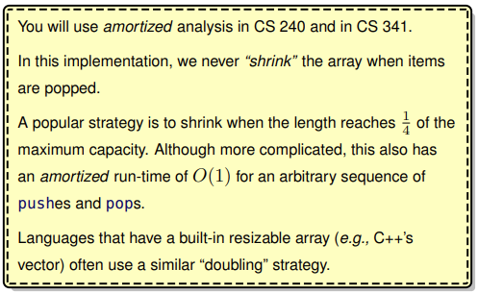

**Section 11**

Linked Lists

* Racket’s list type is more commonly known as a linked list.
* 
* Each node contains an item and a link (pointer) to the next node in the list
* In C, the link in the last node is NULL pointer.
* Linked lists are usually represented as a structure that contains a link (pointer) to the front node.
* 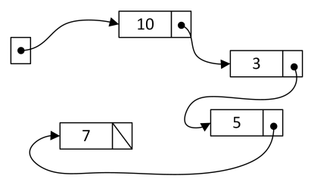
* Unlike arrays, linked list nodes are not arranged sequentially in memory. There is no fast and convenient way to “jump” to the i-th element. The list must be traversed from the front. Traversing a linked list is O(n)
* A significant advantage of a linked list is that its length can easily change, and the length does not need to be known in advance.
* The memory for each node is allocated dynamically

Structure definitions

* A llist points to the front node (which is NULL for an empty list).
* Each llnode stores an item and a link (pointer) to the next node (which is NULL for the last node).
* 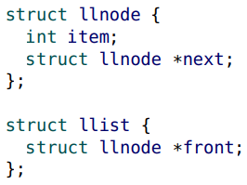
* llnode is a recursive data structure (it has a pointer to its own structure type). llist is not recursive
* There is no “official” way of naming or implementing a linked list node in C.
* The structure we present here is often called a “wrapper strategy”, because the llist structure “wraps” around the front of the list.

Creating a linked list

* 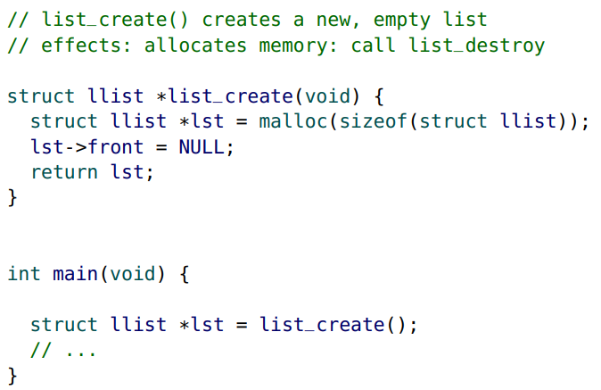

Adding to the front

* 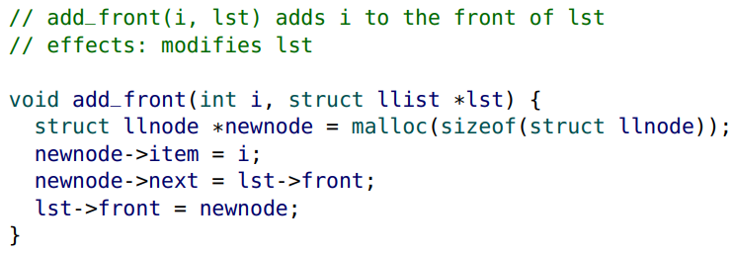
* 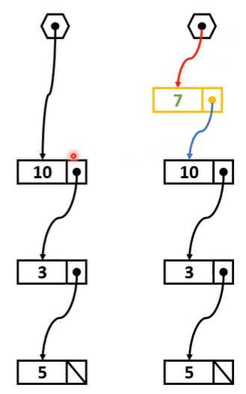
* Notice the colors above correspond to the following changes in the code
* 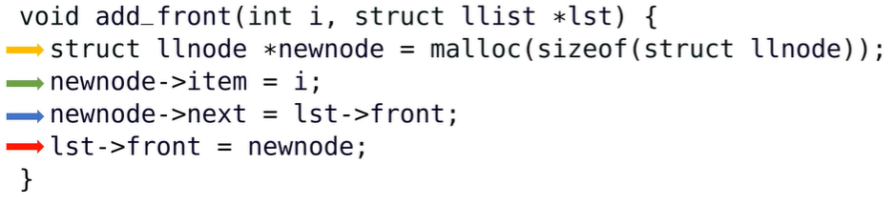
* We could also add “allocates memory” as a side effect, but since most linked list functions use dynamic memory it becomes redundant. In addition, it is not necessarily memory that the client needs to worry about free-ing. Specifying that it modifies the list is sufficient.

Traversing a list

* We can traverse a list iteratively or recursively.
* When iterating through a list, we typically use a (llnode) pointer to keep track of the “current” node.
* 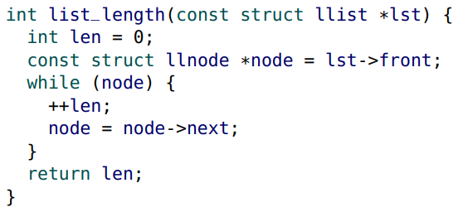
* Recall that NULL returns a value of false so while(node) returns true if node is not NULL and false if the node is NULL. Note that the structure itself is not null, but the pointer to that struct is a null pointer.
* When using recursion, remember to recurse on a node (llnode) not the list (llist).
* Typically, there is a simple function that “unwraps” the llist, which then calls a core function that recurses on llnodes.
* 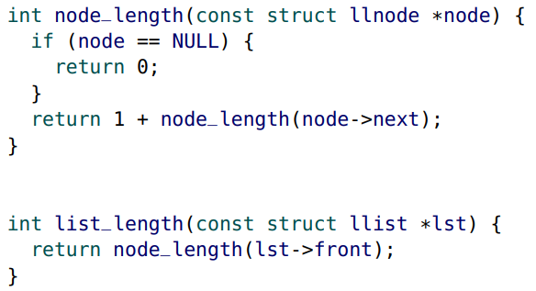

Destroying a list

* In C, we don’t have a garbage collector, so we must be able to free our linked list. We need to free every node and the list itself.
* When using an iterative approach, we are going to need two node pointers to ensure that the nodes are freed in a safe way.
* 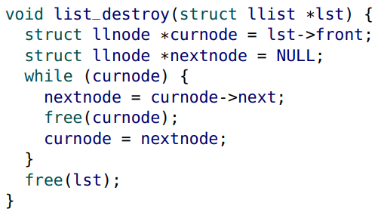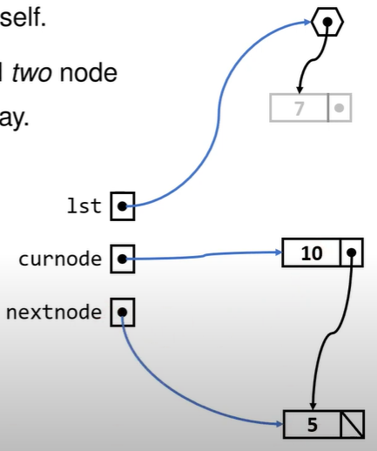
* With a recursive approach, it is more convenient to free the rest of the list before we free the current node.
* 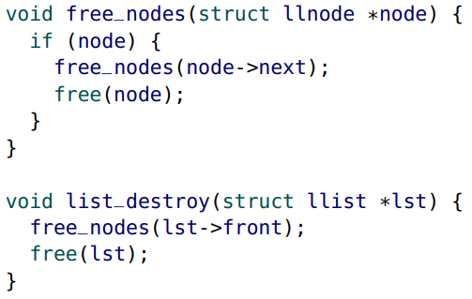

Duplicating a list

* Recursive solution:
* 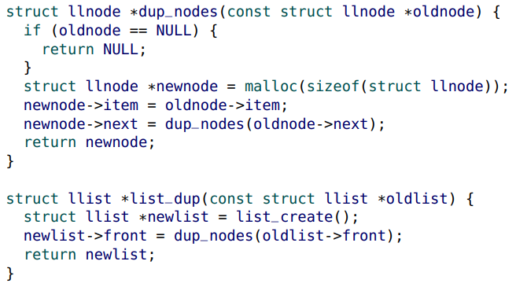
* Iterative solution:
* 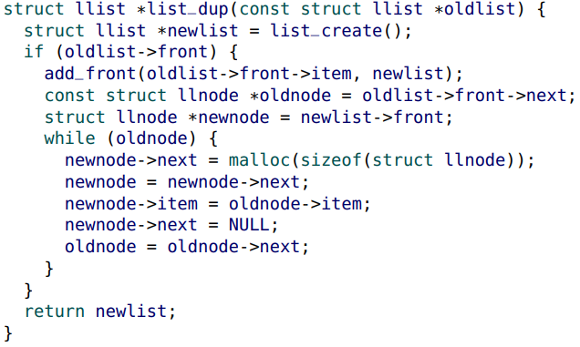

insert into the “middle” of sorted llist

* When inserting into the “middle”, we need to find the node that will be before the new node we are inserting.
* 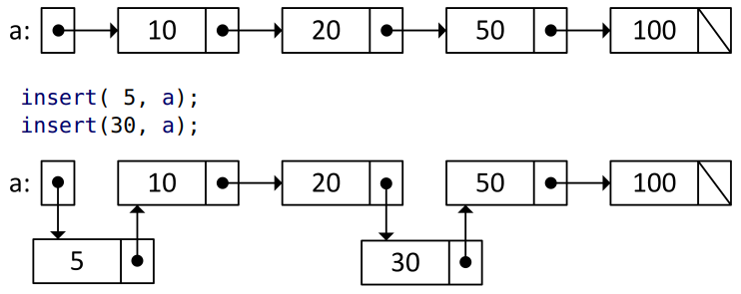
* 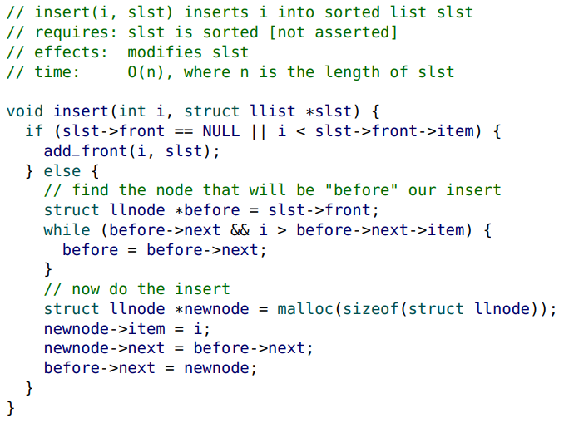

Removing nodes

* When removing nodes, make sure you do not create a memory leak.
* 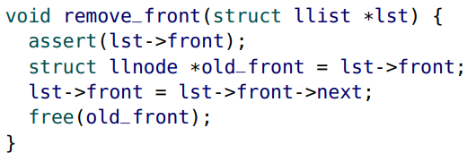
* 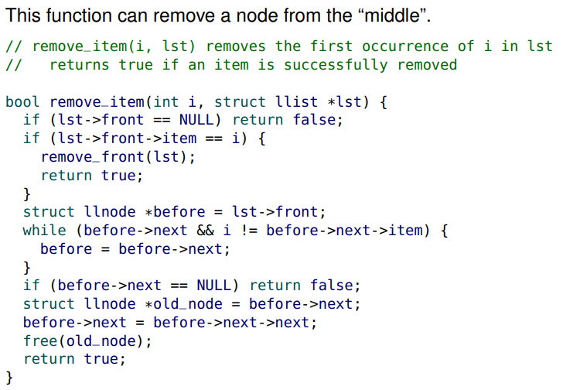

Caching information

* Consider that we are writing an application where the length of a linked list will be queried often.
* Typically, finding the length of a linked list is O(n).
* However, we can store (or “cache”) the length in the llist structure, so the length can be retrieved in O(1) time
* 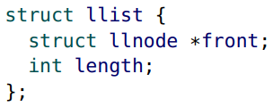
* Naturally, other list functions would have to update the length as necessary
  + • list_create would initialize length to zero
  + • add_front would increment length
  + • remove_front would decrement length
  + • etc.

Data integrity

* The introduction of the length field to the linked list may seem like a great idea to improve efficiency.
* However, it introduces new ways that the structure can be corrupted.
* What if the length field does not accurately reflect the true length?
* For example, imagine that someone implements the remove_item function, but forgets to update the length field?
* Or a naïve coder may think that the following statement removes all of the nodes from the list.
* 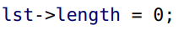
* Whenever the same information is stored in more than one way, it is susceptible to integrity (consistency) issues
* Advanced testing methods can often find these types of errors.
* If data integrity is an issue, it is often better to repackage the data structure as a separate ADT module and only provide interface functions to the client.
* This is an example of security (protecting the client from them messing up the date themselves).

Queue ADT

* A queue is like a “lineup”, where new items go to the “back” of the line, and the items are removed from the “front” of the line. While a stack is LIFO, a queue is FIFO (first in, first out).
* Typical queue ADT operations:
  + • add_back: adds an item to the end of the queue
  + • remove_front: removes the item at the front of the queue
  + • front: returns the item at the front
  + • is_empty: determines if the queue is empty
* A Stack ADT can be easily implemented using a dynamic array (as we did in Section 10) or with a linked list.
* While it is possible to implement a Queue ADT with a dynamic array, the implementation is a bit tricky. Queues are typically implemented with linked lists.
* The only efficiency concern with a linked list implementation is that an add_back operation is normally O(n).
* However, if we maintain a pointer to the back (last element) of the list, in addition to a pointer to the front of the list, we can implement add_back in O(1). The back of the queue is the front of the linked list.
* 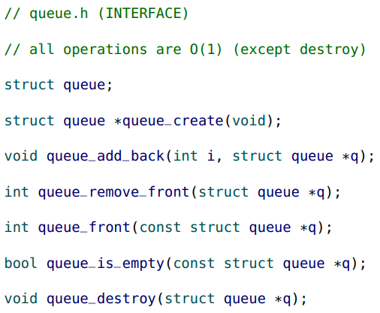
* 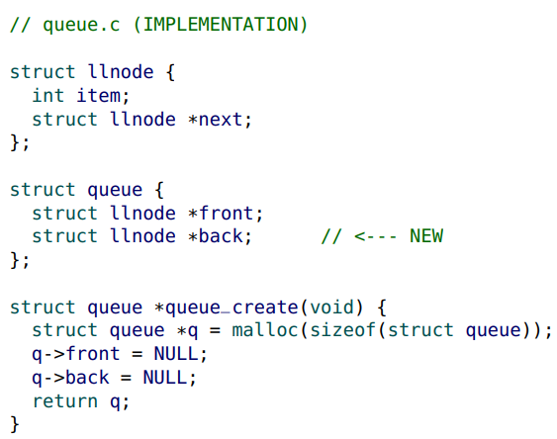
* For an empty queue, both the front and back are NULL
* 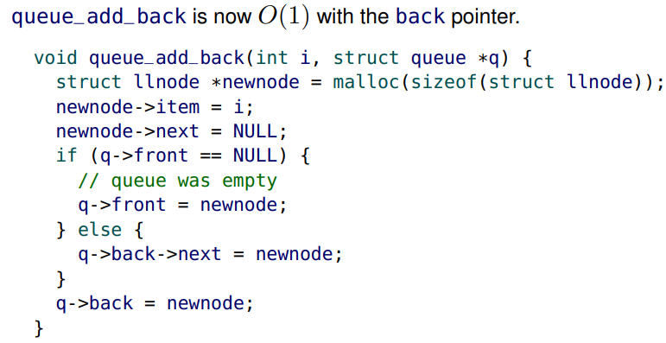
* Common mistake: forgetting to update the front pointer when adding to an empty queue.
* 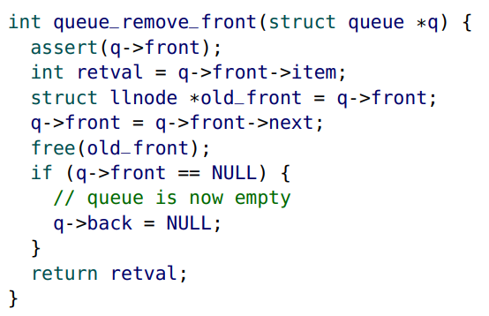
* Common mistake: forgetting to store the return value (retval above) before freeing the node.
* The remainder of the Queue ADT is straightforward
* 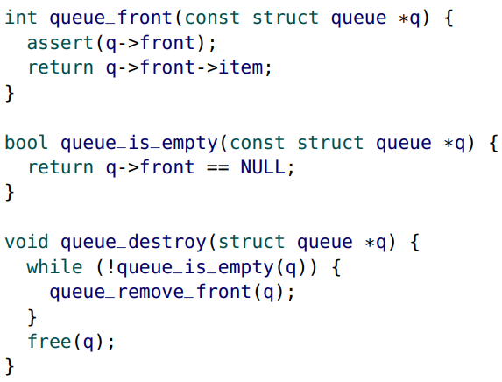

Node augmentation strategy

* In a node augmentation strategy, each node is augmented to include additional information about the node or the structure.
* For example, a dictionary node can contain both a key (item) and a corresponding value.
* Or for a priority queue, each node can additionally store the priority of the item.
* A common node augmentation for a linked list is to create a doubly linked list, where each node also contains a pointer to the previous node. When combined with a back pointer, a doubly linked list can add or remove from the front and back in O(1) time
* 
* Many programming environments provide a Double-Ended Queue (dequeue or deque) ADT, which can be used as a Stack or a Queue ADT.

Trees

* At the implementation level, trees are very similar to linked lists.
* Each node can link to more than one node
* 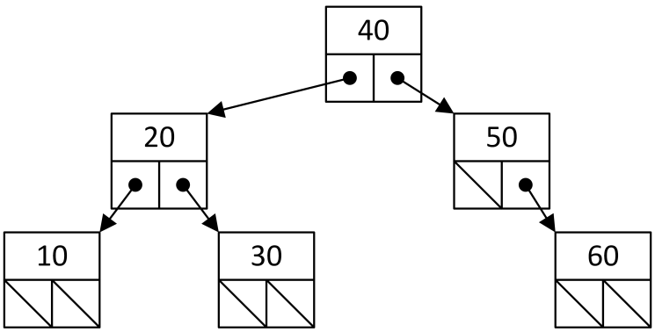

Tree terminology

• the root node has no parent, all others have exactly one

• nodes can have multiple children

• in a binary tree, each node has at most two children

• a leaf node has no children

• the height of a tree is the maximum possible number of nodes from the root to a leaf (inclusive)

• the height of an empty tree is zero

• the number of nodes is known as the node count

Binary Search Trees (BSTs)

* Binary Search Tree (BSTs) enforce the ordering property: for every node with an item i, all items in the left child subtree are less than i, and all items in the right child subtree are greater than i. (we won’t have duplicates)
* 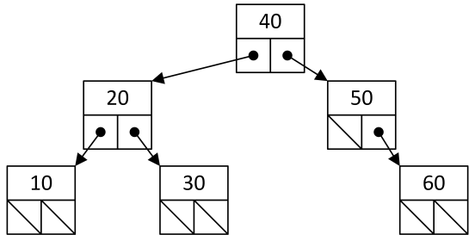
* Our BST node (bstnode) is very similar to our linked list node definition
* 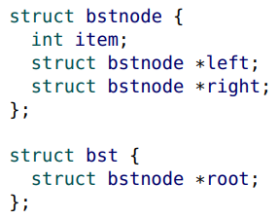
* In CS 135, BSTs were used as dictionaries, with each node storing both a key and a value. Traditionally, a BST only stores a single item, and additional values can be added as node augmentations if required
* As with linked lists, we need a function to create a new BST
* 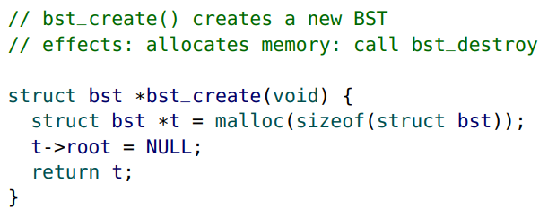

Inserting into a BST

* This is a recursive version of bst_insert. An iterative variant is provided later in this section.
* 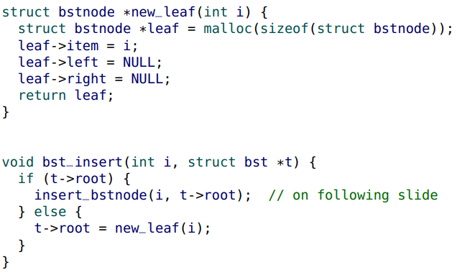
* For the core function, we recurse on nodes.
* 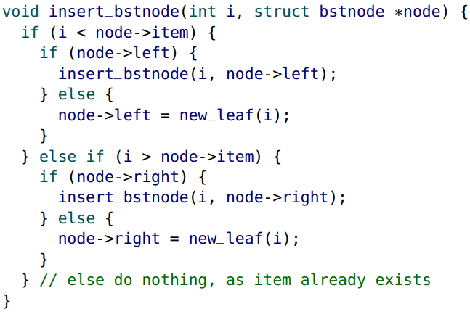

Trees and efficiency

* What is the efficiency of bst_insert?
* The worst case is when the tree is unbalanced, and every node in the tree must be visited.
* 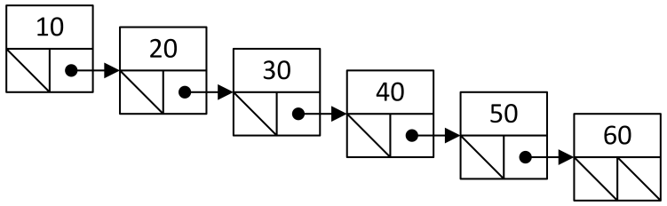
* In this example, the running time of bst_insert is O(n), where n is the number of nodes in the tree.
* The running time of bst_insert is O(h): it depends more on the height of the tree (h) than the number of nodes in the tree (n).
* The definition of a balanced tree is a tree where the height (h) is O(log n).
* Conversely, an unbalanced tree is a tree with a height that is not O(log n). The height of an unbalanced tree is O(n).
* Using the bst_insert function we provided, inserting the nodes in sorted order creates an unbalanced tree.
* With a balanced tree, the running time of standard tree functions (e.g., insert, remove, search) are all O(log n).
* With an unbalanced tree, the running time of each function is O(n).
* A self-balancing tree “re-arranges” the nodes to ensure that tree is always balanced.
* With a good self-balancing implementation, all standard tree functions preserve the balance of the tree and have an O(log n) running time.
* In CS 240 and CS 341 you will see self-balancing trees. Self-balancing trees often use node augmentations to store extra information to aid the re-balancing.

Count node augmentation

* A popular tree node augmentation is to store in each node the count (number of nodes) in its subtree.
* 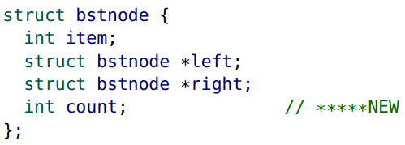
* This augmentation allows us to retrieve the number of nodes in the tree in O(1) time.
* It also allows us to implement a select function in O(h) time.
* select(k) finds item with index k in the tree.
* 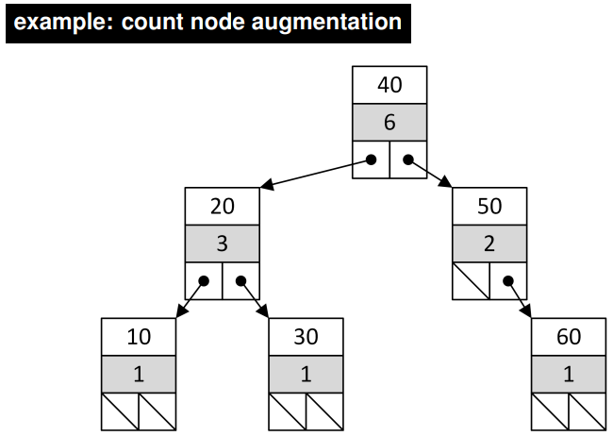
* The following code illustrates how to select item with index k in a BST with a count node augmentation.
* 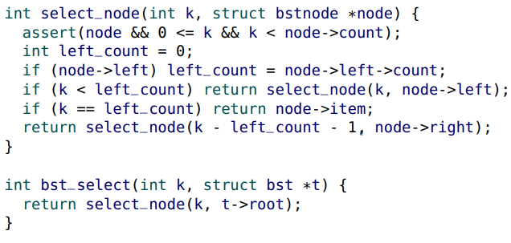
* select(0, t) finds the smallest item in the tree.
* select(n - 1, t) finds the largest item in the tree.

Dictionary ADT (revisited)

* The dictionary ADT (also called a map, associative array, key-value store or symbol table), is a collection of pairs of keys and values.
* Each key is unique and has a corresponding value, but more than one key may have the same value.
* Typical dictionary ADT operations:
  + • lookup: for a given key, retrieve the corresponding value or “not found”
  + • insert: adds a new key/value pair (or replaces the value of an existing key)
  + • remove: deletes a key and its value
* We provide an example Dictionary ADT that uses a BST with int keys and string values. Of course, many other possible types are possible.
* 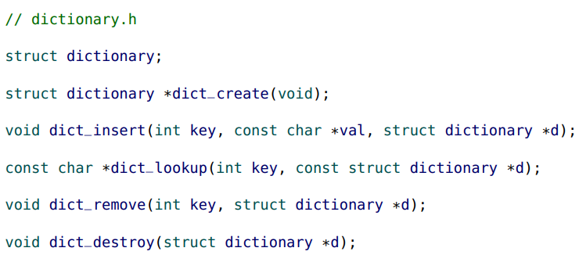
* Using the same bstnode structure, we augment each node by adding an additional value field.
* 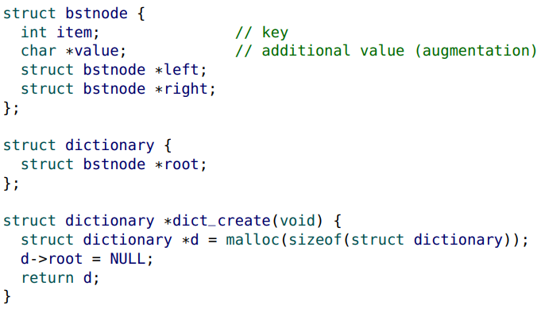
* Our dictionary ADT operations are implemented with an iterative approach.
* The exception is the destroy operation. If a tree function needs to visit all children, a recursive approach is usually the best.
* 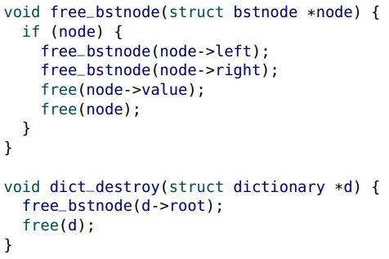
* This implementation of the lookup operation returns NULL if unsuccessful.
* 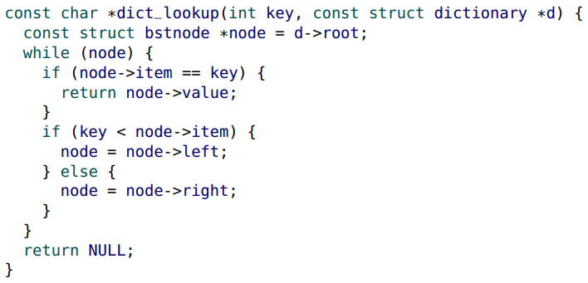
* When inserting an int/string key/value pair into the dictionary, we need to make a copy of the string (value) passed by the client (see new_leaf below).
* 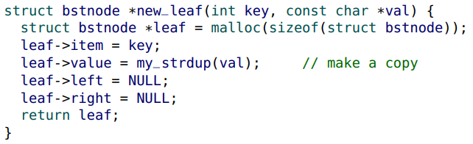
* If a client tries to insert a key that already exists, we replace the value with the new value (as seen on the following slide).
* There are several different ways of removing a node (the “target”) from a BST. Our strategy is as follows:
* • A) If the target is a leaf, we remove it.
* • B) If a child of the target is NULL, the other child will “replace” the target.
* • C) If the target has two children, we will replace the target with the next largest key (the “replacement” node). The replacement node is the smallest key in the target’s right subtree. This replacement is not too complicated because the replacement node is guaranteed to have a NULL left child (otherwise, it wouldn’t be the next largest key).
* First, we need to find the target node to be removed. We will also need its parent so the parent can be updated.
* 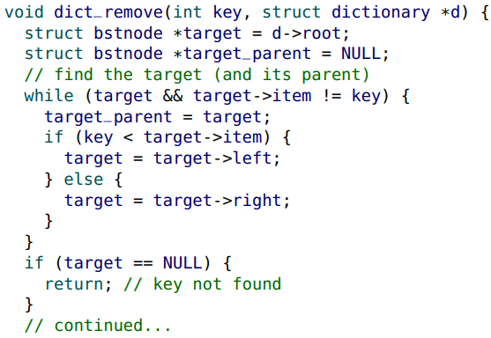
* If either of the target’s children is NULL, the replacement is the other child.
* This also covers the case if the target is a leaf (the replacement is NULL).
* 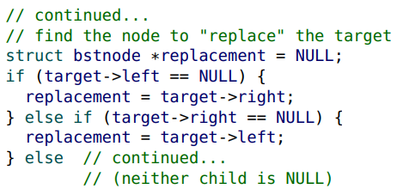
* If the target has two children, the replacement is the next largest node (the smallest node in the target’s right subtree).
* 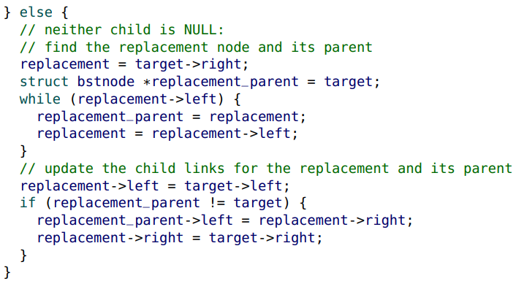
* Finally, the replacement has been found, and so the target must be freed and the parent of the target is updated.
* 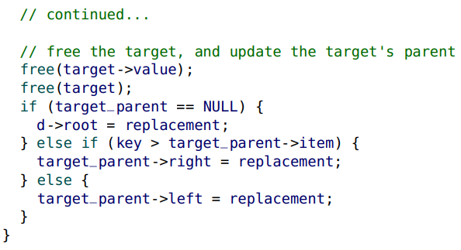

Graphs

* Linked lists and trees can be thought of as “special cases” of a graph data structure. Graphs are the only core data structure we are not working with in this course.
* 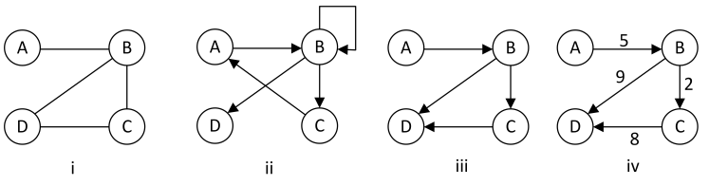
* Graphs link nodes with edges. Graphs may be undirected (i) or directed (ii), allow cycles (ii) or be acyclic (iii), and have labeled edges (iv) or unlabeled edges (iii).